Mrs. Reif’s
GLBAL 10 POLICIES
2016-2017

The Basics

Class Materials-

    - All Global 10 students are given a textbook to use for the year. The version of our textbook, “World History: Patterns of Interaction” is a relatively new set of books that costs $100+ when purchased. To keep these books in good condition, all textbooks MUST be covered at ALL times! Lost, stolen and/or damaged books will result in a fine at the end of the school year.

    - I recommend that each student get a heavy-duty folder or binder to hold notes and handouts. Global History is a two year course with a NYS Regents exam given at the end of the student’s tenth grade year. I encourage that all students keep their materials from their ninth grade year to use to study for the Regents.

Attendance-

  - Your student will have 3 days for every one day absent to make up any work that was missed. This includes any tests, quizzes, homework and participation grades. The homework that was due on the day he/she was absent will be due on the first day he/she returns to school.

Grading Policies

Each assignment will be given a point value by the teacher depending on the size and difficulty of the task. For example, a guided reading may be worth 10 points while a unit exam may be worth 100 points. Points will be deducted for incorrect information, lateness, etc. from the starting value of the assignment.

Exams-

- Tests are given at the end of each unit of study. They will usually consist of multiple choice, matching, true-false questions, document-based scaffolding questions and a short written question.

Projects-
- Projects may be given periodically. The students may be asked to complete these projects individually or in groups, both in class and/or outside of class, depending on the project.

- While projects can be both fun and informative, projects seem to be the type of assignment that gives the students the most issues. This is because they seem to procrastinate or assume that another student in their group will complete it. Please keep in mind that group projects are the responsibility of ALL members of the group meaning that the entire group will be held accountable for late and/or missing work.

Homework-

- Homework will be checked on the day it is due for completion and/or accuracy. Late homework is not accepted.

"Flipped Classroom"-

  - This year, part of my classroom will be "flipped." As this is a new concept for some students, it will take some getting used to. The idea of a flipped classroom is that videos via the web will introduce new subject matter and reinforcement will occur in the classroom in the form of activities, projects, skill work, etc. This means that students' "homework" will be to watch videos at home using the internet. Students will be given advanced notice so that accessing the web will not be an issue. In having done this last year, I have found that some students may choose to not watch the video, only watch parts or even mute the sounds while they copy the notes. To ensure this doesn’t happen, assignments will be given that coincide with the videos. Additionally, there may be unannounced quizzes on the information in the videos. Activities the following class period will ensure that the student has in fact done the homework of watching the videos.

Keeping Up-To-Date

Begin by checking out the class website www.reifshistoryclasses.weebly.com. There is a wealth of information there including enrichment materials for each unit, assignments from class and the programs I will be using below.

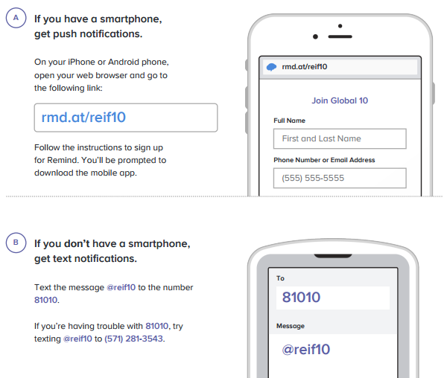
In an effort to keep everyone connected, I will be using a number of different programs to post important information. Below is the codes, links, etc to those programs.

Remind
By downloading this program to your smartphone or by going to www.remind.com, it will allow me to send mass texts regarding important information such as due dates, test dates, etc. In order to receive these texts you need to subscribe below.

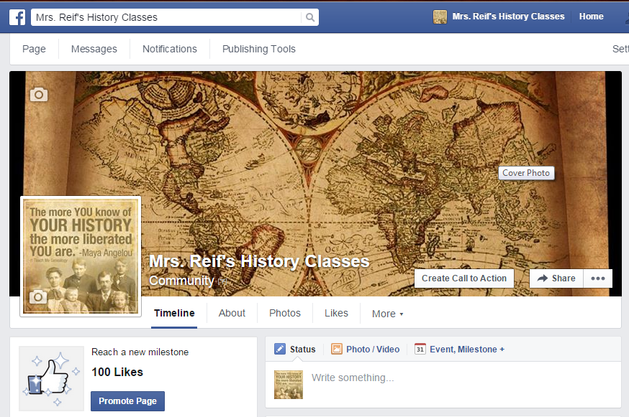
Facebook
For students who have a Facebook account, like my page: Mrs. Reif’s History Classes. *This does not require a “friend request.”* I will post important information such as test dates or homework reminders along with any interesting articles, photos, etc. on this page. Students and parents will also be able to message my page if there are any questions.

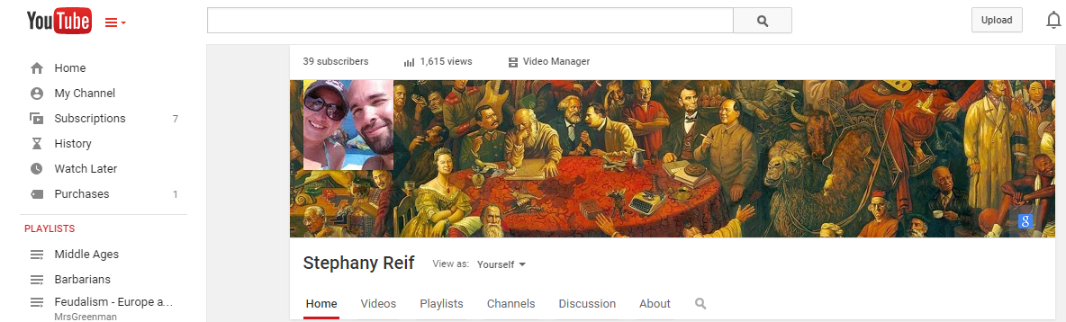
YouTube
Some assignments throughout the year will be video-based. Lectures are recorded by me and then viewed by the student via YouTube. (*See Flipped Classroom below for more details.) The easiest way to access these videos is to subscribe to my YouTube Channel. These videos will be posted to my website as well.

“Those who do not study history are condemned to repeat it.”

