Name: Date:
Global 10/Period: 18th c. Reform Mvmnts

The ideas of the Enlightenment sparked social reform movements in the 18th century and continue to fuel them today. Two of those reform movements were the women’s rights movement and the abolition movement.

What effect did the Enlightenment have on
social reform movements in the 18th century?
Objective: Explain how Enlightenment ideas influenced the women’s rights and abolition movements in England.

The Roots of Feminism and Women’s Rights Movements
Directions: As you read through the information about the Women’s Rights movements below, draw a whereever you see evidence of an Enlightenment idea then complete the task that follows.
Throughout most of history, women were treated as inferior to men and those actions were supported by ideas in culture, religion, and law. In 18th century Europe, women were not as educated as men, and they were restricted by laws and customs that made women look to marriage as a means of stability and made them dependent on men. Due to their favored position in society, men were able to excel in public life, that is, science, philosophy, religion and politics, while women were expected to marry, have children, and take care of the home.

Using Enlightenment ideas, some women, including Mary Wollstonecraft, argued for more equal rights for men and women. Mary Wollstonecraft (April 27, 1759 – September 10, 1797) was a British intellectual, writer, philosopher, and early feminist. She wrote several novels, essays, and children's books, but is best known for her book, A Vindication of the Rights of Woman (1792).

Wollstonecraft argued that all men and women had equal natural rights, and that an ideal society could not be realized until everyone was free to exercise those rights. She spoke out against the situation of women in the eighteenth century, declaring that they were educated to be submissive to men and to value physical attractiveness over character and intelligence.
Sources: Adapted from Social Status of Women in 18th Century English Society As Reflected In a Dictionary of the English Language of Dr. Johnson Karabi Hazarika Research Scholar, CMJ University, Shillong, Meghalaya
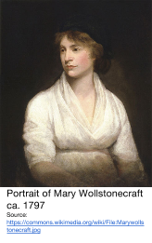
IJCAES Special Issue on Basic, Applied & Social Sciences, Volume II, October 2012. http://www.caesjournals.org/spluploads/IJCAES-BASS-2012-189.pdf; Adapted from “Mary Wollstonecraft.” New World Encyclopedia. http://www.newworldencyclopedia.org/entry/Mary_Wollstonecraft

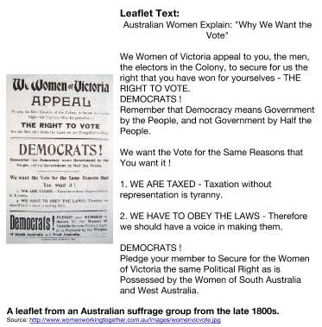  19th and 20th Century Women’s Rights and Suffrage Movement in the United Kingdom (England)  The writings of Mary Wollstonecraft and others in the 18th century inspired women later in history to fight for equal rights. Women led campaigns to improve education for girls, child custody and property rights, career options for women, and the right to vote (suffrage).  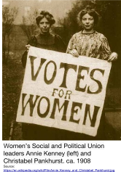 | Identify three examples of Enlightenment ideas in the information and sources about Women’s rights movements in the 18th and 19th centuries.

The Abolition Movement Starts in England
Directions: As you read through the information about the Abolition Movement below, draw a whereever you see evidence of an Enlightenment idea then complete the task that follows.
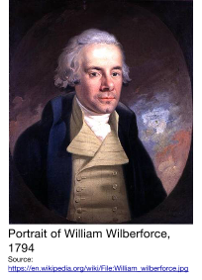
Soon after the colonization of the Western hemisphere, European countries started importing slaves from Africa to work in mines and on farms in the new world. During the course of the 18th century the British perfected the Atlantic slave system. It has been estimated that between 1700 and 1810 British merchants transported almost three million Africans across the Atlantic. That the British benefited from the Atlantic slave system is indisputable. Yet, paradoxically, it was also the British who led the struggle to bring this system to an end.

Several groups who found the practice of slavery immoral petitioned the British government to stop trading slaves in the 1700s, but It was the Society for the Abolition of the Slave Trade, organized in May 1787, that had the greatest impact. Led by Thomas Clarkson and William Wilberforce, the Society for the Abolition of the Slave Trade organized abolitionists, made speeches, released newsletters, and lobbied politicians to gain support for the end of slavery in the British Empire.
Eventually, in 1807 they were successful in getting Parliament to pass a law outlawing slavery and the slave trade in England and all of the British colonies. While slavery was officially illegal, people of African descent were not yet treated equally.
Source: Adapted from Dr. John Oldfield. “British Anti-Slavery.” http://www.bbc.co.uk/history/british/empire_seapower/antislavery_01.shtml
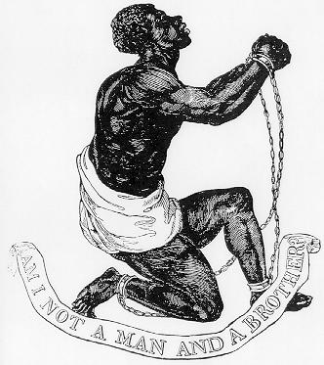  The Official Medallion of the British Anti-Slavery Society  Source: https://en.wikipedia.org/wiki/File:Official_medallion_of_the_British_Anti-Slavery_Society_(1795).jpg | Let us not despair; it is a blessed cause, and success, ere long, will crown our exertions. Already we have gained one victory; we have obtained, for these poor creatures, the recognition of their human nature, which, for a while was most shamefully denied. This is the first fruits of our efforts; let us persevere and our triumph will be complete. Never, never will we desist till we have wiped away this scandal from the Christian name, released ourselves from the load of guilt, under which we at present labour, and extinguished every trace of this bloody traffic, of which our posterity, looking back to the history of these enlightened times, will scarce believe that it has been suffered to exist so long a disgrace and dishonour to this country.  William Wilberforce,  speech before the House of Commons, 18 April 1791  Source: Hansard, T.C. (printer) (1817), The Parliamentary history of England from the earliest period to the year 1803 XXIX, London: Printed by T.C. Hansard, p. 278 from https://en.wikipedia.org/wiki/William_Wilberforce#cite_ref-114
Identify three examples of Enlightenment ideas in the information and sources about the British Abolition Movement in the 18th and 19th centuries.

What effect did the Enlightenment have on monarchs in Europe?
Objective: Explain how Enlightenment ideas influenced the actions of Enlightened Despots.

Introduction:
In the mid-late 1700s, Enlightenment writings circulated around Europe. Some of those reading the ideas of Locke, Rousseau, Montesquieu, and Voltaire were monarchs. Most rulers found Enlightenment ideas dangerous and banned them, but some kings and queens, who historians call ENLIGHTENED DESPOTS incorporated Enlightenment ideas into their rule.

ENLIGHTENED | DESPOT
Influenced by the writings of the Enlightenment philosophers who supported natural rights, the separation of power in a government, the consent of the governed, social contract, and the freedom of expression. | A ruler with absolute power.

Prediction
Given the definitions above, what do you think an Enlightened Despot might do as a ruler? How can one combine Enlightenment ideas with despotism?
Several monarchs that ruled in northern and central Europe in the 18th century are referred to as Enlightened Despots. Of those, Catherine the II (the Great) of Russia was the most well known.
Catherine the Great of Russia
Directions: As you read through the information about Catherine the Great below, draw a whereever you see evidence of an Enlightenment idea then complete the task that follows.
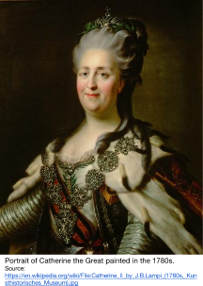
Catherine II, also known as Catherine the Great (Russian: Екатерина II Великая or Yekaterina II Velikaya, born Sophie Augusta Fredericka of Anhalt-Zerbst; May 2, 1729 – November 5, 1796) reigned as Empress of Russia for more than three decades, from June 28, 1762 until her death. She was sometimes referred to as the epitome of an "enlightened despot" and she is rightly remembered as one of the most powerful and successful women rulers, who, like Elizabeth I of England and Isabella of Castile left a permanent mark on her nation, extending territory and patronizing art and learning.

Catherine generally subscribed to the Enlightenment and considered herself a "philosopher on the throne." She was well aware of her image abroad, and always desired to be perceived by Europe as a civilized and enlightened monarch, despite the fact that in Russia she often behaved like a tyrant. Even as she proclaimed her love for the ideals of liberty and freedom, she enacted laws that tied the Russian Serf (slave) to his land and his lord.

Catherine was known as a patron of the arts, literature and education. Catherine wrote comedies, fiction and memoirs. She corresponded with Voltaire for fifteen years, from her accession to his death. Though she never met him face-to-face, she mourned him bitterly when he died. She acquired his collection of books from his heirs and placed it in the Imperial Public Library.

Within a few months of her accession, upon hearing that the publication of the famous French Encyclopedie was in danger of being stopped by the French government because of its irreligious spirit, she proposed to Diderot that he complete his great work in Russia under her protection.

Catherine also wrote a manual for the education of young children, drawing from the ideas of John Locke. She founded the famous Smolny Institute for noble young ladies. This school was to become one of the best of its kind in Europe, and broke ground by admitting young girls born to wealthy merchants alongside the daughters of the nobility.

In addition, she attempted to embody the principles of Enlightenment learned through her study of the French philosophers, into a legislative form. A Grand Commission, acting as a consultative parliament, composed of 652 members of all classes—officials, nobles, burghers and peasants and of various nationalities—was convened in Moscow to consider the needs of the empire and the means of satisfying them. The laws proposed by the commission were influenced by Montesquieu, but were never enacted.
Proposals for a New Law Code from Catherine’s Grand Commission in 1767
33. The Laws ought to be so framed, as to secure the Safety of every Citizen as much as possible. | 123. The Usage of Torture is contrary to all the Dictates of Nature and Reason; even Mankind itself cries out against it, and demands loudly the total Abolition of it.
34. The Equality of the Citizens consists in this; that they should all be subject to the same Laws. | 194. No Man ought to be looked upon as guilty, before he has received his judicial Sentence...
Source: Adapted from “Catherine II of Russia.” New World Encyclopedia. http://www.newworldencyclopedia.org/entry/Catherine_II_of_Russia; Documents of Catherine the Great: The Correspondence with Voltaire and the Instruction of l767 in the English Text of l768, W. F. Reddaway, trans. (Cambridge: Cambridge University Press, 1931), pp. 216-17, 219, 231, 241, 244, 256 258. http://legacy.fordham.edu/halsall/mod/18catherine.asp
Identify three examples of actions taken by Catherine the Great that were influenced by Enlightenment ideas.

Synthesis Activity

Directions: Based on the information from this lesson complete the tasks below.

Women | Supporters of the Slave Trade | Monarchs
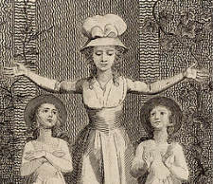  Source | 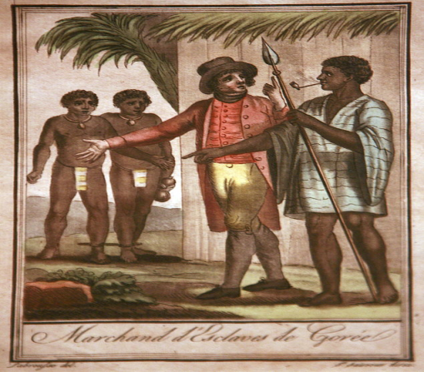  Source | 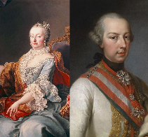  Source 1, Source 2
Summarize how women were affected by the ideas of the Enlightenment. | Summarize how supporters of the slave trade and/or slaves were affected by the ideas of the Enlightenment. | Summarize how Enlightened Despots were affected by the ideas of the Enlightenment.

