The Abbasid Caliphate (750-1258): Golden Age of Islam
Objective: Identify the context and the achievements and innovations of the Golden Age of the Abbasid Caliphate.

Directions: Read the passage below and answer the questions in the right hand column .

The Abbasid Dynasty: The Golden Age of Islamic Civilization  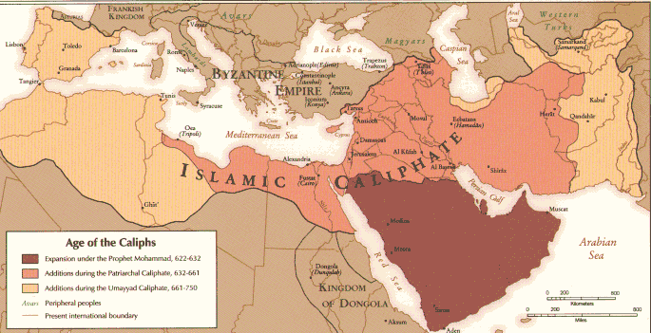  The Abbasid Caliphate, which ruled the Islamic world, oversaw the golden age of Islamic culture. The dynasty ruled the Islamic Caliphate from 750 to 1258 AD, making it one of the longest and most influential Islamic dynasties. For most of its early history, it was the largest empire in the world, and this meant that it had contact with distant neighbors such as the Chinese and Indians in the East, and the Byzantines in the West, allowing it to adopt and synthesize ideas from these cultures…  Islamic Golden Age  ... The fifth caliph of the Abbasid dynasty, Harun al-Rashid (r. 786–809), is remembered as one of history’s greatest patrons of the arts and sciences. Under his rule, Baghdad became the world’s most important center for science, philosophy, medicine, and education. The massive size of the caliphate meant that it had contact and shared borders with many distant empires, so scholars at Baghdad could collect, translate, and expand upon the knowledge of other civilizations, such as the Egyptians, Persians, Indians, Chinese, Greeks, Romans, and Byzantines. The successors of Harun al-Rashid, especially his son al-Ma’mun (r. 813–833), continued his policies of supporting artists, scientists, and scholars. Al-Ma’mun founded the Bayt al-Hikma, the House of Wisdom, in Baghdad. A library, an institute for translators, and in many ways an early form of university, the House of Wisdom hosted Muslim and non-Muslim scholars who sought to translate and gather the cumulative knowledge of human history in one place, and in one language—Arabic. At the House of Wisdom, important ideas from around the world came together. The introduction of Indian numerals, which have become standard in the Islamic and Western worlds, greatly aided in mathematic and scientific discovery. Scholars such as Al-Kindi revolutionized mathematics and synthesized Greek philosophy with Islamic thought. Al-Biruni and Abu Nasr Mansur—among many other scholars—made important contributions to geometry and astronomy. Al-Khwarizmi, expanding upon Greek mathematical concepts, developed Algebra (the word “algorithm” is a corruption of his name). Ibn al-Haytham made important contributions to the field of optics, and is generally held to have developed the concept of the scientific method. A number of very practical innovations took place, especially in the field of agriculture. Improved methods of irrigation allowed more land to be cultivated, and new types of mills and turbines were used to reduce the need for labor (though slavery was still very common in both the countryside and cities). Crops and farming techniques were adopted from far-flung neighboring cultures. Rice, cotton, and sugar were taken from India, citrus fruits from China, and sorghum from Africa. Thanks to Islamic famers, these crops eventually made their way to the West. Such Islamic innovation would continue, even as the Abbasid government fell into chaos.  https://www.saylor.org/site/wp-content/uploads/2012/10/HIST101-9.3.1-AbbasidDynasty-FINAL1.pdf |  | - How did the Abbasid Dynasty’s size impact its cultural history?  - With what other cultures/empires did the Abbasids come into contact?  - What was the House of Wisdom and what was its significance?
PBS Documentary Islam: Empire of Faith (Part 2) Multiple Views and Reads
Directions:
- Preview the questions listed in the right-hand column.
- Watch the video (https://youtu.be/-6FvFg4p7kI) and try to answer the questions.
Time | Questions
2:24 | 1. Describe the city of Baghdad from the 8th to 13th centuries.
3:06 | 2. Based on the video, why were there so many scholars studying math and science in Baghdad during the Abbasid Caliphate?
 | 3. Where did the scholars who worked in the House of Wisdom come from?
5:05 | 4. Where did the scholars from the House of Wisdom get the base of their understanding of math, science, and philosophy from?
6:45 | 5. According to the historian in this segment of the film, what was “the birth of the new Islamic science?” What caused it?
7:26-8:17 | 6. According to this video, what contributions did the scholars of the Islamic Golden Age make to world history?
9:30-10:23 | 7. Based on this excerpt from Islam: Empire of Faith, what inventions propelled the spread of learning throughout the Islamic world? Why did these inventions have that effect?
10:34 | 8. How did availability of books in the Abbasid Caliphate compare to the availability of books in Western Europe from the 700s to the 1300s? How do you think this different effected the two regions?

