Name: Date:
Global 10/Period: The Agricultural Revolution

The Agricultural Revolution
Directions: Using the text, video, and images on the following pages, fill out the graphic organizer below with information about farming before Agricultural Revolution, what caused the changes during the Agricultural Revolution, and the effects of those changes.

Before the Agricultural Revolution | Which innovations caused a change? | Effects of the Agricultural Revolution

What was the Agricultural Revolution?
The Agricultural Revolution (mid-1700s- late 1800s) started in Great Britain and was the first of two important non-political revolutions that started in the 18th century. It was both a revolution itself and an important cause of the Industrial Revolution.

Agricultural Revolution- the transformation of agriculture from traditional medieval farming to more productive, efficient, and mechanical methods of farming through scientific innovation and new techniques starting in the mid-1700s.

The Agricultural Revolution led to a drastic increase in population in Great Britain and elsewhere, and increased urbanization because people moved away from their farms to cities.
Watch this video [https://youtu.be/6QKIts2_yJ0] on the Agricultural Revolution (1:27-end) and read the description of the Agricultural Revolution below then fill in the graphic organizer above with information you learned.

Innovations of the Agrarian Revolution: Enclosure Movement
BEFORE the Agrarian Revolution | INNOVATION | EFFECTS of the Innovation
Common Land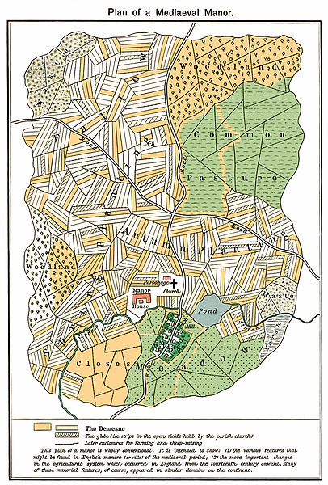  A map of a medieval manor. The green sections were “common land”  During the Middle Ages and up until the Agricultural Revolution, communities had “common land” that was used by all of the peasants to farm and hunt on. | The Enclosure Movement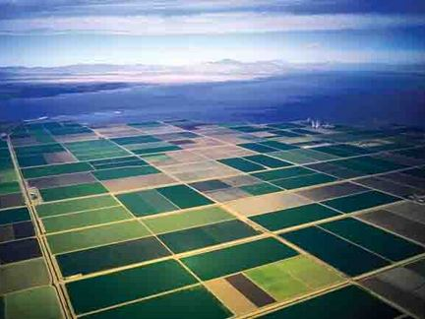  An example of modern-day enclosed fields.  Enclosure was the process of making common land into private land, owned by a farmer. The land was then fenced in, or enclosed. Sometimes an individual bought the land from a town or the government of the town decided to enclose the common itself. | Peasants Move to the City  The peasants who once used the common land to farm and graze animals either worked for the farmers who owned the enclosed land or they moved to a nearby urban area and got jobs in factories.  Agricultural Innovation on Private Farms  The new owner of the land was able to farm it however they liked since it was theirs. They often used innovative techniques that made the land more productive than it had been before.

Innovations of the Agrarian Revolution: Seed Drill
BEFORE the Agrarian Revolution | INNOVATION | EFFECTS of the Innovation
Hand Sowing Seeds  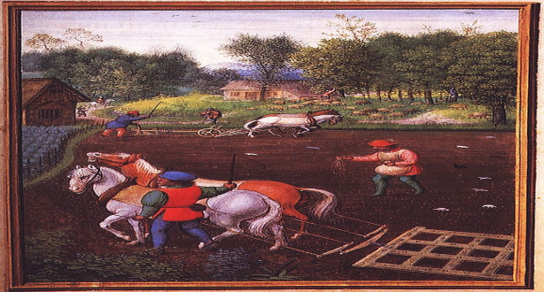  Medieval Farmers plowing a field and sowing seeds by hand.  Before the Agricultural Revolution, farmers used a plow to create furrows (ditches) then scattered seeds into them and covered them back up with dirt. This method was ineffective because birds and other animals could easily eat the seeds and they were planted with little accuracy. | Jethro Tull’s Seed Drill  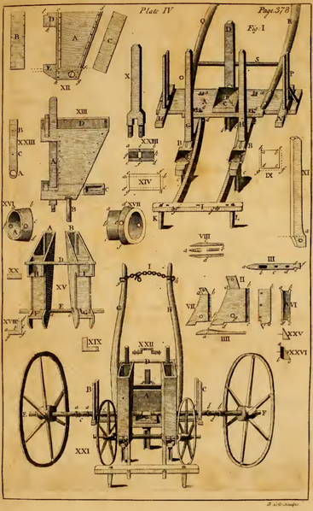  Components of Jethro Tull’s Seed Drill.  Jethro Tull Invented his horse-drawn seed drill in 1701. The machine drilled holes for three rows of seed at a time to the correct depth, planted the seeds, and covered them in dirt in one action. | Higher Agricultural Yields  More Food! More Time! Less Workers!  Tull’s seed drill increased crop yields [the amount of food grown] five times. In addition, planting with the seed drill was much quicker than hand planting and required fewer workers. As a result, farmers could plant and grow more crops. The workers who were no longer needed on the farm had to find work elsewhere, usually in a nearby town or city where factories employed many people.

Innovations of the Agrarian Revolution: Four Crop Rotation System
BEFORE the Agrarian Revolution | INNOVATION | EFFECTS of the Innovation
Three Crop Rotation System  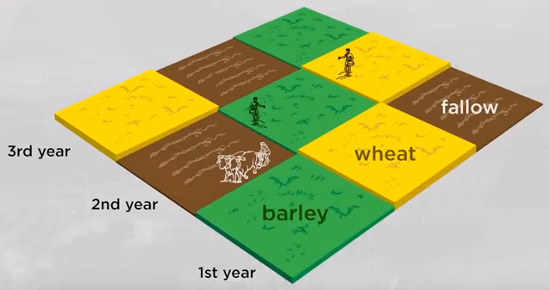  Since the Middle Ages, farmers in Europe had used the three-crop rotation system which involved leaving one field fallow [empty] every year. This meant that they could not grow as much food and that livestock only had one field to graze on. | Dutch Four Crop Rotation System  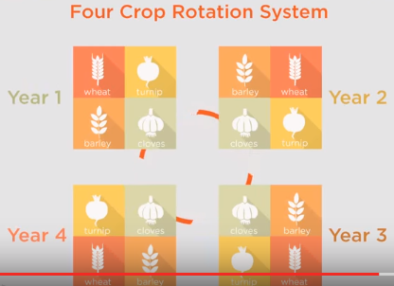  During the Agricultural Revolution, a new method of crop rotation used by the Dutch in the Netherlands was introduced in Great Britain. The Dutch had discovered that a type of vegetable called legumes, like turnips, could replenish the field’s nutrients just as well as leaving it fallow. | More Food and Livestock  As a result of the four-crop rotation system, British farmers could be more productive. The turnips replenished the soil with needed nutrients, provided another crop for farmers to eat and sell, and gave their livestock something to live on during the winter.

