Name: Date:
Global 9R/Period: Alexander the Great

Alexander the Great
DIRECTIONS: As you watch the movie on Alexander the Great, do your best to answer the questions. They do not need to be in complete sentences.

- In 331 BC, who were the Greeks fighting?
- Who was Phillip?
- Where were Phillip and Alexander from?
- What poem inspired Alex?
- Who was Alex’s hero?
- What connection did Alex’s mother believe there was between Alex and Zeus?
- Who was Bucephalus?
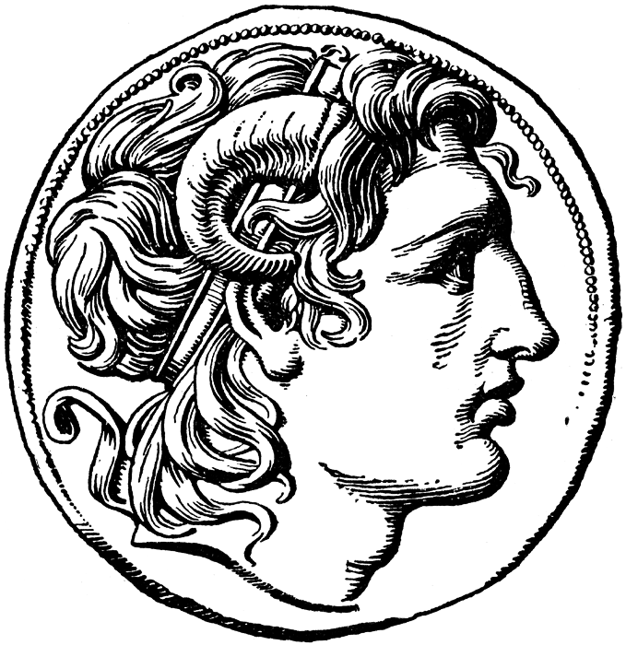
- What happened to Phillip on the way to his daughter’s wedding?
- How old was Alex when he took the throne?
- Following the destruction of Thebes, from what empire did Alex promise to free the Greeks?
- What did Alex take from the tomb of Achilles? Why?

- Who was the king of Persia at this time?
- At what city did the Greeks and Persians meet?
- What did Darius do in battle that was considered “unforgiveable”?
- When the movie mentioned that Alex planned to next travel to the “land of the pharaohs,” to what civilization are they referring?
- What happened in 331 in Memphis?
- Why was Alex now considered “divine”?
- What was the name of the city that Alex built in Egypt?
- In what city do the Greeks and Persians now meet?
- What occurred on September 20, 331 BC?
- By the age of 25, Alex is now the king of what lands?
- In current dollars, about how much money does Alex receive from the Persian Empire?

- How do Alex’s men react to his adoption of Persian customs?
- How did Darius die?
- By 327, where were Alex and his troops?
- What was the “last straw” for Alex’s men?
- By 324, where were Alex and his troops?
- Where did he plan to invade next?
- What disease did Alex contract?
- What occurred on June 10, 323 BC?
- Where is Alexander the Great’s grave?

