How did Kemal Atatürk reform Turkey?
Objectives: Describe how Kemal Atatürk reformed Turkey.

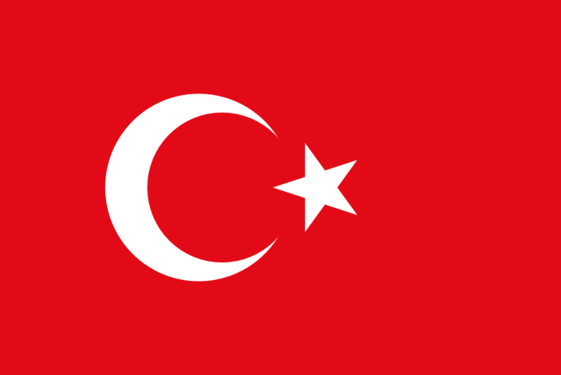  Turkish Flag  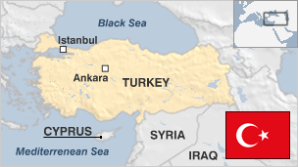 | What was the Ottoman Empire?  The Ottoman Empire was founded in 1299 by a family of nomadic Turks from the region in western Asia known as Asia Minor. Eventually, the Ottoman Empire ruled over vast lands that included a diverse group of inhabitants. As the Ottoman Empire’s control over its territories declined, nationalism among the ethnic groups ruled by the empire inspired rebellion against the Ottomans.  At its height in the 1600s, the Ottoman Empire controlled most of the Middle East, north Africa, and eastern Europe, but its power declined over the next three centuries. Due to a series of weak and ineffective rulers, a corrupt government, nationalist movements within its borders, and European imperialism, Ottoman power diminished.  The leaders of some ethnic groups that were critical of the empire’s weakness and its willingness to adopt European ideals in the 1800s started to pull away from the empire. For example, in southeastern Europe the Greeks revolted in 1821, the Bulgarians in 1876, and Moldavia gained autonomy in 1861.  While nationalism grew throughout the empire in resistance to Ottoman rule, it was also a strong force in Istanbul, the Empire’s capital. A nationalist group called the “Young Turks” came to power in the early 1900s. They wanted to modernize the empire and turn it into a democratic state. They also turned the empire, which historically welcomed other ethnic groups into the fold, against non-Turks.  On the eve of World War I, the Young Turks hoped to redefine the Ottoman Empire while ethnic groups throughout the empire were hoping to carve out a place of their own if the “Sick Man of Europe” (as the Ottoman Empire was known at the start of the 1900s) were to die.  Source: Adapted from http://www.newworldencyclopedia.org/entry/Ottoman_Empire
1. Why did different ethnic groups resist the Ottoman Empire in the 1800s?

2. What did the “Young Turks” want when they came into power? What changes did they hope to make?

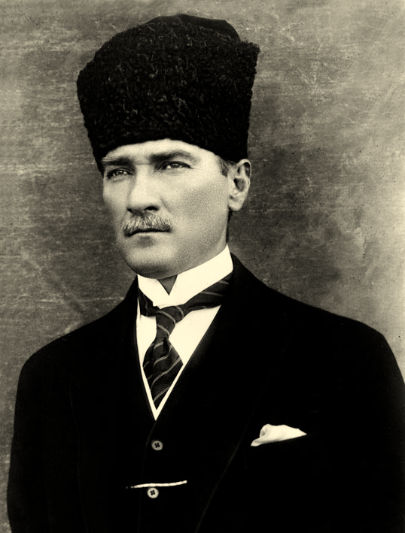 | How did Atatürk change Turkey?  Mustafa Kemal Atatürk (1881-1938) was an army officer who founded an independent Republic of Turkey as the Ottoman Empire was falling. He served as Turkey’s first president from 1923 until his death in 1938. He is most well known for implementing reforms to modernize Turkey. These reforms rapidly secularized and westernized the country.  A reform is a change designed to improve society. Atatürk’s reforms were influenced by ideas of modernization, secularization, and westernization.  Modernize Secularize Westernize
Mustafa Kemal [Atatürk] was a secular nationalist who believed that all the inheritance of the Ottoman Empire should be abandoned and Turkey should be transformed into a modern European state. This involved less of a sudden break with the past than might appear. The Tanzimat reforms [between 1839 and 1876] had laid the foundations of a secular state, and the Young Turks, even while attempting to preserve the empire, had given a powerful impetus [motivation] to the cause of Turkish nationalism. During the war years [1914–1918], the secularization of education had proceeded and the universities and public positions had been opened to women. Certain of the law courts under the control of the religious authorities had been placed under the Ministry of Justice. A law in 1916 had reformed marriage and divorce....
Source: Peter Mansfield, A History of the Middle East, Viking
- According to Peter Mansfield, what did Mustafa Kemal Atatürk believe Turkey should be transformed into?

- According to Peter Mansfield, what is one reform made by Mustafa Kemal Atatürk?

ATATÜRK AS PRESIDENT  Even before he became president, Greece agreed to send some 380,000 Muslims to Turkey in exchange for over 1 million Greek Orthodox practitioners. Meanwhile, under Mustafa Kemal, the forced emigration of Armenians continued. Although Turkey was now almost homogeneously Muslim, Mustafa Kemal deposed the caliph, the theoretical successor to the prophet Muhammad and spiritual leader of the worldwide Muslim community. He also closed all religious courts and schools, prohibited the wearing of headscarves among public sector employees, abolished the ministry of canon law and pious foundations, lifted a ban on alcohol, adopted the Gregorian calendar in place of the Islamic calendar, made Sunday a day of rest instead of Friday, changed the Turkish alphabet from Arabic letters to Roman ones, mandated that the call to prayer be in Turkish rather than Arabic and even forbade the wearing of fez hats.  Mustafa Kemal’s government espoused industrialization and adopted new law codes based on European models. “The civilized world is far ahead of us,” he told an audience in October 1926. “We have no choice but to catch up.” Eight years later, he required all Turks to choose a surname, selecting Atatürk (literally Father Turk) as his own. By that time, Atatürk’s government had joined the League of Nations, improved literacy rates and given women the right to vote, though in practice he essentially imposed single-party rule. He also closed opposition newspapers, suppressed leftist workers’ organizations and bottled up any attempts at Kurdish autonomy.  Source: http://www.history.com/topics/kemal-ataturk | What are examples of Atatürk’s reforms that secularized Turkey?  What are examples of Atatürk’s reforms that westernized Turkey?

