How did Athens and Sparta differ?
Objective: Explain how Athens and Sparta differed.

Directions: Use the videos and text below to compare and contrast life in Athens and Sparta.
ATHENS | vs. | SPARTA
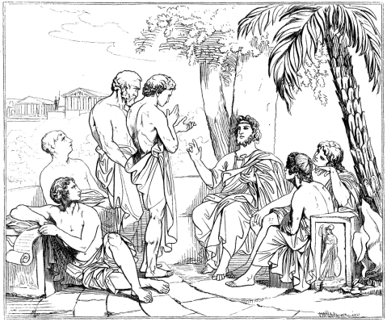 |  | 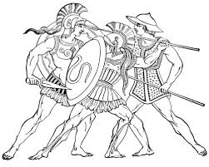

The rivalry between Athens and Sparta, two of the Greek city-states greatly affected Ancient Greece and has now become legendary. Feuding between Sparta and Athens eventually led to a twenty-seven year long civil war called the Peloponnesian War in 431 BC which led to the decline of Greece. Historians use primary sources and secondary sources to identify causes for the rivalry between Sparta and Athens.

Daily Life
Watch this video on Athens and Sparta (https://youtu.be/kLBRnpr4GFI), then describe what life was like for Athenians and Spartans below.
Life in Athens | Life in Sparta
Objective: Explain how Athens and Sparta differed.

