The Middle Ages
How Did It All Begin?

The Fall of
Rome
476 CE

Loss of a Common Language

Change in the Concept of Government
Decline in Learning

Population Shifts

Disruption of Trade

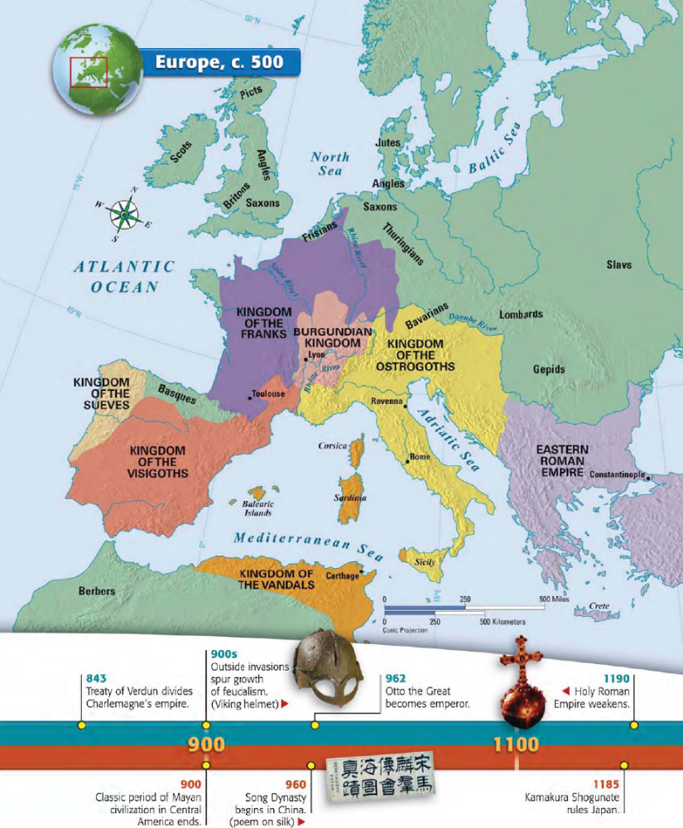
The Fall of Rome Leads to Invasions of Western Europe
In the fifth century, Germanic invaders overran the western half of the Roman Empire. Repeated invasions and constant warfare caused a series of changes that altered the economy, government, and culture:

• Disruption of Trade Merchants faced invasions from both land and sea. Their businesses collapsed. The breakdown of trade destroyed Europe’s cities as economic centers. Money became scarce.
• Downfall of Cities With the fall of the Roman Empire, cities were abandoned as centers of administration.
• Population Shifts As Roman centers of trade and government collapsed, nobles retreated to the rural areas. Roman cities were left without strong leadership. Other city dwellers also fled to the countryside, where they grew their own food. The population of western Europe became mostly rural.

The Decline of Learning The Germanic invaders who stormed Rome could not read or write. Among Romans themselves, the level of learning sank sharply as more and more families left for rural areas. Few people except priests and other church officials were literate. Knowledge of Greek, long important in Roman culture, was almost lost. Few people could read Greek works of literature, science, and philosophy. The Germanic tribes, though, had a rich oral tradition of songs and legends. But they had no written language.

Loss of a Common Language As German-speaking peoples mixed with the Roman population, Latin changed. While it was still an official language, it was no longer understood. Different dialects developed as new words and phrases became part of everyday speech. By the 800s, French, Spanish, and other Roman-based languages had evolved from Latin. The development of various languages mirrored the continued breakup of a once-unified empire.
Germanic Kingdoms Emerge
In the years of upheaval between 400 and 600, small Germanic kingdoms replaced Roman provinces. The borders of those kingdoms changed constantly with the fortunes of war. But the Church as an institution survived the fall of the Roman Empire. During this time of political chaos, the Church provided order and security.

The Concept of Government Changes Along with shifting boundaries, the entire concept of government changed. Loyalty to public government and written law had unified Roman society. Family ties and personal loyalty, rather than citizenship in a public state, held Germanic society together. Unlike Romans, Germanic peoples lived in small communities that were governed by unwritten rules and traditions. Every Germanic chief led a band of warriors who had pledged their loyalty to him. In peacetime, these followers lived in their lord’s hall. He gave them food, weapons, and treasure. In battle, warriors fought to the death at their lord’s side. They considered it a disgrace to outlive him. But Germanic warriors felt no obligation to obey a king they did not even know. Nor would they obey an official sent to collect taxes or administer justice in the name of an emperor they had never met. The Germanic stress on personal ties made it impossible to establish orderly government for large territories.

THE EFFECTS OF FEUDALISM

Directions: Using the text to your right, place the following social classes in the correct ranking on the social pyramid.
Social Classes:  - Serfs and Peasants  - Kings (Monarchs)  - Roman Catholic Church/Pope  - Knights and Vassals  - Lords  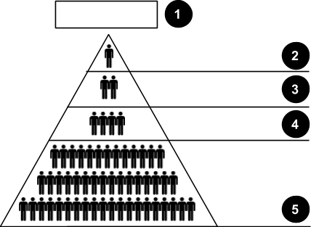 | Serfs and Peasants: Most peasants on a manor were serfs, bound to the land. Serfs were not slaves who could be bought and sold. Still, they were not free. They could not leave the manor without the lord’s permission. If the manor was granted to a new lord, the serfs went along with it.
Kings (Monarchs):
The king owned all the land and allowed the trusted nobles to govern a part of the land in return for other services.
Roman Catholic Church/Pope: In the centuries after the fall of the Roman Empire, the Roman Catholic Church carved out a unique position in Western Europe. It not only controlled the spiritual life of Christians but gradually became the most powerful secular, or non-religious, force in medieval Europe.

During the Middle Ages, the pope was the spiritual leader of the Western Christian Church, based in Rome. Declaring themselves representatives of God on Earth, medieval popes eventually claimed papal supremacy, or authority over all secular rulers, including kings and emperors.

The Church developed their own body of laws, known as canon law, as well as its own courts. [...] Anyone who disobeyed Church law faced a range of penalties. The most severe and terrifying was excommunication. Those who were excommunicated could not receive the sacraments or a Christian burial, which condemned them to hell for eternity.
Knights and Vassals:
For medieval nobles, warfare was a way of life. Rival lords battled constantly for power. Many nobles began training in boyhood for a future occupation as a knight, or mounted warrior. In the later Middle Ages, knights adopted a code of conduct called chivalry.
 | Nobility (Lords): Below the monarchs were powerful lords such as dukes and counts who held the largest fiefs. Each of these lords had vassals.

Thinking Critically about Social Hierarchy
Questions | Responses
1a. Which social class had the greatest amount of power in feudal Europe?  1b. What specific powers did this class have? | 1a.  1b.
2a. Which class of people made up the bulk of the medieval population?  2b. If you were a serf, what would be your opinion of the feudal system? Why? | 2a.  2b.
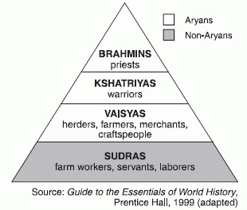  3a. What are the similarities between the feudal social structure and the Hindu caste system?  3b. What are the differences between the feudal social structure and the Hindu caste system? | 3a.  3b.

