What was the Black Plague?

Black Death Vocabulary
Epidemic- (n.) a widespread occurrence of a disease | Pandemic- (adj.) widespread over a whole country or the world | Plague- (n.) a contagious bacterial disease characterized by fever and insanity and the formation of buboes and sometimes an infection of the lungs | Yersinia Pestis- (n.) the bacteria the causes plague | Buboes- (n.) a swollen growths that occur at lymph nodes in the armpit or groin

The Black Death, also known as the Black Plague, was a devastating pandemic that struck large portions of Asia, the Middle East, and Europe in the 14th century (1300s). In Europe, it killed between ⅓ and ⅔ of the population, depending on the region. In total around the world, at least 75 million people were killed by the disease in the mid 1300s.  Most scientists now believe that the Black Death was an outbreak of bubonic plague, which is a disease caused by the bacterium Yersinia pestis which lives in rodents like rats. Those rats, which were common in Medieval cities, often had fleas on them. When the fleas bit the rats, then jumped onto humans and bit them, which spread the disease to humans. Once the disease was in a person it was spread from person to person through body fluid and coughing.  Adapted from “Black Death,” New World Encyclopedia. http://www.newworldencyclopedia.org/entry/Black_Death | 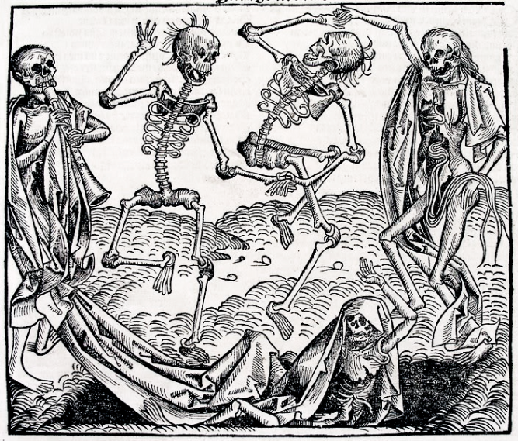  Created in 1493, this image was inspired by the Black Death and depicts the Dance of Death, which was a common theme in Medieval art because of the fear of the plague.  Source: https://commons.wikimedia.org/wiki/File:Danse_macabre_by_Michael_Wolgemut.png
Directions: Watch the clips on the Black Death and then answer the questions below.

- “What was the Black Death? What were the Symptoms” from ClickView (https://goo.gl/E7c78K)
- Bubonic Plague from the Discovery Channel’s “Filthy Cities” (https://goo.gl/vTCQZX)
WARNING: Videos contain images that some may find disgusting and/or disturbing
1. According the video(s) and above, what was the Black Death? | 2. What caused the Black Death? | 3. Why did the Black Death spread so far and kill so many people?

Where did the Black Death originate? Where did it spread? How did it spread?

Directions: Watch “The Black Death Begins” from the History Channel (https://goo.gl/0VxnkA) , then use the map below and the maps on the following pages to answer the accompanying questions

First Incidence of Black Death in Europe and Asia, 1333-1351  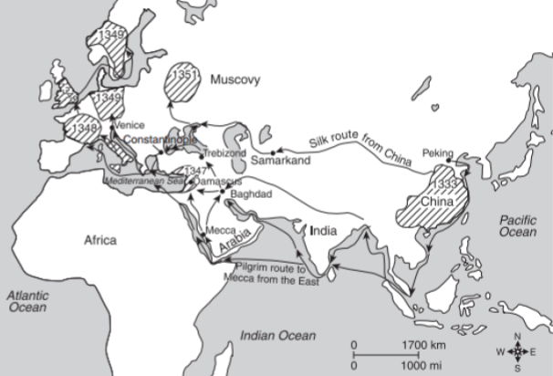  Trade routes along which the Black Death spread from China Areas of outbreaks of plague with first known dates | 1. Based on the map to the right, where did the Black Death originate? What is your evidence?  2. What types of routes did the Black Death travel on?
Major World Trade Routes in the 15th Century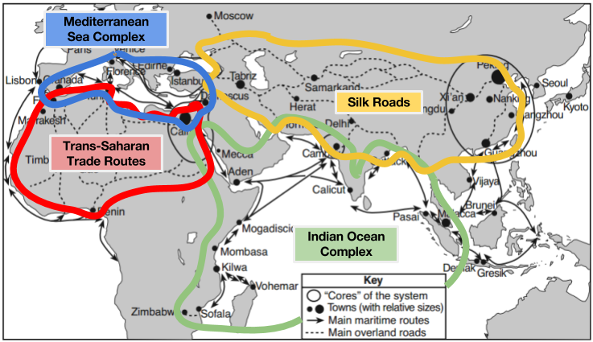
Source: Philippe Beaujard in “The Indian Ocean in Eurasian and African World-Systems before the Sixteenth Century,” Journal of World History (adapted) from the NYS Global History and Geography Regents Examination, August 2012
3. Based on the map above, which trade network(s) did the Black Death travel through in the mid-1300s?
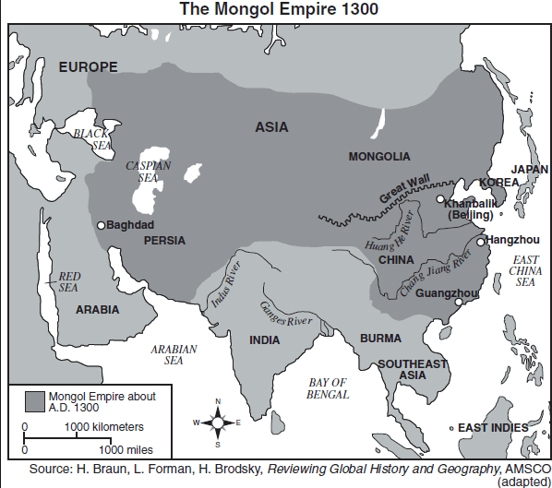

From the beginnings of the Mongol Empire, the Mongol Khans fostered trade and sponsored numerous caravans. The very size of the Mongol Empire encouraged the wider dissemination of goods and ideas throughout Eurasia, as merchants and others could now travel from one end of the empire to another with greater security, guaranteed by the Pax Mongolica.  Source: “The Mongol Empire in World History” by Timothy May from North Georgia College and State University on World History Connected. http://worldhistoryconnected.press.illinois.edu/5.2/may.html. | 4. Based on the quote and map to the left, what role did the Mongols play in the spread of the Black Death?
Source: H. Braun, L. Forman, H. Brodsky, Reviewing Global History and Geography, AMSCO (adapted) from the NYS Global History and Geography Regents Exam.

5. According to the map to the left, in what year and month did the first incidence of the Black Death occur?

6. How long did it take for the Black Plague to reach London after it first hit Europe? Why do you think it took this long?

7. If another disease as contagious and untreatable as the bubonic plague was in the 14th century came to Europe, do you think it would spread faster or slower? Why?

