Name: Date:
Global 10/Period: Boxer Rebellion Investigation

Did the Boxer Rebellion move China closer to or further away from independence?
Objectives: Explain the causes and effects of the Boxer Rebellion, then evaluate whether the revolt moved China closer to or further away from independence.
The Boxer Rebellion (1900-1901)
Watch this video about the Boxer Rebellion (https://goo.gl/HljeFF), read the transcript and additional text below then answer the accompanying questions

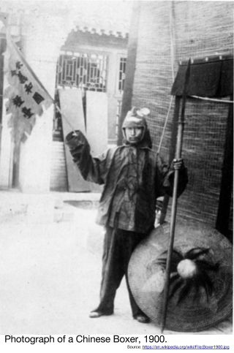
(0:03) The Boxer Rebellion became the first major war to erupt in the new century. Hostilities that had been simmering for decades exploded when China declared war against the foreign powers of France, Russia, England, Japan, Austria, Italy, Germany, and the United States. The beginning of the 20th century found the two thousand-year-old Chinese empire in decline. Foreign powers descended like vultures on what was left to the dying Manchu [Qing] Dynasty. The once-powerful Chinese people fumed as they saw their land and protectorates taken over by foreigners. Hong Kong and Burma were lost to England, Korea to Japan, and Vietnam to France.
(0:52) As the power structure within the Manchu court struggle to maintain its tenuous control within China, foreign encroachment intensified internal political conflicts. What had been an ancient closed society was threatened by the corruption of progress and foreign influence. The Chinese became distrustful of foreigners and were greatly concerned by the influx of Christian missionaries who converted an increasing number of Chinese to an alien religion.
(1:22) [Note: the footage during this section of “Boxers” attacking a Christian mission is staged. It is not real footage from the actual Boxer Rebellion]
A campaign of terror had begun the previous year when a secret organization called Boxers began killing Christian missionaries and their converts in the northern provinces of China. The boxers were a clandestine social society that had been in existence since the early seventeen hundreds. The group preached a mixture of Buddhist, Confucian and Daoist ideas and was radically opposed to any change in Asian culture. Members practiced a form of shadow boxing and believed that followers of the cult were invulnerable.
1. Who were the Boxers? Why did they rebel?

(1:51) In May of 1900, the boxers killed four French and Belgian railway engineers. This was followed by the murder of the Japanese Chancellor in Peking. The foreign powers responded by sending ships and troops to China. The imperial court [of China] had initially condemned the Boxer violence and had sent government troops to quell the uprising, but the ruling Dowager Empress Cixi was eventually won over to the Boxer cause as a result of foreign attacks on Chinese forts and the rumor that the foreign powers wanted to return her deposed nephew to power.

2. How did the Dowager Empress Cixi, the ruler of China at the time, react to the Boxer Rebellion?

(2:27) On June 20th, the Boxers invaded Peking brandishing spears topped with the heads of murdered missionaries. They laid siege to the foreign legations [where ambassadors from foreign countries and their families lived] where almost a thousand foreigners and three thousand Chinese Christians had taken refuge.

3. Why do you think the Boxers murdered missionaries and attacked foreign legations?

(2:41) On August 4th, an international force of twenty thousand headed for Peking to rescue the besieged legations [and protect their business interests]. Although the Boxer troops in the Peking area were estimated at 360,000, the international force broke through the lines after two weeks of heavy fighting. Fifty-four days after the siege began, the foreign legation was rescued. The imperial court fled Peking and the boxers were eventually forced to surrender.
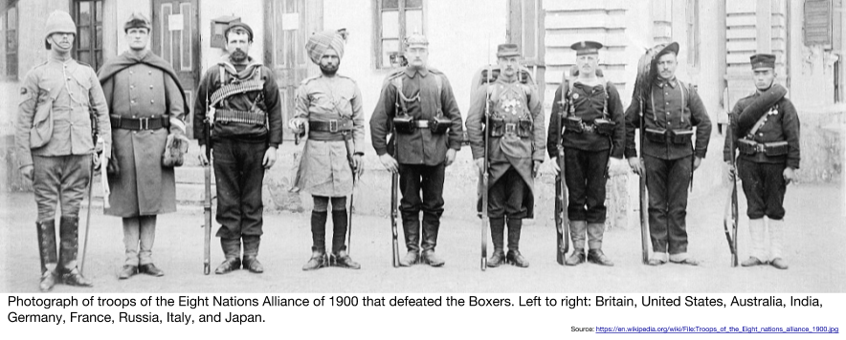
4. Which countries were a part of the international force that defeated the Boxers?
Why did soldiers from all of these nations join together to combat the Boxers?

What were the effects of the Boxer Rebellion?
The following excerpt is from an interview with historian and professor of history at Cornell University, Walter LaFeber.

The outcome of the Boxer Rebellion is in the short term the United States and the other imperial powers won and beat back the Boxers and massacred a number of the Boxers. In the long term, we can now see that it was the beginning of the Chinese Revolution, that the Chinese saw this as something that they would have to organize themselves to defend against. If you go to Beijing now, this is not called the Boxer Rebellion. What happened in 1900 is called the Foreign Intervention. And the Chinese are very quick to tell you that one of the reasons for the Chinese Revolution and the anti-foreignism in the Chinese Revolution that erupted within the next 20 years in China was in large part the result of the foreign brutalities, the foreign missionaries, the foreign industrial entrepreneurs who moved into China in the wake of the Boxers and who essentially tried to act as if nothing had happened. Quite clearly, something very profound had happened in China. What had happened had been that the Chinese for the first time had been able to organize themselves in a way and on a military level to drive back foreign influences. In the end they didn't succeed, but they had shown that it could be done. And, as a result, the Boxer Rebellion now is looked at as the beginning of this long Chinese Revolution that finally climaxed in 1949 [with the start of the Chinese Communist Revolution].

Source: From AMERICAN EXPERIENCE, America 1900. © 1996-2015 WGBH Educational Foundation. http://www.pbs.org/wgbh/amex/1900/filmmore/reference/interview/lafeber_boxerrebellion.html from the NYS Social Studies ToolKit. http://www.c3teachers.org/inquiries/

5. According to Walter LaFeber, what were the long term effects of the Boxer Rebellion?

Directions: Using what you have just learned, answer the following question. Start by choosing a claim. Support your claim by completing the chart with evidence and explanations. Use the claim, evidence and explanations to write a paragraph that thoroughly answers the question.

Did the Boxer Rebellion moved the Chinese closer to independence?
Yes, it moved them closer to independence. | Yes and No | No, it did not move them closer to independence.
The Boxer Rebellion moved China closer to independence because... | Even though the Boxer Rebellion had positive impacts on China such as … , the Boxer Rebellion made China worse because … | The Boxer Rebellion did not move China closer to independence because...
CLAIM
Evidence to Support Your Claim | Reasoning: Explain how your evidence supports your claim.

Did the Boxer Rebellion moved the Chinese closer to independence?

