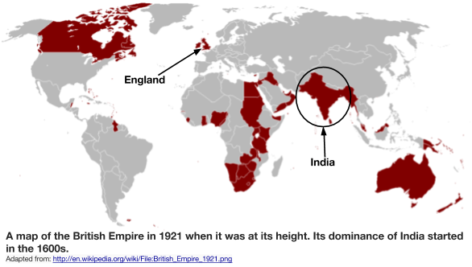
What was India’s place in the British Empire?
In the 19th and 20th centuries, Great Britain had the largest empire in the world. It was said that the British Empire was so expansive that “sun never set” on it because it had so many colonies that no matter what time it was, part the empire was lit with daylight. India, was referred to as the “jewel of the empire” because it was the most populous and prosperous (or wealthiest) British colony.

Why did the British want to trade with, and later control, India?
Reason #1: Raw Materials | Reason #2: Market to Sell Goods
The Industrial Revolution in Great Britain sparked a new desire for colonies to supply raw materials for British factories. India was known for its cotton and crops like indigo that are used to make cloth. | As a result of industrialization in Great Britain, factory owners wanted new groups of people to sell their manufactured goods to for a profit. Industrialists hoped that India, with its large population, would be a profitable new market.
Why did the British want to trade with, and later control, India?

“Jewel in the Crown”
Great Britain and India

How did the British gain, consolidate, and maintain power in India?
Objectives: Describe the methods used by the British to gain, consolidate, and maintain power in India.

The British East India Company Establishes itself in India (1600-1857)

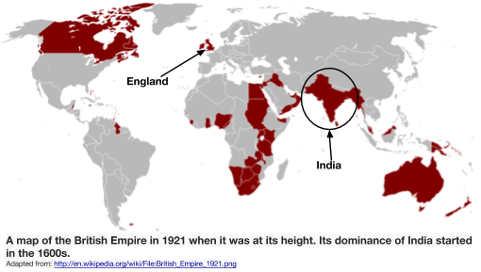  The British East India Company, was a joint-stock company which was granted an English Royal Charter [contract] by Elizabeth I on December 31, 1600, with the intention of exploring and trading with India and the surrounding areas. The British East India Company started out  as a strictly commercial business. The goal was to make money for the company’s shareholders. In 1608, the company established its first trading post in India.  In the 1600s, the Mughal Empire, led by the emperor Jahangir, was in control of India. The Mughals preferred to work with the British over the Portuguese, who had sent their own trading ships to India. The British defeated the Portuguese in a naval battle in 1612, making them the most important European traders in India. As a result, the Mughal emperor signed a treaty that gave the British rights to reside and build trading forts in Indian coastal cities. By 1647, the company had twenty-three posts and ninety employees in India. In 1634 the Mughal emperor extended his hospitality to the English traders to the region of Bengal and in 1717 completely waived customs duties for their trade. The company's mainstay businesses were by now in cotton, silk, indigo, saltpeter, and tea.  Around 1670, King Charles II of England gave the British East India Company rights to autonomous territorial acquisitions, to mint money, to command fortresses and troops, to form alliances, to make war and peace, and to exercise both civil and criminal jurisdiction over the acquired areas. With the freedom to manage its military affairs, the company rapidly raised its own armed forces in the 1680s. They hired local Indian soldiers to fill most of the posts. By 1689 the company was arguably a "nation" in the Indian mainland, independently administering [controlling and managing] the areas of Bengal, Madras, and Bombay, and possessing a formidable and intimidating military strength.  In 1757, the British East India Company turned from a trading organization with an army to protect its business, and became an imperial force within India. For example, company-funded soldiers commanded by Robert Clive defeated the Nawab of Bengal at the Battle of Plassey in 1757 to take control of Bengal. Bengal came directly under the rule of the East India Company. Bengal's wealth then flowed to the Company, which attempted to enforce a monopoly on Bengali trade. Bengali farmers and craftsmen were forced to work for the Company with little payment, while the Company increased their taxes. The British East India Company continued its expansion through military conquest and treaties in the mid-1800s.  The British Government Takes Direct Control of India  (1858-1947)  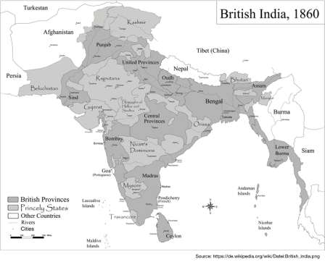  As a result of a two-year long revolt called the Sepoy Rebellion (more on this in a later lesson), in which Indian soldiers working for the British East India Company rebelled against the company, the British government took control of the lands that the Company once ruled. The British government took firm and direct control of India. They exiled the last Mughal emperor and shot his sons. Cultural and religious centres were closed down, properties and estates of those participating in the uprising were confiscated. The British transformed the colonial government to mimic their own in England. British attitudes toward Indians shifted from relative openness to insularity [ignorance to or a lack of interest in cultures] and racism. British families and their servants lived in military homes at a distance from Indian settlements. The British took a more direct role in industry and agriculture as well, controlling what and how much was produced for the benefit of the British government, usually at the expense of Indian workers and farmers.  Source: Adapted from “British East India Company,” New World Encyclopedia. http://www.newworldencyclopedia.org/entry/British_East_India_Company;  “British Raj,” New World Encyclopedia. http://www.newworldencyclopedia.org/entry/British_Raj | 1. What was the British East India Company? What was their goal in India? What did they trade?
 | 2. How were the British initially treated by the Mughal government in India?
 | 3. What rights did King Charles grant the British East India Company in the 1670s? How did this change the Company’s role in India?
 | 4. Based on the situation in Bengal, what effects did British East India Company rule have on Indians?
 | 5. What were the effects of the Sepoy Rebellion?
 | 6. Based on your annotations, how did the British gain, consolidate, and maintain power in India?

