Buddhism
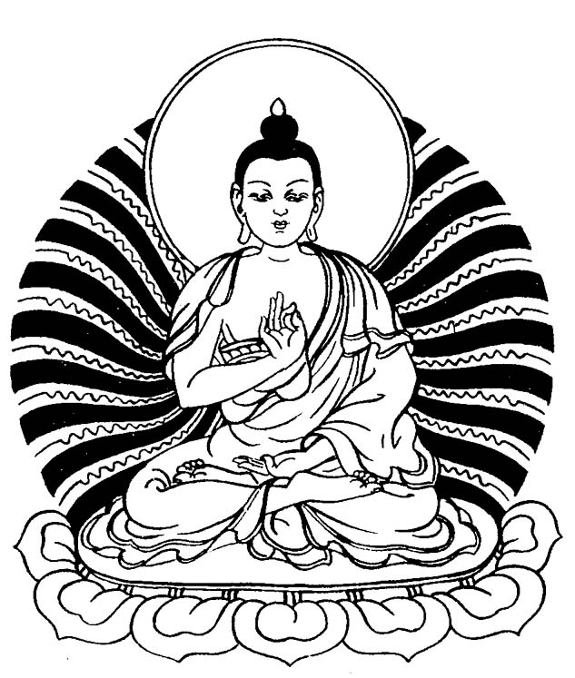
Name:
Global 9/Period:
Date:
What is Buddhism? Where is it practiced?
Objective: Identify Buddhism’s place of origin and where it is currently practiced.

What is Buddhism? Where did it originate? Who started it?
Where is it practiced today?

Directions: Read the excerpt and map below, then answer the questions that follow.
Around 600 B.C.E. most Indians were Hindu and believed that the only way to escape the cycle of reincarnation and achieve moksha was to follow the dharma (duty) of their caste as described in the Bhagavad Gita. Following the caste system meant that people that were not born to a high caste could not achieve moksha in their lifetime and often had to perform undesirable duties in society.
Some spiritual teachers disagreed with the strict Hindu caste system. One of them was a Kshatriya named Siddhartha Gautama, better known as the Buddha (the Enlightened One). Born a prince in northeastern India, around 480 B.C.E., Gautama observed that life is full of suffering like disease, aging, and death. He left his comfortable lifestyle in search of spiritual answers to the cause of suffering and ways to end it. Eventually, he achieved Enlightenment, also known as Nirvana or Sambodhi, which are the Buddhist words for moksha, through intense meditation. According to the story, seven weeks after achieving Enlightenment, the Buddha met five other spiritual men in a deer park. He gave a sermon [religious speech] explaining to them the path he took to Enlightenment, which he called the Middle Path, sometimes called the Middle Way. These five men became the first disciples [followers] of the belief system that came to be known as Buddhism.
Percentage of Buddhist Population in Each Nation Worldwide 2014
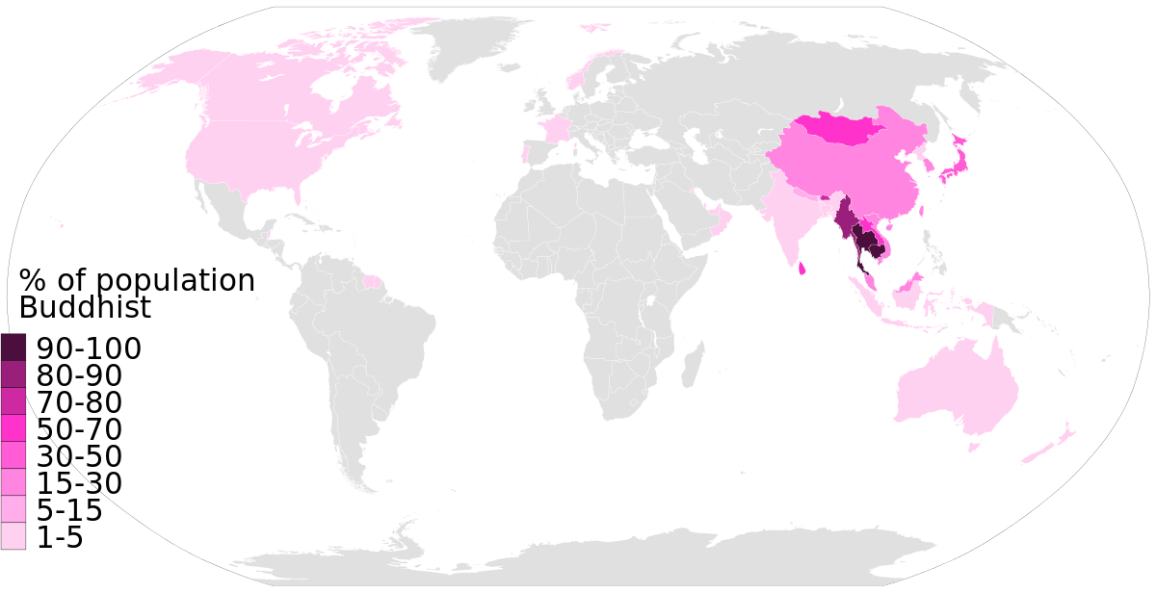
Source: https://en.wikipedia.org/wiki/File:Buddhism_percent_population_in_each_nation_World_Map_Buddhist_data_by_Pew_Research.svg
Who was the founder of Buddhism? | Where did Buddhism originate? | Where is Buddhism practiced today?

What are the sacred texts and major beliefs and practices of Buddhism? What effects did Buddhism have on social order?
Objective: Identify the major texts, beliefs, practices, and effects on society of Buddhism.

The Sacred Books of Buddhism

Tripitaka- “Three Baskets of Wisdom”
The Tripiṭaka (Sanskrit) or Tipiṭaka (Pāli), meaning "three baskets," is the formal term for the earliest surviving Buddhist teachings. It is also called the "Pali Canon" named after the language it was written in.
The teachings were passed down orally for around 200 years after the Buddha’s death before they were finally written down by Buddhist monks
The Pali Canon falls into three general categories, or baskets, the first was the code of ethics to be obeyed by the early monks and nuns. The second category consists primarily of accounts of the Buddha's teachings. The third category contains early commentary on the Buddha’s teachings from his followers.
Source: Adapted from “Tripitaka.” New World Encyclopedia. http://www.newworldencyclopedia.org/entry/Tripitaka
1. Who wrote the Tripitaka?

2. What is contained in the Tripitaka?

2. Before the Tripitaka was written down, how were the stories in it passed from generation to generation? For how long were they passed down in this way?

3. As a source, why might a historian question the reliability of the Tripitaka as a historical document?

Core Beliefs and Practices of Buddhism

Directions: Read the notes below and answer the questions that follow.

1. Philosophy or Religion?
Many people debate whether Buddhism is a philosophy or a religion. We refer to it as a “belief system” which includes both religions and philosophy.

Those who argue that Buddhism is a philosophy note that there is no worship of gods in the beliefs and practices associated with Buddhism. Instead, one’s spiritual journey is guided by their own determination and their teacher. In this way, Buddhism is different than Hinduism which has thousands of gods.
1a. Why do some people consider Buddhism a philosophy rather than a religion?

2. Reincarnation, Enlightenment, and Nirvana
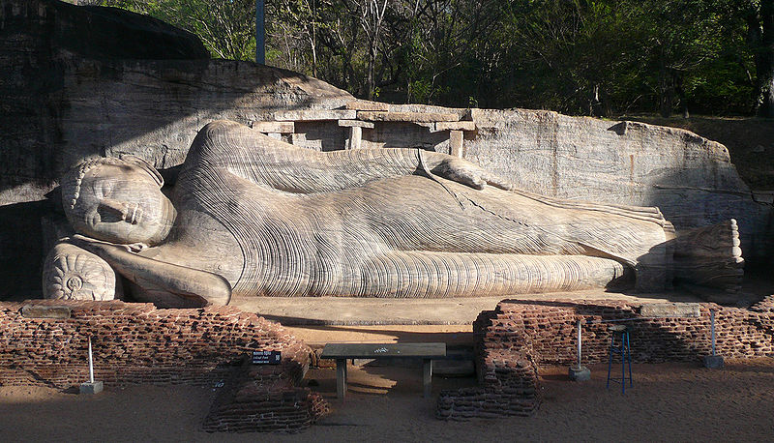
Like Hindus, Buddhists believe that there is escape from the cycle of reincarnation. For Buddhists, the goal of spiritual life is to reach “nirvana” after death. It is similar to moksha that Hindus strive for. Nirvana, in Sanskrit, means “blown out,” as in a candle. It is the state of a still and empty mind. This can be accomplished by reaching a state of enlightenment like the Buddha did through intense meditation.

Statue of the reclining Buddha in Gal Vihara, Sri Lanka. The image of the reclining Buddha represents the last moments of the Buddha’s life before he died and entered state of nirvana.
Source: https://commons.wikimedia.org/wiki/File:Galvihara-sunny.jpg
2a. Do Buddhists believe in reincarnation?

2b. What is nirvana?

2c. How do Buddhists believe one can achieve enlightenment?

3. Four Noble Truths
Buddha taught four principles that he believed to be true. They are called the Four Noble Truths. Put simply they are:
- The Noble Truth of Suffering: Life is suffering.
- The Noble Truth of the Cause of Suffering: Suffering is caused by desire.
- The Noble Truth of the Cessation [Stopping] of Suffering: To end suffering, one must end desire.
- The Noble Truth of the Path: To end suffering, follow the Eightfold Path.

Excerpt 2 from “Setting in Motion the Wheel of the Law[Dharma]” from the Tripitaka
'This, O Bhikkhus, is the Noble Truth of Suffering: Birth is suffering; decay is suffering; illness is suffering; death is suffering. Presence of objects we hate, is suffering; Separation from objects we love, is suffering; not to obtain what we desire, is suffering. Briefly...clinging to existence is suffering.
'This, O Bhikkhus, is the Noble Truth of the Cause of Suffering: Thirst, that leads to rebirth, accompanied by pleasure and lust, finding its delight here and there. (This thirst is threefold), namely, thirst for pleasure, thirst for existence, thirst for prosperity.
'This, O Bhikkhus, is the Noble Truth of the Cessation of Suffering: (It ceases with) the complete cessation of this thirst,--a cessation which consists in the absence of every passion,--with the abandoning of this thirst, with the doing away with it, with the deliverance from it, with the destruction of desire.
'This, O Bhikkhus, is the Noble Truth of the Path which leads to the cessation of suffering: that holy Eightfold Path, that is to say, Right Belief, Right Aspiration, Right Speech, Right Conduct, Right Means of Livelihood, Right Endeavour, Right Memory, Right Meditation….
3a. What does the Buddha list as examples of suffering?

3b. Buddhists believe that the 2nd Noble Truth, “Suffering is caused by desire,” is true. Do you? State a claim and provide evidence (examples from your experience) to support it.

3c. According to Buddha, how can one end suffering?

4. Eightfold Path
Buddhism’s Fourth Noble Truth states, “To end suffering, follow the Eightfold Path.” The Eightfold Path describes how one should act to eliminate desire and thus suffering. The Eightfold Path is the moral code of conduct for Buddhists, similar to the Ten Commandments in Judaism and Christianity.
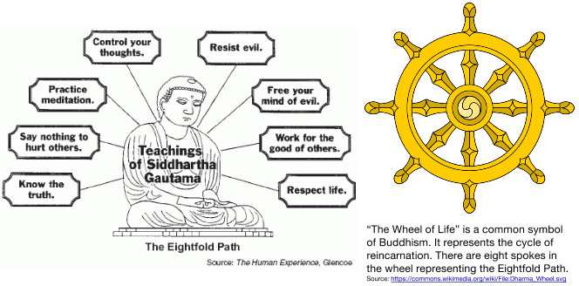
Excerpt 3 from “Setting in Motion the Wheel of the Law [Dharma]” from the Tripitaka
'Which, O Bhikkhus, is this Middle Path the knowledge of which the Tathâgata has gained, which leads to insight, which leads to wisdom, which conduces to calm, to knowledge, to the Sambodhi, to Nirvâna? It is the holy Eightfold Path, namely, Right Belief, Right Aspiration, Right Speech, Right Conduct, Right Means of Livelihood, Right Endeavour, Right Memory, Right Meditation. This, O Bhikkhus, is the Middle Path the knowledge of which the Tathâgata has gained, which leads to insight, which leads to wisdom, which conduces to calm, to knowledge, to the Sambodhi, to Nirvâna.
'But since I possessed, O Bhikkhus, with perfect purity this true knowledge and insight into these four Noble Truths...then I knew, O Bhikkhus, that I had obtained the highest, universal Sambodhi….
'And this knowledge and insight arose in my mind: "The emancipation of my mind cannot be lost; this is my last birth; hence I shall not be born again!"'
5. What do Buddhists suggest people do to alleviate suffering?

5. Rejection of the Caste System
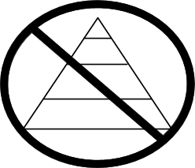
Buddhism started in a region of the world where Hinduism dominated, but Buddha rejected a major part of Hindu society: the caste system.

Buddha taught that anyone, regardless of their place in society, could achieve enlightenment if they realized the Four Noble Truths and followed the Eightfold Path.
6a. If you were a member of the Brahmin caste, how would you react to Buddha’s teachings? Why?

6b. If you were a member of the Untouchables or the Shudras caste, how would you react to Buddhism? Why?

How did Buddhism spread throughout Asia?
Objective: Identify where and describe how Buddhism spread throughout Asia.
Directions: Examine the map and read the passage below, then answer the questions that follow.
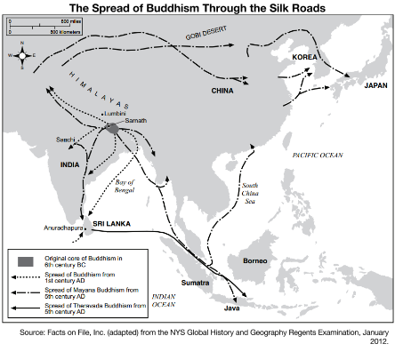
During the time of Ashoka’s reign, trade routes were opened through southern India. Some of the merchants using these roads were Buddhists who took their religion with them. Buddhist monks, some of which were sent by Ashoka, also used these roads for missionary activity. Buddhism entered Sri Lanka during this time. A Buddhist chronicle known as the Mahavamsa claims that the ruler of Sri Lanka, Devanampiya Tissa, was converted to Buddhism by Mahinda, Ashoka’s son, who was a Buddhist missionary…After reaching Sri Lanka, Buddhism crossed the sea into Myanmar (Burma)...After Myanmar, Buddhism travelled into Cambodia, Thailand, Vietnam, and Laos, around 200 CE. The presence of Buddhism in Indonesia and the Malay Peninsula is supported by archaeological records from about the 5th century CE.

BUDDHIST EXPANSION ACROSS CENTRAL & EAST ASIA
Buddhism entered China during the Han dynasty (206 BCE-220 CE): The first Buddhist missionaries accompanied merchant caravans that travelled using the Silk Road, probably during the 1st century BCE. The majority of these missionaries belonged to the Mahayana school.

[...]Buddhism managed to build a solid presence in China towards the fall of the Han dynasty on 220 CE, and its growth accelerated during the time of disunion and political chaos that dominated China during the Six Dynasties period (220-589 CE)...

From China, Buddhism entered Korea in 372 CE, during the reign of King Sosurim, the ruler of the Kingdom of Koguryo, or so it is stated in official records. There is archaeological evidence that suggests that Buddhism was known in Korea from an earlier time.
Source:www.ancient.eu/buddhism/
1. Describe two ways that Buddhism spread from India to other parts of Asia. Identify which ruler had a major role in spreading Buddhism within and outside of Buddhism.
2. Explain how Buddhism spread from India to Korea. What regions did it pass through? How did it spread to those regions?

