Name: Date:
Global 9/Period: The Beginning of the Byzantine Empire Map
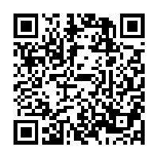
DIRECTIONS: Using the maps and information found on Mrs. Reif’s website, complete the following map. Use the space on the back to complete the map analysis questions.

Map Analysis Questions

