**Name: Date:**

**Global 9/Period: Byzantine Empire Notes**

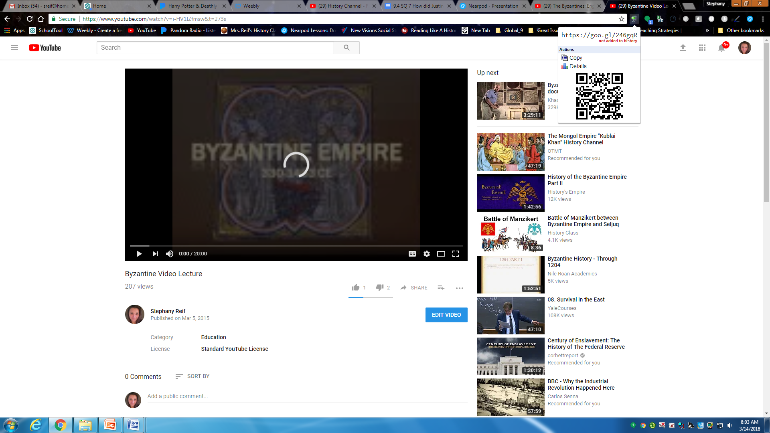

**DIRECTIONS: Use the video from my website or YouTube channel**

**(**[**https://youtu.be/i-HV1IZfmsw**](https://youtu.be/i-HV1IZfmsw)**) to complete the notes.**

**Byzantine Empire**  
**Rome Has Fallen! Rome Has Fallen!**

Umm…. Not quite.  
Rome is sacked by the barbarians from the north…but only the Western Empire crumbles!  
The Eastern Empire exists for 1,000 more years.  
Its called the…

**The Roman Empire Divided** 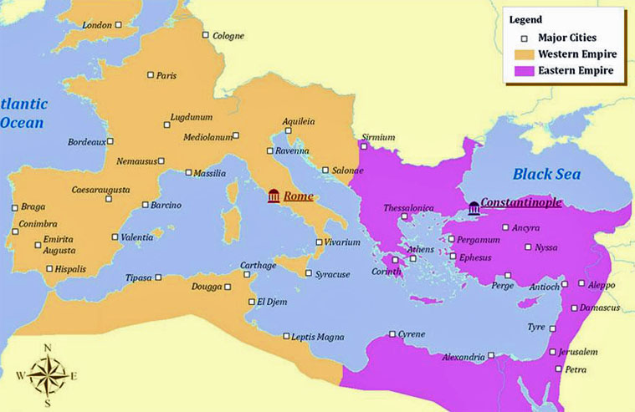

**Why did Constantine create a new eastern capital for the Roman Empire?**

* Communication issues

* Linked Europe and Asia at Silk Road
* $$ from taxes on trade

**Why is the location of the Byzantine Empire so significant?**

* Geography
* Links Mediterranean and Black Seas

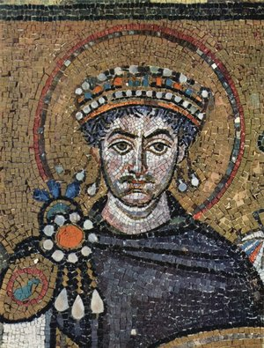**The Emperor Justinian**

**Who was Justinian?**

* 527-565: Emperor

**The Achievements of Justinian**

**Explain Justinian’s law code**

* Four Parts-
  + The Code-
  + The Digest-
  + The Institutes-Explains to law students how to use the laws
  + The Novellae-Laws passes after 534

**Explain the effect the Justinian Code had on the Byzantine Empire.**



**What did Justinian do for Constantinople?**

**What did he build?**

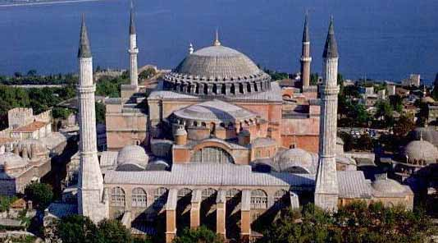



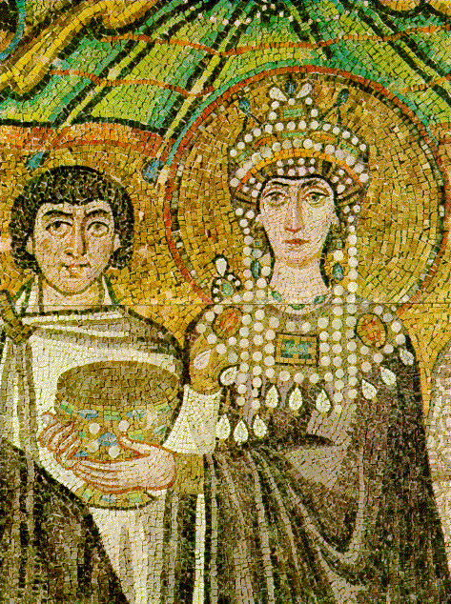**Why was Empress Theodora so significant?**

* Justinian’s wife.
* + Man couldn’t beat wife
  + Women could sue for divorce.
  + Women could own property
* Involved in Byzantine politics; tempered king’s religious extremism
* Built hospitals and convents for homeless women

**Decline of the Byzantine**

* Justinian dies in 565
* Constantly invaded by enemies
* + Begins the Crusades
    - Byzantine would last another 1000 years but…

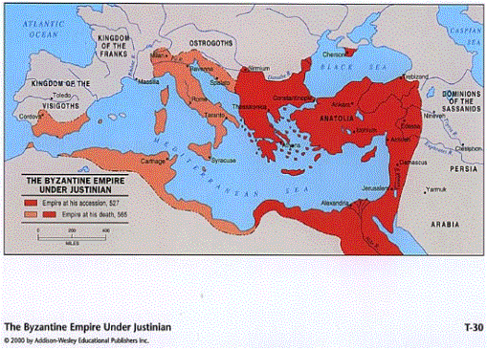



**The East-West/Great Schism**

**What was the controversy concerning icons?**

* A Byzantine emperor banned the use of icons

**What caused the Christian Church to split?**

* Western Church:
* Eastern Church:
  + Pope and patriarch excommunicated each other
    - Excommunicate-
* 1054-

**How were the Byzantines different from the Western Church?  
How were the Byzantines different from the Western Church?**

**Leader of the Western Church: Leader of the Eastern Church:**

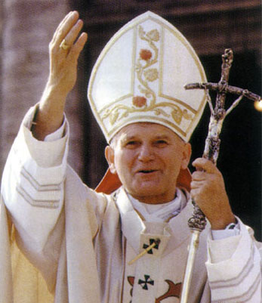 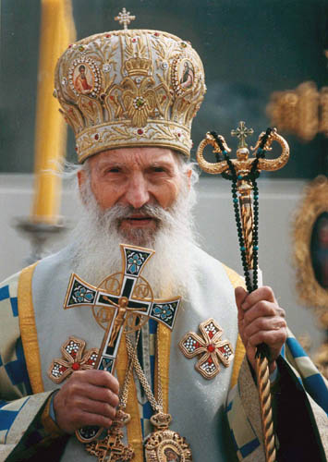 

**But the patriarch still bowed to …**

**Explain the differences between the Roman Catholic Church**

**and The Greek Orthodox Church.**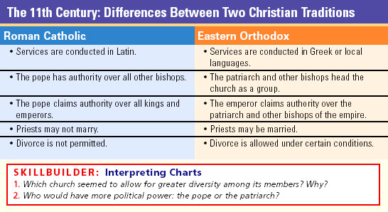

**Churches split:**

**The Legacy of the Byzantine Empire**

**Who were Saint Methodius & Saint Cyril?**

* Missionaries

**What was the Legacy of the Byzantine?**

* Spread Christianity to Russia
* Missionaries taught people how to read & write