How did the Islamic Caliphates
gain, consolidate, and maintain power?

What is a caliph?
After Muhammad’s death in 632 CE, the Muslim community was led by a caliph. The caliph was the successor of Muhammad and was the chief Muslim ruler. Though the term caliph is no longer used, it was the word used to describe the ruler of the Islamic Empires during the post-classical period.

What is a caliphate?
A caliphate is an empire that was ruled by a caliph. The caliphates that ruled during the post-classical era were large land empires that stretched from Spain to North Africa, the Middle East, and into Asia and Eastern Europe.

Which caliphates ruled during the post-classical period?
Several caliphates ruled during the post-classical era, but the two that you will study are the Umayyad Caliphate (661–750) and the Abbasid Caliphate (750–1258). These caliphates were the largest, longest lasting, and had the most impact on Islamic states that came after the post-classical period.

Document 1: Timeline of the Rise of Islamic Empires (570-1248 CE)

What does this map reveal about how the Islamic Caliphates gained, consolidated, and/or maintained power?

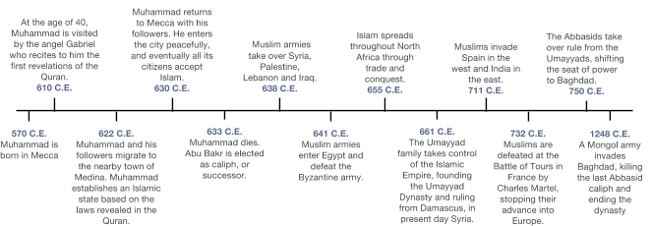

Circle one or more:
This document illustrates how the Islamic Caliphates:
GAINED POWER
CONSOLIDATED POWER
MAINTAINED POWER

What does this map reveal about how the Islamic Caliphates gained, consolidated, and/or maintained power?
Document 2: Map of Islamic Conquests 622-750

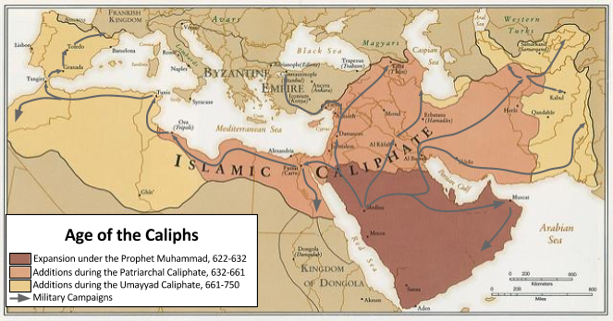

Circle one or more:
This document illustrates how the Islamic Caliphates:
GAINED POWER
CONSOLIDATED POWER
MAINTAINED POWER

Document 3: Religious Toleration and the Poll Tax

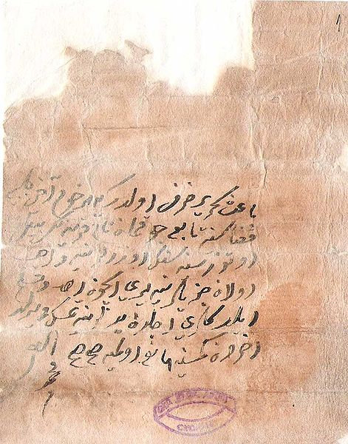  Image is in the public domain.  A jizyah document from the Ottoman Empire in 1615 stating the amount owed to the government by a non-Muslim living in the empire. | Islamic Caliphates after the death of Muhammad followed the example he started when dealing with non-Muslims in their empires.  Non-Muslims were allowed to practice their religions and follow their religious laws as long as they paid a yearly tax called the jizyah, sometimes referred to as kharāj (though the two were sometimes different taxes), the poll tax, or the land tax.  The jizyah was both a punishment for not converting to Islam and payment for continued protection to practice one’s religion. The money from the tax was used to finance the government and for the welfare fund that supported Muslims and non-Muslims alike.  With a few exceptions, the jizyah is no longer collected in Muslim majority countries.
What does this document reveal about how the Islamic Caliphates gained, consolidated, and/or maintained power?
Circle one or more:
This document illustrates how the Islamic Caliphates:
GAINED POWER
CONSOLIDATED POWER
MAINTAINED POWER

Document 4: Pact of Umar
Starting in the mid-600s CE, Islamic armies conquered vast regions in the Middle East, north Africa, and Europe. The areas they conquered were often home to people who were not Muslims. In those areas, the rulers of Islamic Caliphates often made agreements with non-Muslims based on the Pact of Umar, a document that originated in 637 and was the first of these agreements which was between Umar I, one of the first and most powerful caliphs, and the Christians of Syria. The excerpt below is from a Pact of Umar that was used in the 9th century.
In the name of God, the Merciful, the Compassionate!

This is a writing to Umar from the Christians of such and such a city. When You [Muslims] marched against us [Christians],: we asked of you protection for ourselves, our posterity, our possessions, and our co-religionists; and we made this stipulation with you,

that we will not erect in our city or the suburbs any new monastery [place where monks live], church, cell or hermitage [secluded retreat];
that we will not repair any of such buildings that may fall into ruins, or renew those that may be situated in the Muslim quarters of the town;
that we will not refuse the Muslims entry into our churches either by night or by day;
that we will open the gates wide to passengers and travellers;
that we will receive any Muslim traveller into our houses and give him food and lodging for three nights;
that we will not harbor any spy in our churches or houses, or conceal any enemy of the Muslims.

That we will not teach our children the Qu'ran;
that we will not make a show of the Christian religion nor invite anyone to embrace it;
that we will not prevent any of our kinsmen from embracing Islam, if they so desire.

That we will honor the Muslims and rise up in our assemblies when they wish to take their seats; that we will not imitate them in our dress, either in the cap, turban, sandals, or parting of the hair; that we will not make use of their expressions of speech, nor adopt their surnames...
that we will not sell wine;

That we will not display the cross upon our churches or display our crosses or our sacred books in the streets of the Muslims, or in their marketplaces;
that we will not recite our services in a loud voice when a Muslim is present;
that we will not carry Palm branches [on Palm Sunday] or our images in procession in the streets; that at the burial of our dead we will not chant loudly or carry lighted candles in the streets of the Muslims or their marketplaces;
and that we will not strike any Muslim.

All this we promise to observe, on behalf of ourselves and our co-religionists, and receive protection from you in exchange; and if we violate any of the conditions of this agreement, then we forfeit your protection and you are at liberty to treat us as enemies and rebels.

Source: The History of the Decline and Fall of the Roman Empire, by Edward Gibbons (1789). This text is part of the Internet Medieval Source Book. http://legacy.fordham.edu/halsall/source/gibbon-fall.html
Circle one or more:
This document illustrates how the Islamic Caliphates:
GAINED POWER
CONSOLIDATED POWER
MAINTAINED POWER

What does this pact reveal about how the Islamic Caliphates gained, consolidated, and/or maintained power?

Document 5:Umayyad (661- 750) and Abbasid (750-1258) Dynasties Centralize and Standardize the Islamic Caliphates

After over one hundred years of rapid growth, the Islamic caliphates ruled by the Umayyad Dynasty (661-750) and the Abbasid Dynasty (750-1258) consolidated and maintained Muslim power by organizing their governments and creating long-lasting political institutions. Read about some of the methods that the Umayyad and Abbasid Dynasties used to consolidate and maintain their power below.

Document 5a: Arabic Made the Official Language

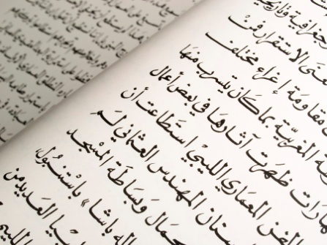
The area controlled by the Umayyad and Abbasid Dynasties were diverse in culture, religion, and language. Before the Umayyad dynasty, each of the areas in the empire kept records in their local language or often Greek since that was the language the Byzantines used. The Umayyad made Arabic the official language of the empire and required that all government documents were written in it. The Abbasid Dynasty continued the same policy.
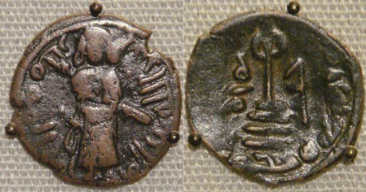
Document 5b: Standard Coinage

The Umayyad and Abbasid Dynasties replaced Byzantine coins and the coins of other empires that once ruled the areas they controlled with coins that they minted themselves, communicating to inhabitants that they were in control of the economy.

Two copper coins from the Umayyad Caliphate. Aleppo, Syria, ca. 695 CE.
Image created by PHGCOM, licensed under the Creative Commons Attribution-Share Alike 3.0 Unported license and modified by New Visions.
Circle one or more:
This document illustrates how the Islamic Caliphates:
GAINED POWER
CONSOLIDATED POWER
MAINTAINED POWER

What do these documents reveal about how the Islamic Caliphates gained, consolidated, and/or maintained power?

Document 5c: Division of the Empire into Provinces

The Umayyad and Abbasid Dynasties were two of the largest empires in history. To make it easier to control and organize the empire, the caliphs divided it into provinces and appointed a governor for each province. The governor was in charge of religious officials, local military, policy, and other government workers. They collected taxes for the province and the caliph and enforced the caliph’s decisions.

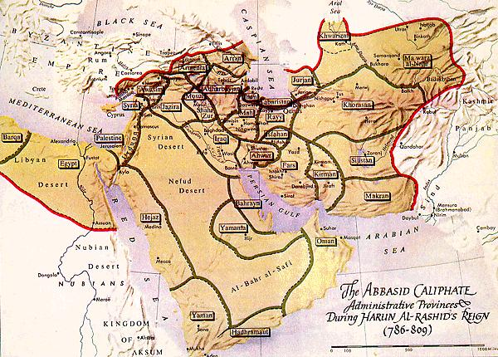

Document 5d: Central Diwans
Diwans were boards, or committees, of advisors that helped the caliph divide up the responsibilities of the caliphate’s central government. There were six central diwans.

1. Diwan al-Khara
The Central Board of Revenue administered the government’s money. They collected taxes and divided funds.
2. Diwan al-Rasa’il
Coordinated communication between the boards.
3. Diwan al-Khatam
This board prevented forgery in the government by creating a copy of each official document and filing it before sending the original to its destination. By doing this the government had a record of all correspondence.
4. Diwan al-Barid
This board administered the postal service created during the Umayyad Dynasty. The board managed stations that were setup along paths used by the government where horse, donkey, or camel riders handed off letters to be taken by other riders or to switch animals until the letters got to their final destination.
5. Diwan al-Qudat
The Board of Justice managed judges who ruled on legal cases.
6. Diwan al-Jund
This board managed the military, payment of soldiers, and supplies.
Circle one or more:
This document illustrates how the Islamic Caliphates:
GAINED POWER
CONSOLIDATED POWER
MAINTAINED POWER

What do these documents reveal about how the Islamic Caliphates gained, consolidated, and/or maintained power?

