What characteristics do all civilizations have in common?
Historians have identified several characteristics that most civilizations have in common, including:
religion, job specialization, cities, government, writing systems, public works, social classes and arts and architecture.

Directions: Within your group, read through the placards. Discuss the questions and come up with answers to the questions to share with the class.

Religion  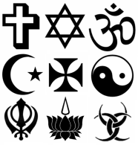 | Job Specialization  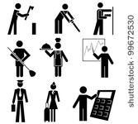  The division of work into specific jobs. | Cities | Organized Government
What is this?  What does it do/provide? What is the purpose? | What is this?  What does it do/provide? What is the purpose? | What is this?  What does it do/provide? What is the purpose? | What is this?  What does it do/provide? What is the purpose?

Writing Systems | Public Works | Social Classes  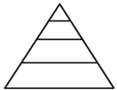  The division of society based on wealth, religion, ethnicity, or other factors | Arts & Architecture
What is this?  What does it do/provide? What is the purpose? | What is this?  What does it do/provide? What is the purpose? | What is this?  What does it do/provide? What is the purpose? | What is this?  What does it do/provide? What is the purpose?

