To what extent did the Catholic church have power
over secular and religious life in Medieval Europe?
Objective: Students will describe the role the Medieval Catholic church played in both secular and religious life.

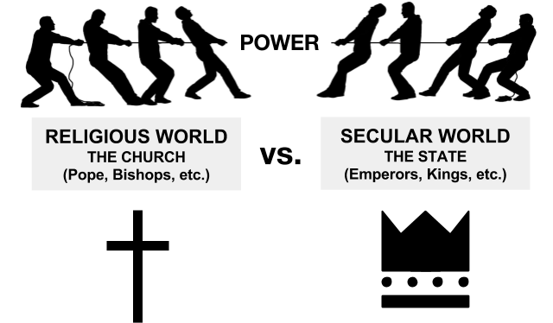
- What does secular mean?

- How is this different from the Byzantine?
Document 1

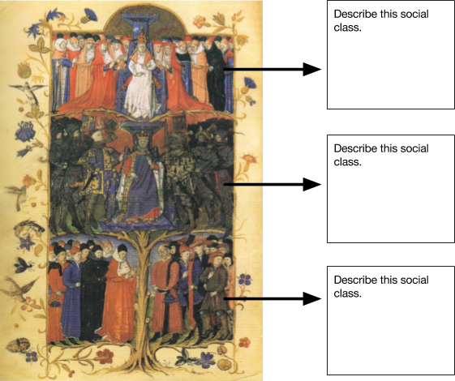
Source: http://commons.wikimedia.org/wiki/File:Mittelalterliches_St%C3%A4ndebild_15._Jahrhundert.png
1a. This is an example of what kind of power?  POLITICAL  SOCIAL  ECONOMIC | 1b. Identify a piece of textual or visual evidence from this document that supports the claim this document makes.

Document 2  Watch 01:28-02:35  Transcript:  So, during the European Middle Ages, the Catholic Church really dominated European civilization. It’s almost impossible to imagine the scope of the Church’s power in the Middle Ages, but let’s try.  First off, the Catholic Church was the caretaker of the most important thing that Christians had, their souls, which, unlike our temporal bodies, were eternal. And then there was the parish priest, who played a pivotal role throughout every person’s life, baptizing them, marrying them, hearing their confessions, providing last rites.  The church also provided all of the social services: It distributed alms to the poor, and ran orphanages, and provided what education was available. And most Europeans would in their lives meet exactly one person who could read the Bible, which was only available in Latin - their parish priest.  And, the church owned over 1/3 of all the land in Europe, which helped make it the most powerful economic and political force on the continent.  And the Pope claimed authority over all the kings of Europe, as the successor to the Roman Emperor. So this was a very powerful institution...  Source: Crash Course World History, “Luther and the Protestant Reformation: Crash Course World History #218.” https://www.youtube.com/watch?v=1o8oIELbNxE&list=PL8dPuuaLjXtNjasccl-WajpONGX3zoY4M&index=18 | 2a. This is an example of what kind of power?  POLITICAL  SOCIAL  ECONOMIC  2b. Identify a piece of textual or visual evidence from this document that supports the claim this document makes.
Document 3: Dictatus papae  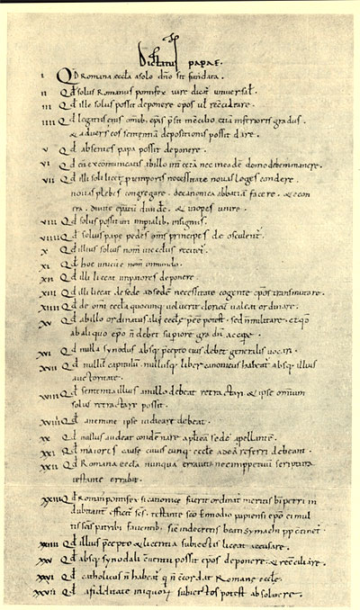  Pope Gregory was elected pope in 1073 CE. He believed that as pope, he was God's "vicar [representative] on earth" and that his authority extended over religious life and secular political life. In 1075, he issued a decree forbidding a practice called lay investiture. Lay investiture was a practice whereby secular rulers like emperors or kings could select leaders of the church. Pope Gregory felt that this practice reduced his power so he ended the practice. This angered many kings and emperors. Dictatus papae is a compilation of 27 statements about the powers of the pope. It was included in Pope Gregory VII's register under the year 1075. There is debate over whether Pope Gregory wrote it or if had another authority. Regardless of these doubts about who wrote the statement, many historians have no doubt that Dictatus papae reflects the views of Pope Gregory about the power of popes.  9. That of the pope alone all princes shall kiss the feet.  12. That it may be permitted to him [pope] to depose [remove from power] emperors.  14. That he has power to ordain a clerk of any church he may wish.  17. That no chapter and no book shall be considered canonical without his authority.  18. That a sentence passed by him may be retracted by no one; and that he himself, alone of all, may retract it.  19. That he himself may be judged by no one.  Source: http://cengagesites | 3a. This is an example of what kind of power?  POLITICAL  SOCIAL  ECONOMIC  3b. Identify a piece of textual or visual evidence from this document that supports the claim this document makes.
Document 4: The Medieval Church  The Church developed its own body of laws, known as canon law, as well as its own courts. Canon law, based on religious teachings, governed many aspects of life, including wills, marriages, and morals. Anyone who disobeyed Church law faced a range of penalties. The most severe and terrifying was excommunication. Those who were excommunicated could not receive the sacraments [sacred rites of the church] or a Christian burial, which condemned the to hell for eternity. A powerful noble who opposed the Church could face the interdict, or an order excluding an entire town, region, or kingdom from receiving most sacraments and Christian burial. Even the strongest ruler gave in rather than face the interdict, which usually caused revolts by the common people.  The Church tried to use its great authority to end warfare among nobles. It declared periods of temporary peace known as the Truce of God. It demanded that fighting stop between Friday and Sunday each week and on religious holidays. Such efforts may have contributed to the decline of warfare in Europe during the 1100s.  Source: Prentice Hall: World History, 2007. Elisabeth Gaynor Ellis and Anthony Esler | 4a. This is an example of what kind of power?  POLITICAL  SOCIAL  ECONOMIC  4b. Identify a piece of textual or visual evidence from this document that supports the claim this document makes.
Document 5: Tithes  In the Middle Ages, the Catholic church in Europe collected a tax of its own, separate from the kings' taxes, which was called a tithe. Tithe means "one-tenth", because people were supposed to give the Church one-tenth of all the income they earned. The priests and bishops kept the tithes in tithe barns like this one.  You had to pay the tithe, because otherwise the priest or bishop would excommunicate you. You might say, "So what? I didn't want to go to church anyway," but in the Middle Ages most people didn't feel that way - they wanted to go to church and get forgiven for their sins so they could go to Heaven after the Last Judgment.  Besides, even if you didn't care about Heaven, being excommunicated was a very serious thing - nobody else was allowed to talk to a person who had been excommunicated, or sell them anything, so you couldn't buy food, or go to work, or anything. Even your children and your parents were not supposed to speak to you.  Source: http://quatr.us/medieval/religion/tithes.htm#topbar | 5a. This is an example of what kind of power?  POLITICAL  SOCIAL  ECONOMIC  5b. Identify a piece of textual or visual evidence from this document that supports the claim this document makes.
Based on the evidence from these documents, write a thesis statement in response to the questions, “Was the Catholic Church powerful in Medieval Europe?”

Remember, CLAIM + REASONS = THESIS

CLAIM | REASONS
___________________________________________ + | as demonstrated by ____________________________________________________________________________________________________________________________________________________________________________________________
Examples: The Catholic Church was very powerful in Medieval Europe … | Reminder: List your reasons that support the claim.

FINAL THESIS

