How did industrialization and urbanization affect British cities?
Effects of Industrialization and Urbanization on British Cities
Pushed out of rural areas because of a lack of jobs, and drawn by employment opportunities at new factories, people flocked to industrial cities throughout Great Britain. The process of people moving to cities, the growth of cities and the development of new industries is called urbanization. Cities throughout Great Britain experienced intense urbanization during the Industrial Revolution with positive and negative effects on those living in them.
Watch this Timelines.tv video on the Urban Slums in Industrial England then answer the questions below.
1. Why did so many people move to Manchester in the 1700s? | 2. What innovation made it possible to have factories in Manchester?
3. Describe the living conditions in Manchester during the Industrial Revolution. | 4. What were the effects of industrialization and urbanization on the health of people who lived in Manchester during the Industrial Revolution? Why were there so many negative effects on health?
Document Set 1
Population of Selected British Cities (1801-1891)
Town | 1801 | 1861 | 1891
Birmingham | 74,000 | 296,000 | 523,000
Leeds | 53,000 | 207,000 | 429,000
Liverpool | 80,000 | 444,000 | 704,000
Manchester | 90,000 | 339,000 | 645,000
Source: B.R. Mitchell, International Historical Statistics: Europe, 1750-1988, Stockton Press, Third Edition (adapted) from the NYS Global History and Geography Regents Exam.
Population Density: Great Britain, 1801  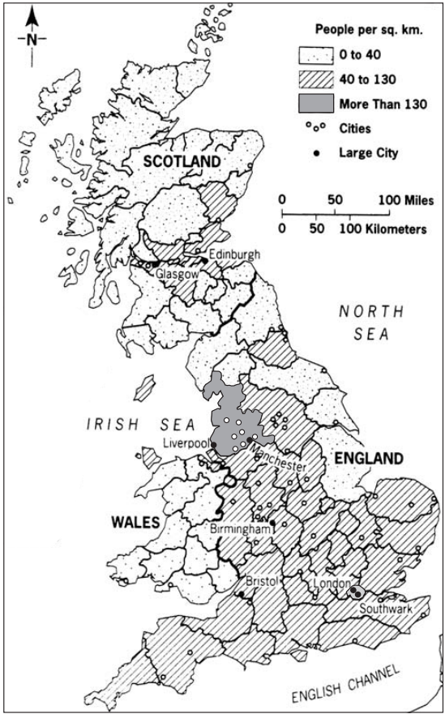 | Population Density: Great Britain, 1851  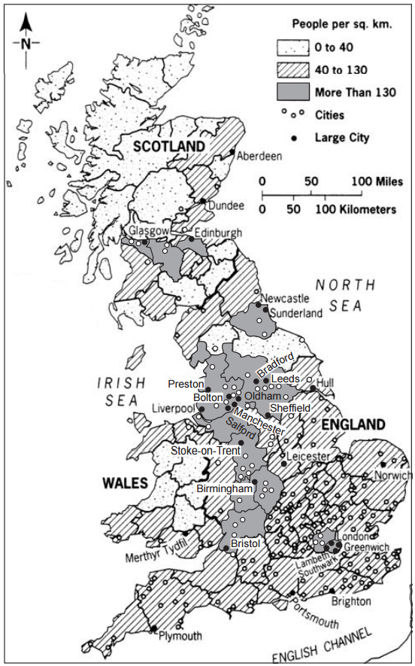
Source: World Civilizations: Sources, Images, and Interpretations, McGraw-Hill (adapted) from the NYS Global History and Geography Regents Exam, June 2006.
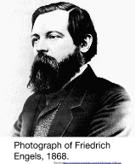
Document 2

Friedrich Engels (November 28, 1820 – August 5, 1895) was a nineteenth century German political philosopher. He was the son of a textile manufacturer who became a socialist. After observing the appalling situation of British factory laborers while managing a factory in Manchester, England, he wrote his first major work, The Condition of the Working Class in England in 1844 (excerpted below). In 1844, he met Karl Marx in Paris, beginning a lifelong collaboration. He and Marx wrote The Communist Manifesto (1848) and other works.
Source: “Friedrich Engels.” New World Encyclopedia. http://www.newworldencyclopedia.org/entry/Friedrich_Engels
. . . Every great town has one or more slum areas into which the working classes are packed. Sometimes, of course, poverty is to be found hidden away in alleys close to the stately homes of the wealthy. Generally, however, the workers are segregated in separate districts where they struggle through life as best they can out of sight of the more fortunate classes of society. The slums of the English towns have much in common—the worst houses in a town being found in the worst districts. They are generally unplanned wildernesses of one- or two-storied terrace houses built of brick. Wherever possible these have cellars which are also used as dwellings. These little houses of three or four rooms and a kitchen are called cottages, and throughout England, except for some parts of London, are where the working classes normally live. The streets themselves are usually unpaved and full of holes. They are filthy and strewn with animal and vegetable refuse. Since they have neither gutters nor drains the refuse accumulates in stagnant, stinking puddles. Ventilation in the slums is inadequate owing to the hopelessly unplanned nature of these areas. A great many people live huddled together in a very small area, and so it is easy to imagine the nature of the air in these workers’ quarters. However, in fine weather the streets are used for the drying of washing and clothes lines are stretched across the streets from house to house and wet garments are hung out on them. . . .
Source: Friedrich Engels, The Condition of the Working Class in England in 1844, W. O. Henderson and W. H. Chaloner, eds., Stanford University Press from the NYS Global History and Geography Regents Exam, June 2006.

Document Set 3
In 1869, the journalist Blanchard Jerrold (1826-1884) joined forces with the famous French artist Gustave Doré (1832-1883) to produce an illustrated record of the ‘shadows and sunlight’ of London. As Jerrold later recalled, they spent many days and nights exploring the capital, often protected by plain-clothes policemen. They visited night refuges, cheap lodging houses and the opium den described by Charles Dickens in the sinister opening chapter of The Mystery of Edwin Drood; they travelled up and down the river and attended fashionable events at Lambeth Palace, the boat race and the Derby. The ambitious project, which took four years to complete, was eventually published as London: a pilgrimage with 180 engravings.

Contemporary critics had severe reservations about the book. Doré disliked sketching in public so there were many errors of detail; it showed only the extremes of society, and Jerrold’s text was superficial. Both were transfixed by the deprivation, squalor and wretchedness of the lives of the poor, even though they realised that London was changing and some of the worst social evils were beginning to be addressed. Despite these criticisms, Doré’s work has become celebrated for its dramatic use of light and shade, and the power of his images to capture the atmosphere of mid-Victorian London.
Source: http://www.bl.uk/victorian-britain/articles/the-built-environment#sthash.GnxzDjCL.dpuf
Document 3a  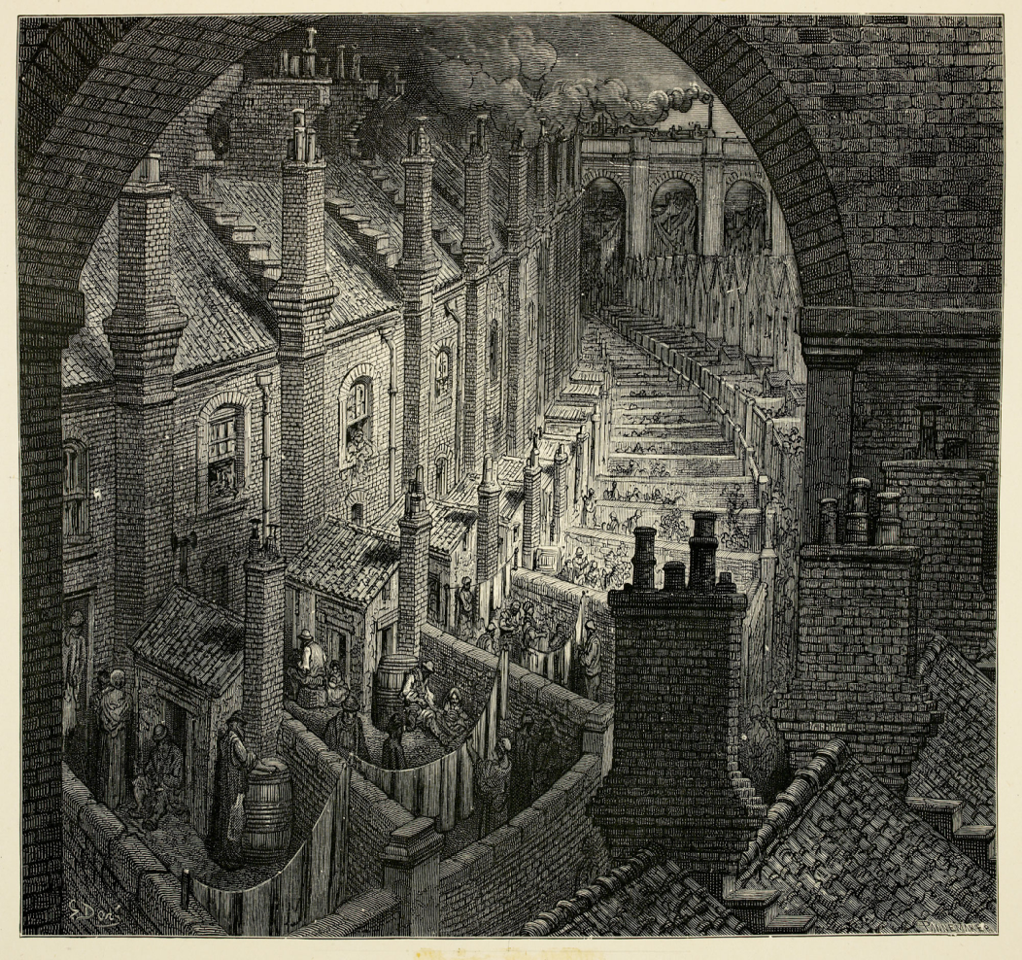 | Document 3b  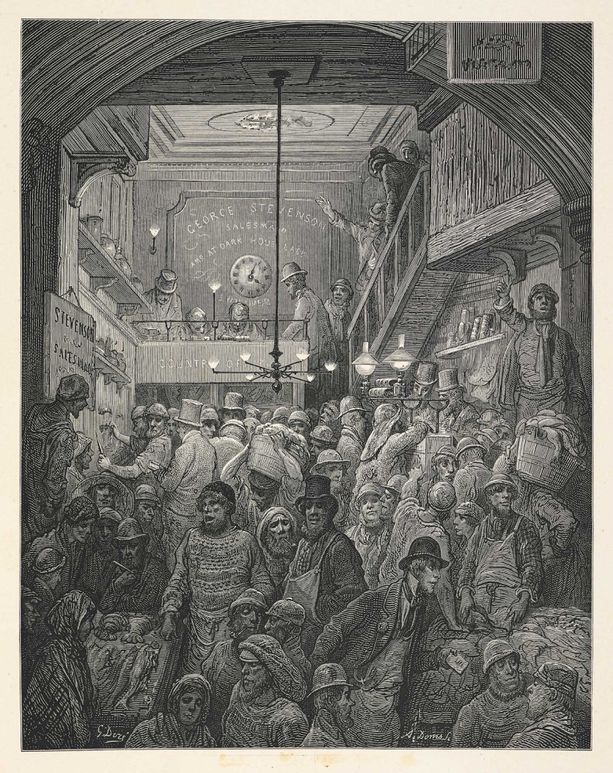

Document 3c  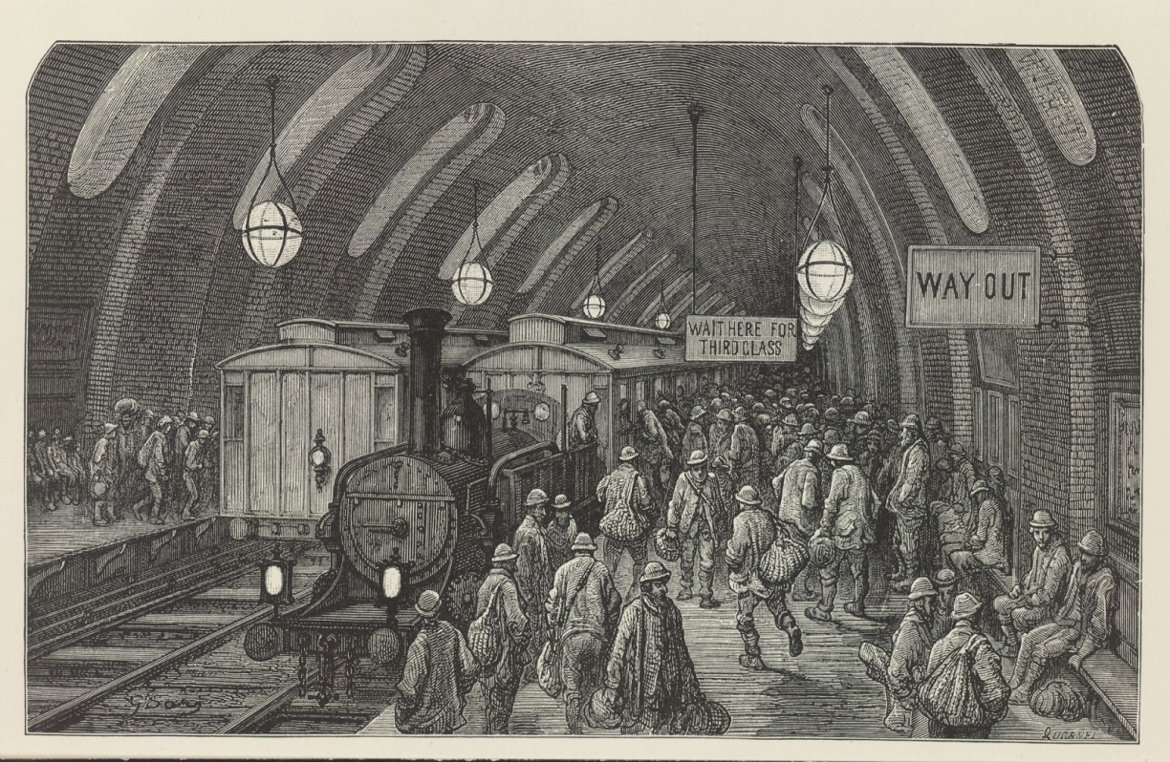 | Document 3d  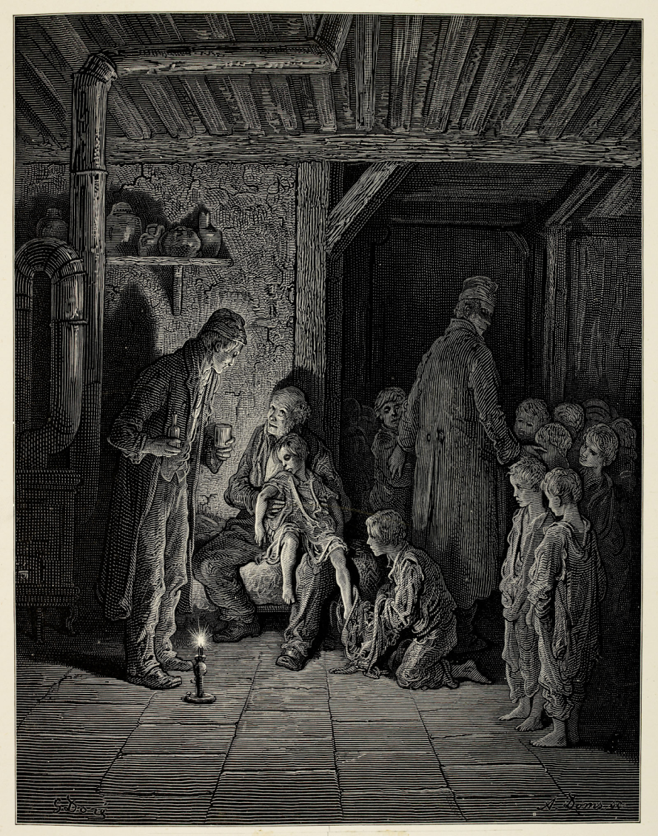
Source: London: A Pilgrimage. With illustrations by Gustave Dore, 1872. http://www.bl.uk/victorian-britain/articles/the-built-environment#sthash.GnxzDjCL.dpuf

Document Set 4
In July and August of 1858, hot weather combined with untreated human waste and industrial pollution to turn the Thames River in London into a disgusting body of water in an event known as “the Great Stink.” The increase in population in the city overwhelmed its sewage system, and industries along the waterway dumped the byproducts of their production into the water. Though Londoners at the time believed that the foul stench coming from the river led to epidemics, it was overcrowding and poor sanitation that led to outbreaks of disease like cholera. The political cartoons below were drawn during “the Great Stink.”
Document 4a  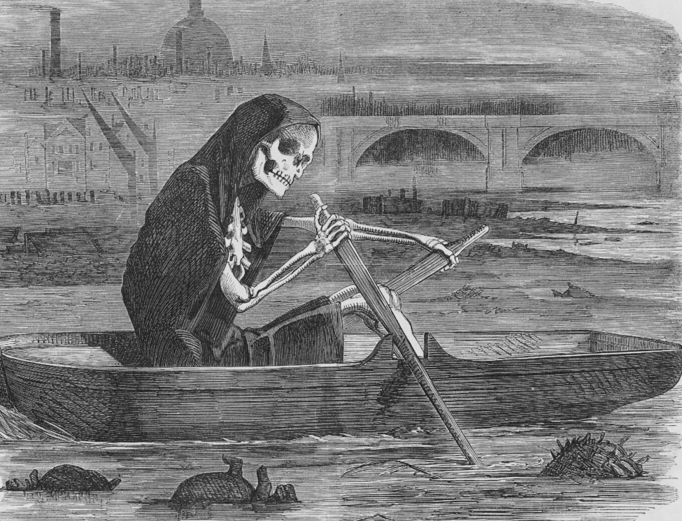  The silent highwayman : Death rows on the Thames, claiming the lives of victims who have not paid to have the river cleaned up, during the Great Stink.  Source: https://en.wikipedia.org/wiki/File:The_silent_highwayman.jpg | Document 4b  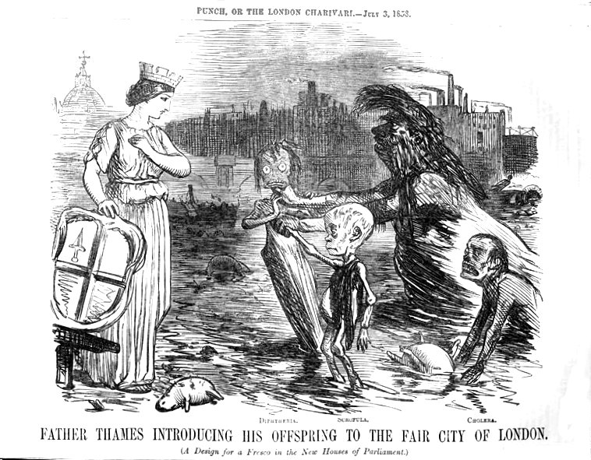  Caricature published in Punch magazine at the time of the "Great Stink.” The River Thames introduces his children – diphtheria, scrofula and cholera – to the city of London.  Source: https://en.wikipedia.org/wiki/File:Father_Thames_introducing_his_offspring_to_the_fair_city_of_London.jpg

Document Set 5
Document 5a
“. . . A place more destitute of all interesting objects than Manchester, it is not easy to conceive. In size and population it is the second city in the kingdom, containing above fourscore thousand [80,000] inhabitants. Imagine this multitude crowded together in narrow streets, the houses all built of brick and blackened with smoke; frequent buildings among them as large as convents, without their antiquity, without their beauty, without their holiness; where you hear from within, as you pass along, the everlasting din of machinery; and where when the bell rings it is to call wretches to their work instead of their prayers, . . . ”
— Robert J. Southey, Letters from England, 1807
Document 5b
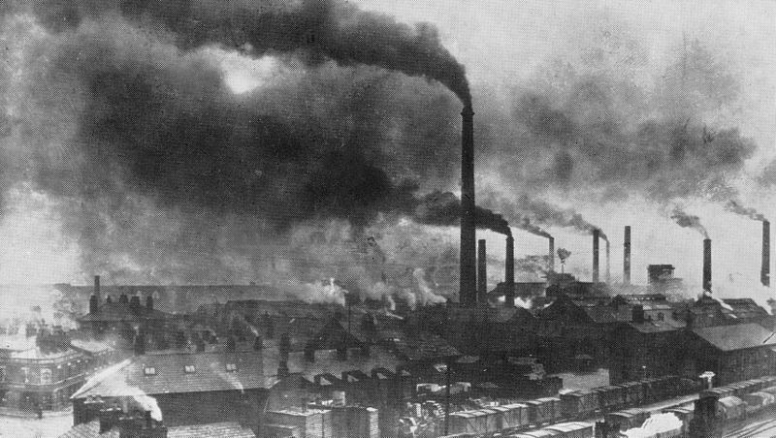
Photograph of Widnes, England in the late 19th century.
Source: https://commons.wikimedia.org/wiki/File:Widnes_Smoke.jpg

Primary Source Graffiti Graphic Organizer
Research Question: How did industrialization and urbanization affect British cities?

Document | Sourcing Information  (What type of document is it? Who wrote it? When was it written? What do you know about the author?) | Evidence to Answer Research Question
1
2
3a
3b
3c
Document | Sourcing Information  (What type of document is it? Who wrote it? When was it written? What do you know about the author?) | Evidence to Answer Research Question
3d
4a
4b
5a
5b

