How did industrialization affect the British middle class?

Effects of Industrialization on the British Middle Class
The Industrial Revolution created an entirely new class in Great Britain, the middle class. The middle class was made up of business owners, doctors, lawyers, managers, government employees, and office workers and their families. The middle class represented a wide range of wealth. Some were as wealthy or richer than members of the aristocracy, while others earned just more than the working class, but they did not engage in hard labor like factory workers or miners.
Watch an excerpt of the BBC Documentary “The Victorians” (start to 3:00, 8:06-11:40) then answer the questions below.

Vocabulary Note: Victorian refers to the time period when Queen Victoria was the monarch in Great Britain (1837-1901).
1. What values did the middle class in Great Britain have? | 2. What was life like for the middle class in Great Britain during the Victorian era?
Document 1
Samuel Smiles was a Scottish writer whose book, Self-Help, was a bestseller in late 19th century Great Britain. The book stresses the importance of individual perseverance as a way of succeeding in life. It represents how many middle class British people felt in the 19th century.
Excerpt from Self-Help by Samuel Smiles (1882)
"Heaven helps those who help themselves" is a well-tried maxim, embodying in a small compass the results of vast human experience. The spirit of self-help is the root of all genuine growth in the individual; and, exhibited in the lives of many, it constitutes the true source of national vigour and strength….

All nations have been made what they are by the thinking and the working of many generations of men. Patient and persevering labourers in all ranks and conditions of life, cultivators of the soil and explorers of the mine, inventors and discoverers, manufacturers, mechanics and artisans, poets, philosophers, and politicians, all have contributed towards the grand result, one generation building upon another's labours, and carrying them forward to still higher stages...

The spirit of self-help, as exhibited in the energetic action of individuals, has in all times been a marked feature in the English character, and furnishes the true measure of our power as a nation. Rising above the heads of the mass, there were always to be found a series of individuals distinguished beyond others, who commanded the public homage [respect]. But our progress has also been owing to multitudes of smaller and less known men. Though only the generals' names may be remembered in the history of any great campaign, it has been in a great measure through the individual valour and heroism of the privates that victories have been won. And life, too, is "a soldier's' battle,"-men in the ranks having in all times been amongst the greatest of workers. Many are the lives of men unwritten, which have nevertheless as powerfully influenced civilisation and progress as the more fortunate….

Biographies of great, but especially of good men, are nevertheless most instructive and useful, as helps, guides, and incentives to others. Some of the best are almost equivalent to gospels-teaching high living, high thinking, and energetic action for their own and the world's good. The valuable examples which they furnish of the power of self-help, of patient purpose, resolute working, and steadfast integrity, issuing in the formation of truly noble and manly character, exhibit in language not to be misunderstood, what it is in the power of each to accomplish for himself; and eloquently illustrate the efficacy of self-respect and self-reliance in enabling men of even the humblest rank to work out for themselves an honourable competency and a solid reputation.
Source: Samuel Smiles (1812-1904), Self-Help (London: John Murray, 1882), pp. v, 1-3,,5-7. 294. http://legacy.fordham.edu/halsall/mod/1882smiles.asp

Document 2
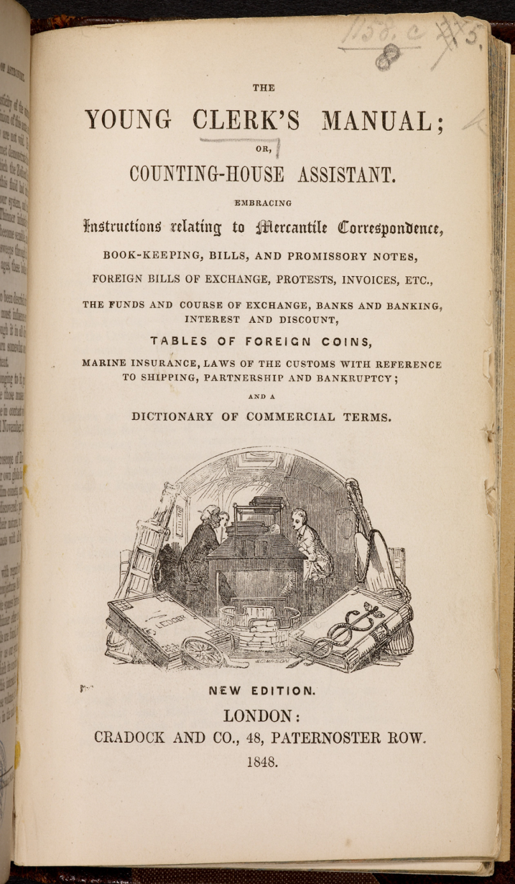 | The title page of this instructional manual - The Young Clerk’s Manual, or Counting House Assistant, published in 1848 - features a woodcut illustration of office clerks at their desk, flanked by cash and capital ledgers as though in a heraldic painting.  19th-century Britain saw the growth of what we would now call ‘white collar’ workers: people paid to oversee, administer and annotate financial or legal transactions ordered by heads of business. With Britain’s simultaneous manufacturing and trading boom, the number of clerks in commercial industries grew enormously. The 1841 census records only 20,000 commercial clerks in Britain, but by 1871 the number of ‘clerks, accountants and bankers’ had grown to 119,000.  As the word ‘clerk’ suggests (it is Old English for ‘lettered person’, via ‘cleric’), the job mostly involved transcription. A letter from a manager would have to be copied and recopied by hand until there were enough to send to all involved parties; likewise every invoice and account ledger. A junior banking clerk at the time of this illustration would likely have earned around £100 a year. A skilled engineer might have earned double that, but because engineering was manual work and clerkship was not, the clerk was the one considered ‘middle-class.’  Source: The Young Clerk's Manual; or, Counting-house assistant. Embracing instructions relating to mercantile correspondence, book-keeping ... etc. ... and a dictionary of commercial terms. New edition. London, 1848.  http://www.bl.uk/collection-items/the-young-clerks-manual#sthash.nEhKT6z1.dpuf

Document Set 3
Due to their newfound wealth, time saving machines and conveniences, and white collar jobs with predictable hours and days off, the middle class in the 19th century enjoyed a luxury that in the past was only available to the rich: money and leisure time (free time). New attractions and activities catering to the middle class drew crowds.
Document 3a  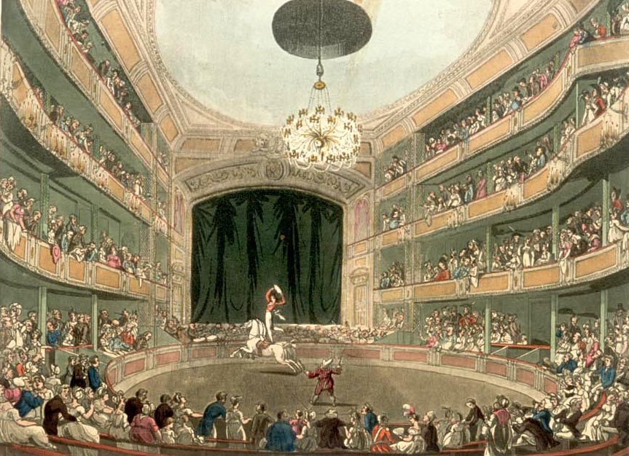  Drawing of Astley’s Amphitheatre in London (1808-1811). Astley’s Amphitheatre is credited as being the first modern circus.  Source: https://en.wikipedia.org/wiki/File:Astley%27s_Amphitheatre_Microcosm_edited.jpg | Document 3b  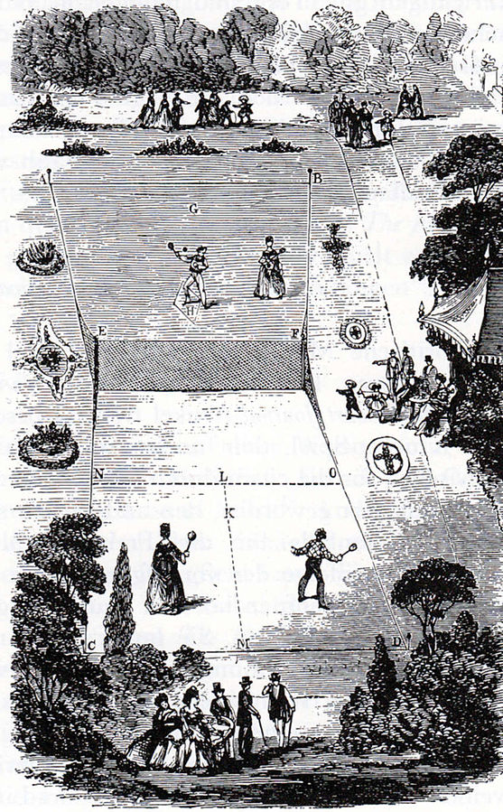  Drawing of a Lawn Tennis court (1874). Tennis, and other sports like cricket became very popular in the 19th century with the middle class.  Source: https://en.wikipedia.org/wiki/File:Lawn_Tennis_Court_1874.jpg

Document 3c
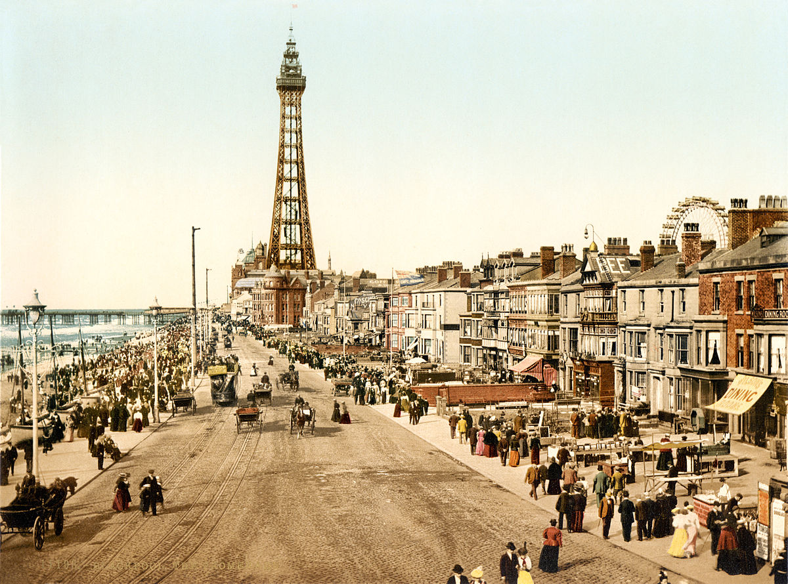
A colored photograph of the Blackpool Promenade (ca. 1890). Blackpool was a popular seaside resort that the middle class used to escape congested and polluted industrial cities if they could afford the train ride.
Source: https://commons.wikimedia.org/wiki/File:The_promenade,_Blackpool,_Lancashire,_England,_ca._1898.jpg

Document Set 4
In 1856 Samuel Beeton persuaded his wife, Isabella, to be a joint editor with him in a new publishing venture, a monthly paper called The Englishwoman's Domestic Magazine. This was the first cheap magazine for young middle-class women, and it was an immediate commercial success, with an advertised circulation of 50,000 copies by 1856.

Isabella wrote domestic management [house keeping] material, embroidery patterns, cooking, dressmaking and all the translations of French novels that were serialised in the periodical from 1855 until her early death in 1865. The contents also included a range of serial fiction, biographical sketches, gardening and medical tips (including some useful advice on birth control), and a correspondence page. There was always a strong emphasis on practical instruction and useful knowledge.
Source: http://www.bl.uk/victorian-britain/articles/the-victorian-middle-classes#sthash.7ATm8Gu2.dpuf
Document 4a
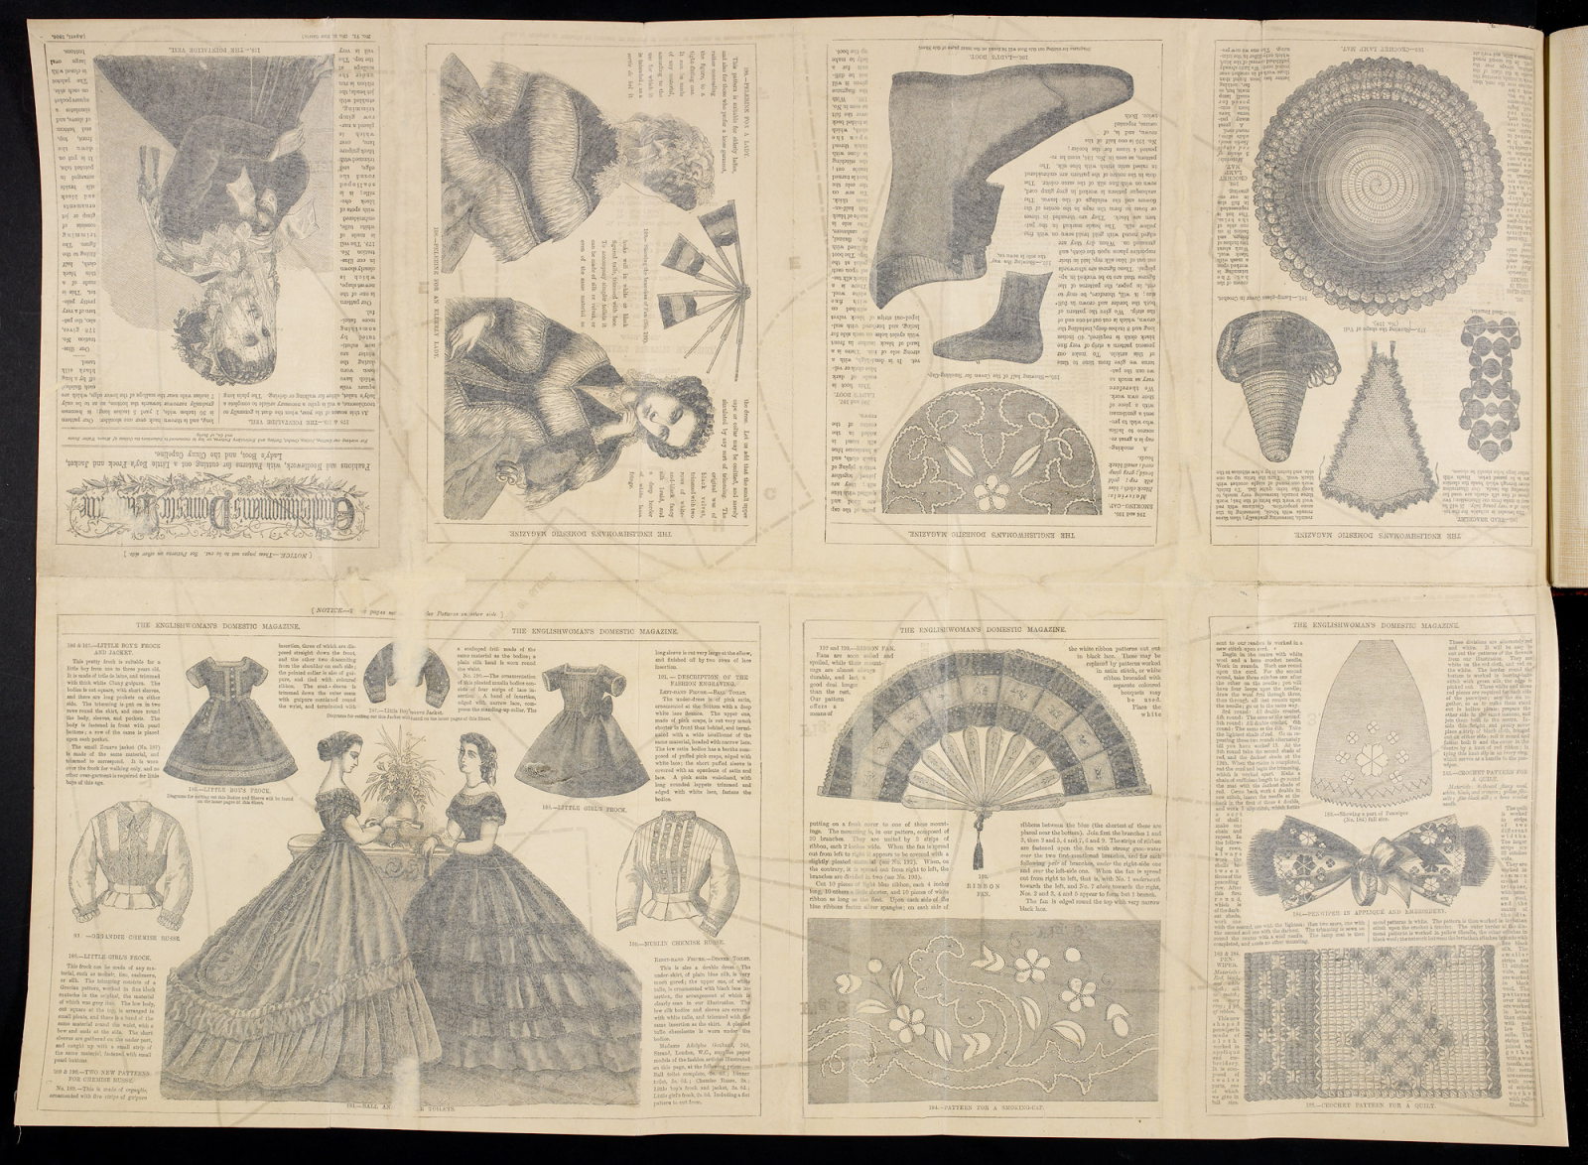
Document 4b  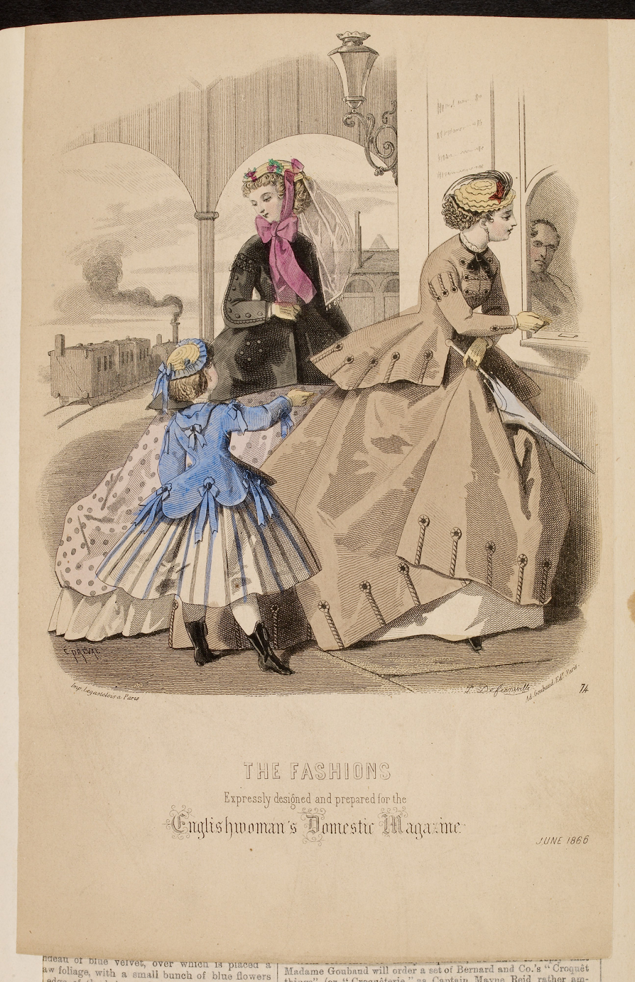 | Document 4c  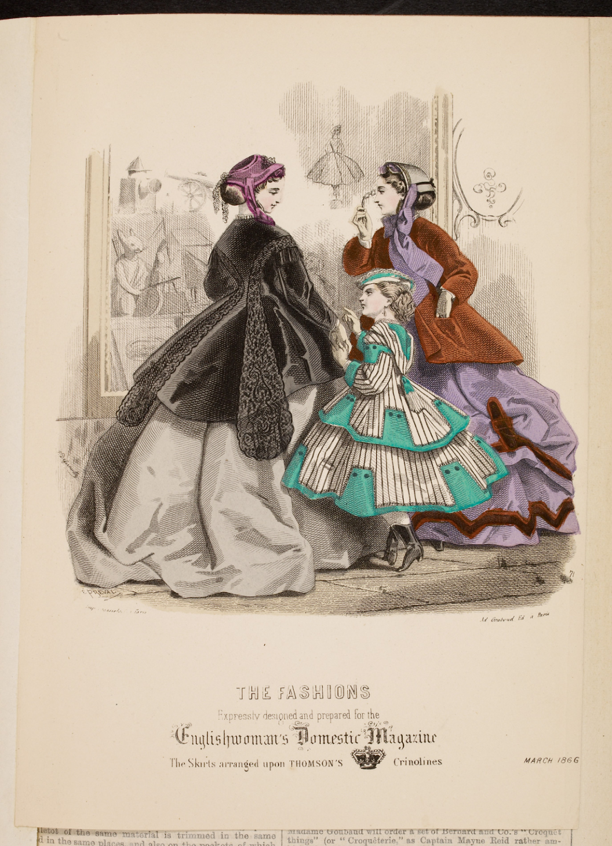

Primary Source Graffiti Graphic Organizer
Research Question: How did industrialization affect the British middle class?
Document | Sourcing Information  (What type of document is it? Who wrote it? When was it written? What do you know about the author?) | Evidence to Answer Research Question
1
2
3a
3b
Document | Sourcing Information  (What type of document is it? Who wrote it? When was it written? What do you know about the author?) | Evidence to Answer Research Question
3c
4a
4b
4c

