What and when was the Classical Era? What makes a civilization "classical?"
Identify characteristics that Classical Civilizations had in common.

What is periodization?
Periodization-the process or study of dividing the past into
periods of time and naming them

Sometimes when historians engage in periodization, the ways they divide up the time and the labels they give them has an effect on the way people think about that era and what happened during it.

➡ Directions: Read the following names of time periods and then draw an image that represents them and explain what you think these eras were like.
“The Stone Age” | “The Dark Ages” | “The Golden Age of Greece”
What do you think it was like during the “best years of my life”? | What do you think it was like during “The Dark Ages”? | What do you think it was like during “The Golden Age of Greece”?

What and when was the Classical Era? What makes a civilization “classical”?

Directions: Examine the text, timeline, and images below having to do with the Classical Era, then respond to the accompanying prompts.

Circle the words or phrases in the  definition to the right that you do not know or are confused by. |  | Classical Era/Period/Age (600 BCE- 900 CE)  Period of time in which complex civilizations expanded to establish large land empires and were more interconnected through trade than earlier civilizations. These civilizations made great contributions to our collective learning as a result of golden ages marked by prosperity. Most of the major belief systems that still impact our world were established during this time.
Based on the definition to the right,
why do you think we study the Classical Era?

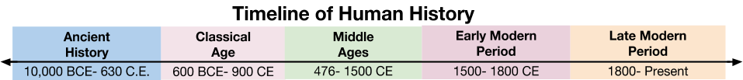

“Classical Age,” “The Classical Era,” “The Classical Period,” or “The Age of Classical Civilizations.”
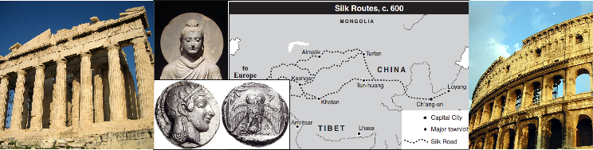

Based on the names of this time period and the images above, what do you predict the events in this time period will have in common?

Analyzing the Timeline of the Classical Period
Directions: Examine the timeline below and use it to answer the questions on the following page.
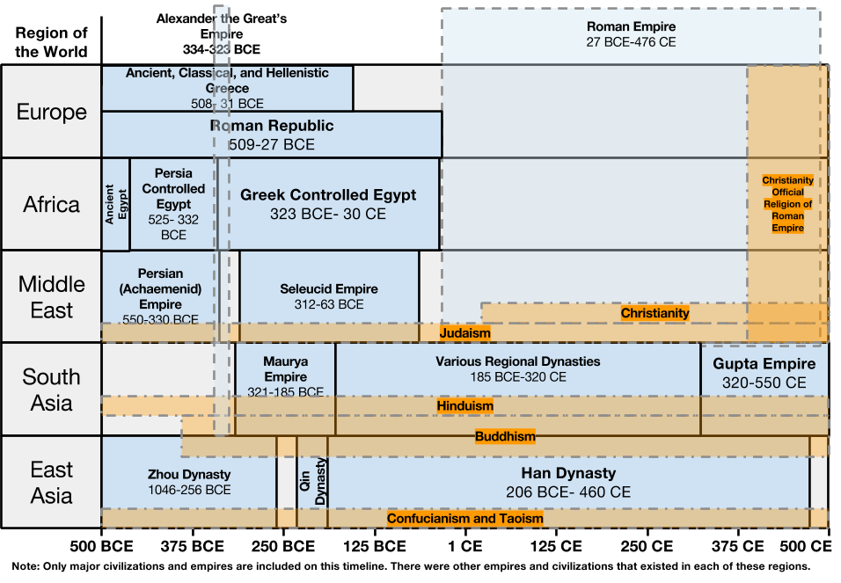
1. When does this timeline start? When does it end? | 2. What increments of time are used to break up the timeline (hint: look at the x-axis)?
3. What do the labels on the y-axis represent? | 4. Why do you think Alexander the Great’s Empire and the Roman Empire appear in multiple rows of the timeline?
5. All of the sections of the timeline that are circled, identify belief systems (most of them are religions) that were influential during that time in the regions they cover. List all of the belief systems on the timeline that you have heard of.
6. The Han Dynasty ruled China for more than 600 years. List the other dynasties and empires that existed at the same time and what region of the world they were in.
Dynasty or Empire that Existed During the Han Dynasty | Region of the World it Existed In

7. What is the purpose of this timeline?

