Where were classical civilizations located?
- Identify where classical civilization were located.

Introduction
Directions: Label the continents, regions, and bodies of water listed on the map below.
Continents |  |  | Regions |  | Bodies of Water
North America | Asia | South America | Middle East | South Asia | Atlantic Ocean | Indian Ocean
Africa | Europe | Antarctica | East Asia | North Africa | Pacific Ocean | Southern Ocean
 |  |  |  |  | Mediterranean Sea
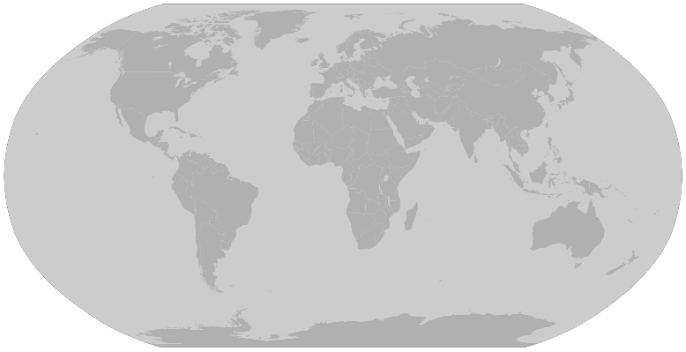
Mapping the Classical Civilizations

Directions: As you read the maps below, answer the questions accompanying each map. You can find these maps in full color on my website.

Map #1: Classical Civilizations in 500 BCE
1. Which continent was the Zhou Dynasty located on?
2. What body of water did the Roman Republic border in 500 BCE? (Reference your introduction activity)
3. Which civilization controlled the greatest amount of land in 500 BCE? Which region was it located in?
4. Which two civilizations labeled on the map were closest to the Greek City States in 500 BCE?
Map #2: Classical Civilizations in 200 BCE
5. Which continent was the Han Dynasty on? Which dynasty was in a similar location 300 years before?
6. Which group was in control of most of South Asia around 200 BCE?
7. Looking at Map #1 and #2, how did the Roman civilization change between 500 BCE and 200 BCE?

Map #3: Classical Civilizations in 200 CE
8. Which two civilizations controlled the greatest amount of land in 200 CE?
9. Identify the three continents that the Roman Empire controlled land on.
10. What changed in South Asia between 200 BCE and 200 CE? Why do you think this change took place?
Map #4: Classical Civilizations in 500 CE
11. Which civilization had control of most of South Asia in 500 CE?
12. To travel from the Eastern Roman Empire to the Persian Empire in which direction would a merchant have to go?
13. Looking at Map #3 and Map #4, what changed in Europe and East Asia between 200 CE and 500 CE?

