What was Pax Mongolica? What were the effects of Pax Mongolica?

Directions: Read the text below, then complete the questions that follow.
Through their conquests and strong-handed rule, Genghis Khan and his sons and grandsons who followed him created stability and peace in the Mongol Empire in the 1200s and 1300s. Historians now refer to this period of order as Pax Mongolica, or “Mongol Peace.” You may recall that the years between 27 BC and 180 AD of the Roman Empire are known as Pax Romana, or the “Roman Peace” because of the prosperity in the Roman Empire that resulted from a strong centralized government and few wars. The same was true for Pax Mongolica.  The political stability during the hundred years of Pax Mongolica led to more and safer trade on the Silk Roads. Under the protection of the Mongols, goods and ideas moved between China and the Middle East once again. Most importantly, the innovations that started in the Golden Ages of the Tang and Song Dynasties in China, spread to the rest of Eurasia. Chinese techniques for making paper, printmaking, the compass, new agricultural techniques, and the use of gunpowder were then used and improved upon by people in Central Asia, India, the Middle East, North Africa, and eventually Europe.  These innovations spurred historical events for centuries to come including the Age of Exploration during which European sailors using compasses for navigation travelled to the western hemisphere; The Reformation, a religious movement fueled by the writings of a monk named Martin Luther whose ideas circulated in paper pamphlets rapidly produced by printing presses; and gunpowder continues to spark conflict throughout the world. | 1. During which years did Pax Mongolica last?  2. What does the phrase “Pax Mongolica” mean?  3. What effects did Pax Mongolica have on the Mongol empire and surrounding societies?  4. What effects did Pax Mongolica have on future societies?

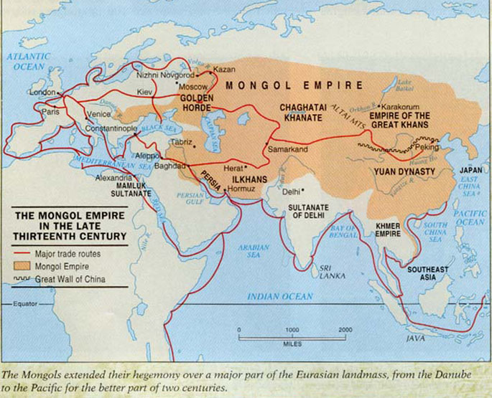
DIRECTIONS: Watch Crash Course World History: The Mongols (start: 6:55; end: 8:30) (https://goo.gl/xHRzQE) and answer the following questions. (John Green can speak very quickly. Put on the captions. )

John Green talks about Mongol “Awesomeness” identifying 5 ways that the Mongols were awesome. Identify and explain each of them.
1.

2.

3.

4.

5.

