Name: Date:
Global 9R/Period: Development of England and France
DIRECTIONS: While watching the video (https://goo.gl/5wUBlo), complete the notes and then complete the questions at the end.
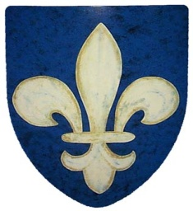
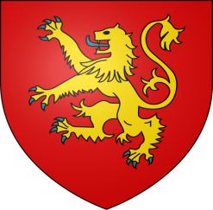
The Development of England & France

DEVELOPMENT OF ENGLAND
The English Kings

England Comes Under Norman Control
- Early 800s-
- 1016-danish king, Canute conquers England
- January 1066-King Edward dies without an heir

    - Claims crown
- Oct. 14, 1066-Battle of Hastings

- William

Goals of the English Kings

Henry II
- 1154-1189

- Added French territory through marriage
- Accomplishments-

  - Common Law-
King John
- 1199-1216
- Bad military leader

- June 15, 1215

    - Guaranteed certain political rights

Edward I
- Developed idea of a parliament

- 1295-
  - 1st parliament
  - Consisted of:

    - Burgesses
    - Knights
    - Bishops
    - Lords

- Two groups of Parliament
  - House of Commons-
  - House of Lords-
DEVELOPMENT OF FRANCE
The French Kings
Capetian Dynasty
- Dynasty ruled from 987-1328

  - Ruled small territory which included Paris
Philip II
- 1180-1223
- 1204-
- Tripled land under his control
- Est. bailiffs

Philip IV
- 1285-1314
- 1302-Fight w/ Pope

  - Philip said the Pope didn’t have that right
  - Phil. called for a mtg. of his lords & bishops; then included commoners
    - Estates-General
      - First Estate-
      - Second Estate-
      - Third Estate-
Beginnings of Democracy in England & France
- Step I-
- Step II-
- Step III-

- Describe how England and France developed as nations.

- Explain how individuals became part of the political process.

