What is nationalism? What impact can it have?
Objective: Explain what nationalism is and what effect it can have on individuals and on society.
Introduction
Directions: Examine the images and information presented, then answer the question that follows.
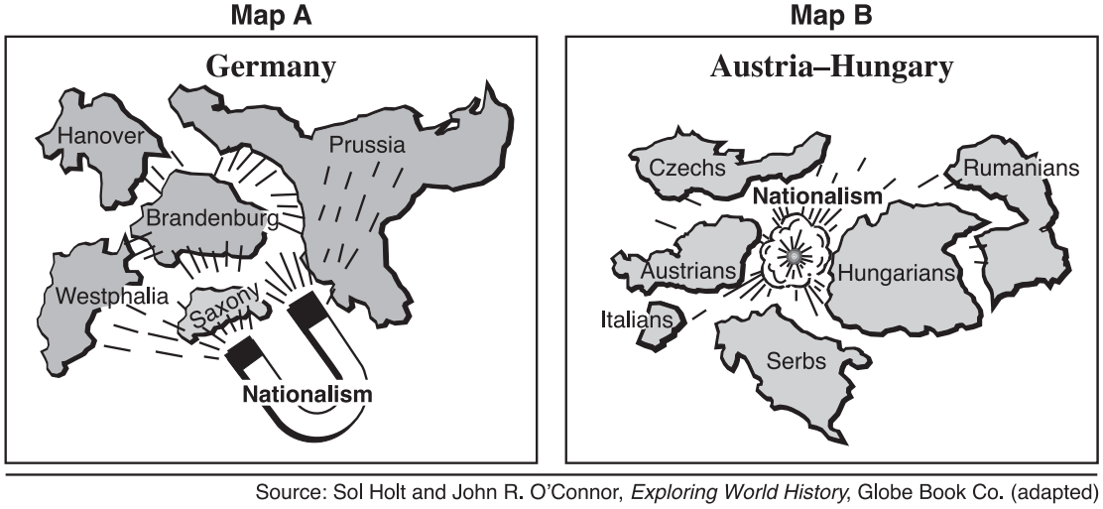
According to the authors of these two images, what effects might nationalism have on a country?
What effect did nationalism have on Europe in the 19th century?
Objective: Describe how nationalism affected Europe in the 19th century with regards to the unification of Germany and Italy, and the weakening of the Austrian and Ottoman Empires.
Predict
Examine the two maps below, then answer the questions that accompany them.
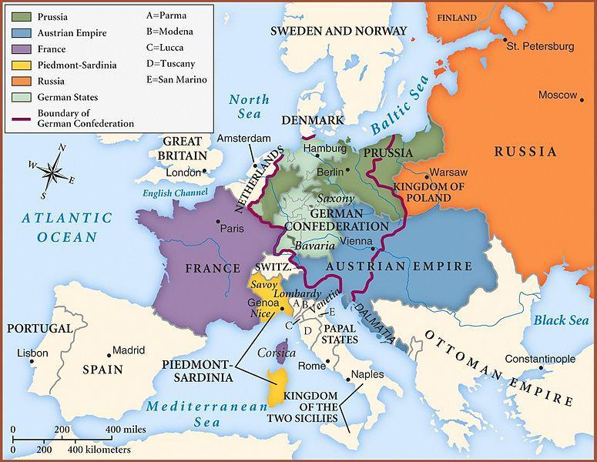  Map of Europe after the Congress of Vienna, 1815.  Source: https://en.wikipedia.org/wiki/File:Map_congress_of_vienna.jpg | 1. In 1815, what two empires existed in Europe?  2. The German Confederation was a group of states that spoke German that Napoleon created when he controlled most of Europe prior to the Congress of Vienna in 1815. At the Congress of Vienna, other powers in Europe decided to dissolve the confederation. In 1815, which states controlled land that was once a part of the German Confederation?  3. Locate the Italian peninsula. It looks like a boot that juts into the Mediterranean Sea. How many different states/kingdoms control sections of the Italian peninsula?

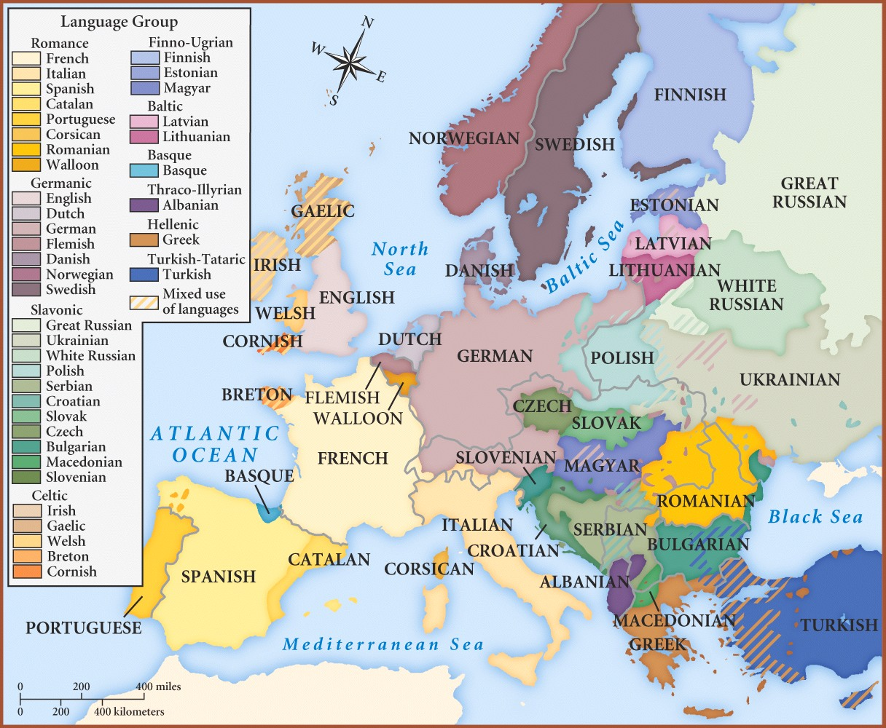  Map of Language Groups in Europe, 1910  Source: http://thedockyards.com/wp-content/uploads/2015/03/Language-map-of-Europe-1910.jpg | 1. What is the purpose of this map?  2. Based on both maps, which language(s) were spoken in France? Spain? Why do you think this was?  3. Which languages were spoken in the Austrian Empire?  4. Which languages were spoken in the Ottoman Empire?  5. Which states controlled land where people spoke German the most?  6. Which states controlled land where people spoke Italian the most?
7. Based on both maps, which areas are most likely to be pulled together by nationalism? Why?

8. Which states are most likely to be pulled apart by nationalism? Why?

The Impact of the French Revolution and Napoleon on European Nationalist Movements
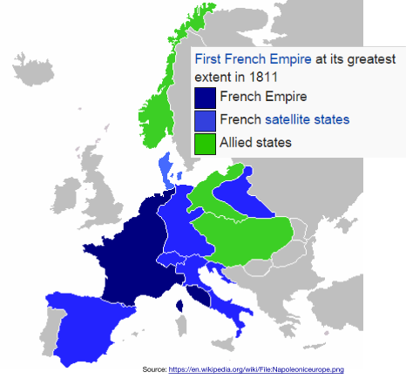
The French Revolution (1789–1799) was a period of political and social upheaval in France and Europe, during which the French government, previously an absolute monarchy, underwent radical changes based on Enlightenment principles of republic, citizenship, and inalienable rights.

This revolution sparked five wars between the well-trained armies of Napoleonic France and neighbors including Prussia and Austria. From 1803 to 1814, Napoleon ruled over a large section of Europe. During that time he and the ideals of the French Revolution greatly affected the regions he controlled. The revolution’s nationalistic call for “liberty, equality, and fraternity” and a government ruled by the will of the French people, instead of a royal family with connections outside of France, inspired similar feelings in regions occupied by Napoleon’s troops.

In central Europe, for example, Napoleon created the German Confederation, an association of German speaking states that were previously part of the Holy Roman Empire, Prussia, and the Austrian empire. Soon after Napoleon was defeated the German Confederation was dismantled. At the Congress of Vienna (1815) the major European powers decided to given the land back to Prussia and the Austrian Empire, but the idea of unity for German speaking people remained.

The French Revolution and Napoleon affected people living on the Italian peninsula as well. Napoleon ruled the entire area as the Napoleonic Kingdom of Italy. His reign inspired nationalistic feelings in the Italians. As happened to the German Confederation, the Kingdom of Italy was broken up after Napoleon’s defeat. The representatives at the Congress of Vienna divided Italy up into small independent governments and gave the Austrian Empire control of Northern Italy. Austrian Chancellor Franz Metternich, an influential diplomat at the Congress of Vienna, stated that the word Italy was nothing more than "a geographic expression."

Though Napoleon was defeated, the nationalism that he and the French Revolution inspired lingered in German and Italian speaking regions, threatening the Austrian Empire.
What effects did the French Revolution and Napoleon's rule have on the German and Italian speaking people in Europe?

Synthesis Map Activity
Directions: Examine the maps below and answer the questions that follow.
Map of Europe after the Congress of Vienna, 1815.  Source: https://en.wikipedia.org/wiki/File:Map_congress_of_vienna.jpg | Map of Europe in 1914. 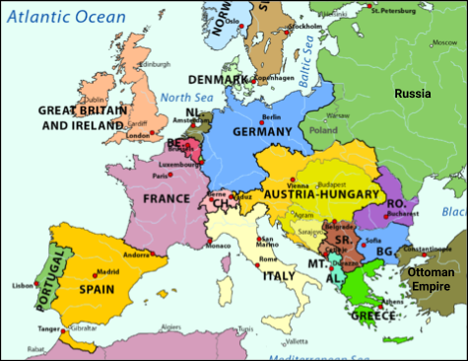  Source: https://commons.wikimedia.org/wiki/File:FR-WW1-1914.png
1. Based on the maps above, identify three changes in Europe between 1815 and 1914.

2. Based on the maps above, which two states lost the most land in the hundred years after 1815?

3. How do you think this affected those two states?

