The British in India Document Analysis Activity

Directions: After examining documents on British power in India, fill in the chart below. For each method of control listed, identify if it helped the British gain, consolidate, and/or maintain power in India. Then, explain why you think so.
GAIN  Gaining power is the process of  getting it and expanding it. | CONSOLIDATE  Consolidating power is the process of taking control  from other people who also have power. | MAINTAIN  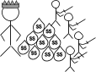  Maintaining power is the process of keeping one’s power.

Document | Gain, Consolidate, and/or Maintain Power?  Circle all that apply. | Explanation  Explain why the method of control described made is possible for  the British to gain, consolidate, and/or maintain power in India.
Document 1:  Military Force | GAIN
 | CONSOLIDATE
 | MAINTAIN
Document 2: Railroads | GAIN
 | CONSOLIDATE
 | MAINTAIN
Document 3: Advances in Telecommunication | GAIN
 | CONSOLIDATE
 | MAINTAIN
Document 4: Control of Industry and Agriculture | GAIN
 | CONSOLIDATE
 | MAINTAIN
Document Set 1: Military Force
The British used their military might and advanced technology to conquer and keep control of most parts of India. The British Indian Army was made up of roughly two-thirds Indian soldiers hired to defend the British East India Company and later the British government’s interests, and just one-third British soldiers. The British held the highest positions in the military.  With the addition of the Maxim Gun, the first widely used machine gun, the military was nearly unstoppable. The gun could fire bullet after bullet without reloading and could swivel from side to side. | 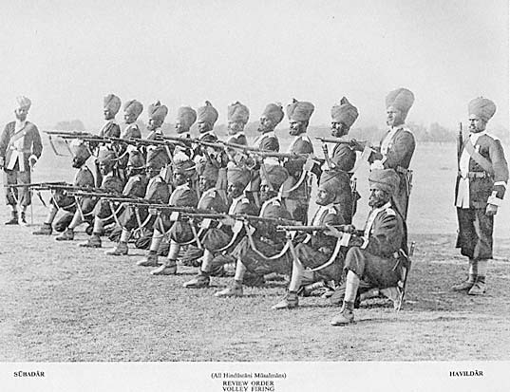  British Indian Army soldiers, 1895.  Source: https://commons.wikimedia.org/wiki/File:BritishIndianArmy.jpg
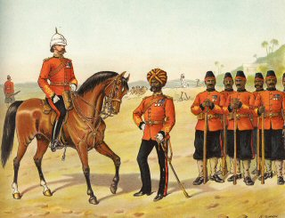  Illustration of British Indian Army soldiers and their British commander, 1896.  Source: https://commons.wikimedia.org/wiki/File:The_Queen%27s_Own_Madras_Sappers_and_Miners,_Review_Order.jpg | 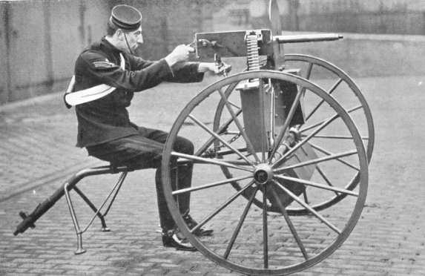  Maxim machine gun mounted on a Dundonald gun carriage, ca. 1890.  Source: https://commons.wikimedia.org/wiki/File:Maximgun.jpg

Document Set 2: Railroads
An enduring monument to British imperialism in India is the Indian railway system, which at the time of independence in 1947 had more track mileage than that of any European state and less than only the United States, Canada, and the Soviet Union. The first railway track was laid in India in 1850, and by 1915 India had better than forty thousand miles of track and approximately one hundred million railroad passengers per year. Indian railway building was supported by several powerful groups: British cotton manufacturers, for whom railways were a cheap and efficient way to get cotton to the coast for shipment to England; British industrialists, who supplied India with most of its rails, locomotives, moving stock [railroad cars], and equipment; colonial officials, who saw railroads as a way to move troops quickly to trouble spots and an essential part of the Indian postal system; and millions of Indians, who, rather to the surprise of the British, took to rail travel with great alacrity [enthusiasm]….
Source: Andrea and Overfield, The Human Record: Sources of Global History, Houghton Mifflin from the NYS Global History and Geography Regents Exam, January 2012.
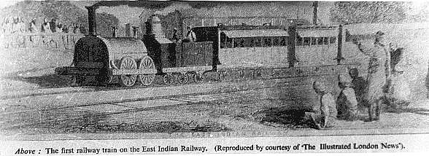  The first railway train on the East Indian Railway, 1854. The Illustrated London News.  Source: . https://commons.wikimedia.org/wiki/File:First_Train_of_East_Indian_Railway-1854.jpg | 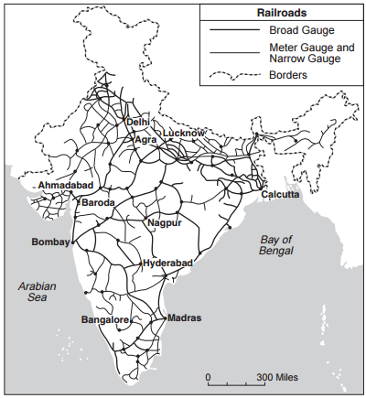  Source: Ashok K. Dutt et al., India in Maps, Kendall/Hunt Publishing Company (adapted) from the NYS Global History and Geography Regents Exam, June 2013.

Document Set 3: Advances in Telecommunications
In what was is sometimes called the “Second Industrial Revolution,” telecommunications technology advanced in the mid-late 1800s and early 1900s. The telegraph was invented, making it possible to communicate with people far away in very little time. At first, these technologies were only used for governmental and commercial reasons. The telegraph was integral to British control in India. The British put up lines all over the country connecting their military posts so they could relay information about needed supplies or emergencies. Before the telegraph, a message could only travel as fast as a train. With the telegraph, a message about a riot could be communicated while it was in progress and soldiers could be sent quickly to stop the revolt and gain control once again.
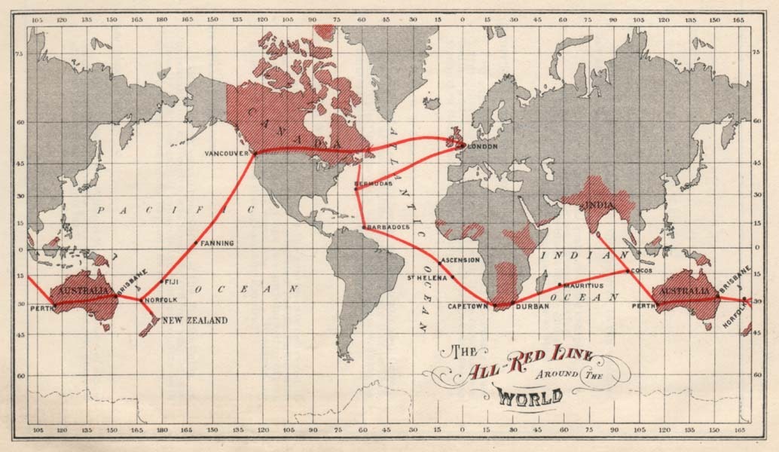  Map of the All Red Line as drawn in 1902 or 1903. The All Red Line was a telegraph line put up by the British government to connect all of its colonies around the world. It was submerged underwater for transoceanic connections.  Source: https://commons.wikimedia.org/wiki/File:All_Red_Line.jpg | 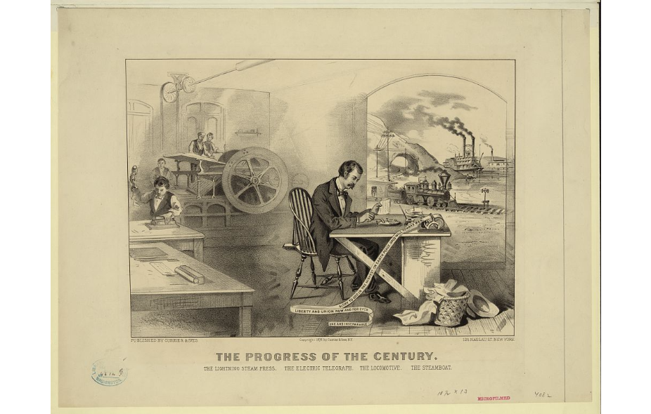  The progress of the century - the lightning steam press, the electric telegraph, the locomotive, [and] the steamboat digital file from original print.  Source: https://www.loc.gov/resource/ppmsca.17563/

Document Set 4: Control of Industry and Agriculture
The British East India Company’s interest in India were commercial and under the British government, making money remained an important goal. The textile industry, in particular, made the British government and British companies very wealthy. They used Indian labor to grow and harvest the raw materials they needed to make cloth, like cotton to make the yarn and plants like indigo to make dye. The British forced Indian farmers to grow “cash crops” like these instead of food that could be used to feed local populations. Later, when famine hit India those policies were identified as one of the possible causes.

The raw materials were then sent back to Britain and made into finished clothing. The British brought the manufactured goods back to India and sold them to Indians to make a profit. Indian businesses could not compete with cheap British-made goods so they closed down and the British were the only suppliers. The Indian economy was devastated by the effects of British manufacturing dominance. Before British rule, India produced about 17% of the world’s Gross Domestic Product (GDP), but afterwards, it was less than one percent.
Source: Adapted from “British Raj,” New World Encyclopedia. http://www.newworldencyclopedia.org/entry/British_Raj
. . . First and foremost among the active imperialist groups come certain business interests. Not the whole so-called “capitalist class,” as many an earnest Socialist would have us believe, but only a minority of business interests are directly interested in imperialism. They are easily identified. To begin with, there are the exporters and manufacturers of certain goods used in colonies. The following figures of English exports to India tell the story.  English Exports to India (Average 1920–1922)  Cotton goods and yarn . . . . . . . . . . . . . . . . . . . . . . . . . . . .£53,577,000  Iron and steel, tools, machinery, and locomotives . . . . . . . .37,423,000  Wagons, trucks, and automobiles . . . . . . .. . . . . . . . . . . . . . 4,274,000  Paper . . . . . . . . . . . . . . . . . . . . . . . . . . . . . . . . . . . . . . . . . . . 1,858,000  Brass goods. . . . . . . . . . . . . . . . . . . . . . . . . . . . . . . . . . . . . . .1,813,000  Woolens . . . . . . . . . . . . . . . . . . . . . . .. . . . . . . . . . . . . . . . . . 1,600,000  Tobacco . . . . . . . . . . . . . . . . . . . . . . . . . . . . . . . . . . . . . . . . . 1,023,000  No other item over £1,000,000. . . .  Source: Parker T. Moon, Imperialism and World Politics, Macmillan Co., 1926 from the NYS Global History and Geography Regents Exam, June 2004. | 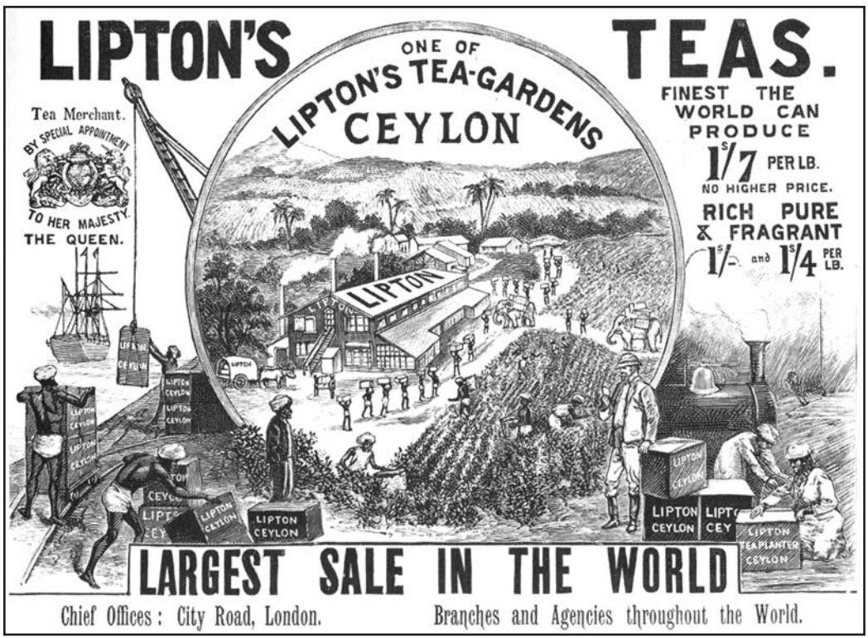  Source: Andrea and Overfield, The Human Record, Houghton Mifflin, 2001 from the NYS Global History and Geography Regents Exam, June 2004.

