Document 1
Greek architects provided some of the finest and most distinctive buildings in the entire Ancient World and some of their structures, such as temples, theatres, and stadiums, became staple features of towns and cities from antiquity [Classical Era] onwards. In addition, the Greek concern with simplicity, proportion, perspective, and harmony in their buildings would go on to greatly influence architects in the Roman world and provide the foundation for the classical architectural orders [styles] which would dominate the western world from the Renaissance to the present day.
Greek Columns  Greek architects created the three “orders,” or styles, of columns. Those three, depicted in the image below are the Doric, Ionic, and Corinthian orders. These styles are still common on many modern buildings especially museums, libraries, and government buildings.  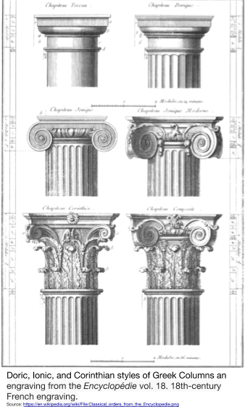 | The Parthenon
 | 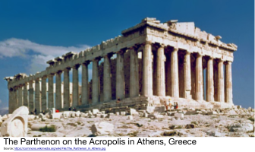
The magnificent temple on the Acropolis of Athens, known as the Parthenon, was built between 447 and 432 BCE in the Age of Pericles, and it was dedicated to the city’s patron deity, Athena. The Acropolis was the center of Athenian life built on top of a hill in the city where the most important civic buildings were located. The acropolis itself measures some 300 by 150 metres and is 70 metres high at its maximum. Marble from the nearby Mt. Pentelicus was used for the building, and never before had so much marble been used in a Greek temple.

Source: Adapted from “Parthenon.” Ancient History Encyclopedia. http://www.ancient.eu/parthenon/

Document 2
Greek artists and architects used mathematics to complete their projects and philosophers used it to explore the true nature of the world. For example,
Pythagoras, a philosopher,
developed a method for explaining the relationship between the angles and legs of right triangles now called the Pythagorean Theorem.

Document 3
"... Our form of government is called a democracy because its administration is in the hands, not of a few, but of the whole people. In the settling of private disputes, everyone is equal before the law. Election to public office is made on the basis of ability, not on the basis of membership to a particular class. No man is kept out of public office by the obscurity of his social standing because of his poverty, as long as he wishes to be of service to the state. And not only in our public life are we free and open, but a sense of freedom regulates our day-to-day life with each other. We do not flare up in anger at our neighbor if he does what he likes. And we do not show the kind of silent disapproval that causes pain in others, even though it is not a direct accusation. In our private affairs, then, we are tolerant and avoid giving offense. But in public affairs, we take great care not to break law because of the deep respect we have for them. We give obedience to the men who hold public office from year to year. And we pay special regard to those laws that are for the protection of the oppressed and to all the unwritten laws that we know bring disgrace upon the transgressor when they are broken.
Pericles’ Funeral Oration, given to the Athenians in about 430 BCE

Document 4
Hellenistic Culture is a combination of Greek, Persian, and Indian art, philosophy, science, math, architecture, and traditions that were created through contact between people ruled by Alexander the Great and spread by those that traveled in his empire.

Document 5
Appian, The Destruction of Carthage
The Roman Empire fought three wars against the Carthaginian Empire in North Africa that were called the Punic Wars. The last war ended with the destruction of Carthage in 146 BCE. Appian, who lived in the second century CE, wrote a vivid description of the destruction of the African city led by Scipio. An excerpt from that description is below.
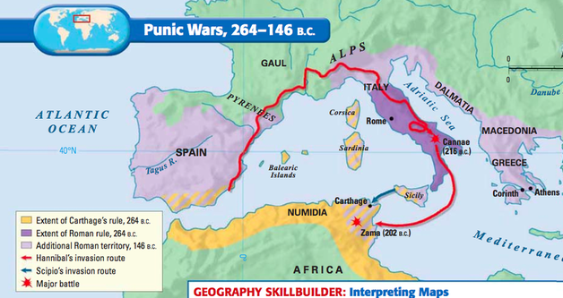
After penetrating into the city [Carthage], Scipio [the Roman commander] turned his attention to the citadel, its strongest point, where many people had taken refuge. Three streets leading from the marketplace to the citadel were lined on both sides with six story houses, from which the Romans were pelted. They seized the first houses and used them as a base for attacking the next. From their roofs they made bridges of planks and beams to cross over to the next. While one battle was in progress on the roofs another was fought, against all comers, in the narrow street below.
Everywhere there was groaning and wailing and shouting and agony of every description. Some Carthaginians were killed out of hand, some flung down alive from the roofs to the pavement, and of these some were caught on upright spears or ambers or swords….
Others were seen still living, especially old men, women, and young children who had hidden in the inmost corners of the houses, some of them wounded, some more or less burned, and uttering pitiful cries. Still others thrust out and falling from such a height with the stones, timbers, and fire, were torn asunder in all shapes of horror, crushed and mangled.
Nor was this the end of their miseries, for the street cleaners, who were removing the rubbish with axes, mattocks, and forks, and making the roads passable, tossed with the dead and the living together into holes in the ground….
Six days and nights were consumed in this kind of fighting.... Soldiers worked in shifts to ensure that that they might not be worn out with toil, slaughter, lack of sleep, and these horrid sights.
The city of Carthage which had flourished for seven hundred years from its foundation, which had held broad dominion over lands and islands and seas, which had vied with the greatest of empires in its wealth of arms and ships and elephants and money, which had manifested extraordinary courage by resisting a strong enemy and famine for three years after its ships had been taken—this city was now being utterly blotted out and destroyed. As Scipio looked on he is said to have wept and openly to have lamented the enemy’s fate. For a long while he remained sunk in thought, reflecting that the fortunes of all cities and peoples and empires, like of those of individuals, must change. Troy had fallen, once so prosperous a city; the empires of the Assyrians, and the Medes, and the Persians after them, had fallen, and so, lately, the Macedonian empire, the most brilliant of them all.
Source: Excerpt from Appian, The Punic Wars 27 which is published on livius.org.
Document 6
These sometimes massive structures, with single, double, or triple tiers of arches, were designed to carry fresh water to urban centres from sources sometimes many kilometres away. The earliest in Rome was the Aqua Appia (312 BCE), but the most impressive example is undoubtedly the Pont du Gard near Nimes (c. 14 CE). Romans used the arch to span rivers and ravines.
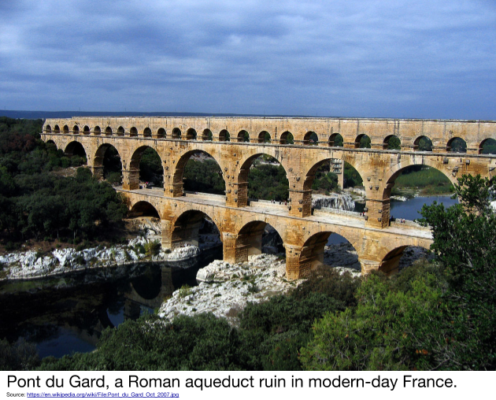
Source: Adapted from “Roman Architecture.” Ancient History Encyclopedia. http://www.ancient.eu/Roman_Architecture/

Document 7
The Twelve Tables of Rome
In 509 BCE, the Roman Republic was established in Italy. At first, the government was only made up of patricians, members of the landholding upper class of Rome. Later, the farmers, merchants, artisans, and traders known as plebeians won the right to be elected to the government too. The plebeians demanded that all of the Roman laws be written down and displayed in public so all Romans would know the rules and the punishments for breaking them. As a result, around 450 BCE the government had the laws inscribed on twelve stone tablets and placed in the Roman marketplace, called the Forum. The following are excerpts from the Twelve Tables of Rome.
Table VIII: Laws of Injury
2. If one has maimed a limb and does not compromise with the injured person, let there be retaliation [revenge]. If one has broken a bone of a freeman with his hand or with a cudgel, let him pay a penalty of three hundred coins If he has broken the bone of a slave, let him have one hundred and fifty coins. If one is guilty of insult, the penalty shall be twenty-five coins.
10. Any person who destroys by burning any building or heap of corn deposited alongside a house shall be bound, scourged, and put to death by burning at the stake provided that he has committed the said misdeed with malice [intention to do harm] aforethought; but if he shall have committed it by accident, that is, by negligence, it is ordained that he repair the damage or, if he be too poor to be competent for such punishment, he shall receive a lighter punishment.
12. If the theft has been done by night, if the owner kills the thief, the thief shall be held to be lawfully killed.
13. It is unlawful for a thief to be killed by day....unless he defends himself with a weapon; even though he has come with a weapon, unless he shall use the weapon and fight back, you shall not kill him. And even if he resists, first call out so that someone may hear and come up.
23. A person who had been found guilty of giving false witness [lying] shall be hurled down from the Tarpeian Rock.

Table IX: Public Law
5. Treason: he who shall have roused up a public enemy or handed over a citizen to a public enemy must suffer capital punishment.
6. Putting to death of any man, whosoever he might be unconvicted is forbidden.

Table XI: Supplement I
1. Marriages should not take place between plebeians and patricians.

Table XII: Supplement II
2. If a slave shall have committed theft or done damage with his master’s knowledge, the action for damages is in the slave's name.
Source: Oliver J. Thatcher, ed., The Library of Original Sources (Milwaukee: University Research Extension Co., 1901), Vol. III: The Roman World, pp. 9-11. Scanned and modernized by J. S. Arkenberg, Dept. of History, Cal. State Fullerton. Retrieved from: http://www.fordham.edu/Halsall/ancient/12tables.asp

Document 8

Purposes and Kinds of Roman Roads
Why did the Romans build roads? The Romans considered a well-organized and efficient transportation system a basic element of proper administration; i.e. an indispensable element in creating and maintaining the Roman state. The earliest highways or main roads were constructed for the use of the military, and their economic benefit for civilians was a later byproduct and not the main reason for their creation. The military nature of the roads continued to be essential as Romans expanded into territory outside Italy. In the province of Arabia Petraea (which included what is now Jordan), the movement of troops and ease of communication for the army and Roman administration were the primary reasons for construction of the Via Nova, one of the many viae militares or military roads built in conquered provinces. However, smaller, shorter, and less well-constructed local roads (actus) or tracks (callis) also increased in territory after it was brought under Roman control. Nevertheless, the main public highways (viae publicae) normally began as military roads and only gradually evolved into civilian conduits [passageways].
Source: Virtual Karak Resources Project, An Appalachian College Association (adapted)

