Name: Date:
Global 10R/Period: End of WWI Notes

America Joins the Allies
Reason #1-Unrestricted Submarine Warfare
- Beginning of WWI- all subs had to surface in order to sink a ship
- 1917- Germany began using unrestricted submarine warfare

- They had actually tried this before….
- The ship was called
Impact of the Sinking

- Ends unrestricted submarine warfare for a while
- By 1917 they begin to use it again
Reason # 2-Zimmerman Telegram
- Feb 1917
- GB intercepts telegram from German Foreign Secretary Arthur Zimmerman to German Ambassador in Mexico

- GB makes sure US receives telegram
Impact of Zimmerman Telegram
- U.S. citizens very ANGRY
- April 2, 1917 –
- “MAKE THE WORLD SAFE FOR DEMOCRACY”
Problems in Russia
- March 1917-
- Civil unrest due to

- New govt est.
Russia Drops Out: March 1918
- Nov. 1917-
- Communists realize they can’t continue to fight
- March 1918-
- Germany gets a some of Russia’s land including Poland
The Effects & Legacy of WWI
The Last Days of WWI
THE WAR ENDS!
The Armistice
- Consent to an armistice
- Armistice -

Paris Peace Conference
- Jan 18, 1919-
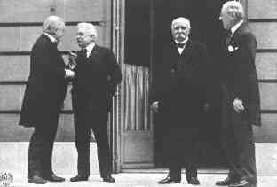
- The “Big Four”

- Not represented

Wilson’s Idea
- The Fourteen Points-
- Self-determination-
Peace or Revenge?
- GB & Fr showed little signs of agreeing to the 14 Pts
- More concerned w/ nat’l security & stripping Ger of its ability to wage war
- June 28, 1919-
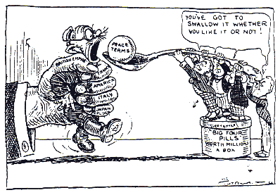
Treaty of Versailles
- League of Nations-

- Article 231-
- Placed responsibility for war on Ger.
- Had to pay war reparations
Effects of the Treaties

- Former colonies are upset b/c they are not given independence
- Japan & Italy did not receive as much land as they had hoped for their efforts in the war
“A peace built on quicksand”
What effect might these complaints have later??

The Legacy of the War
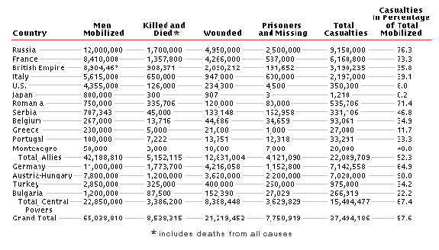
Total Costs of the War

Weapons weren’t the only cause of major deaths during the war…
1918 Flu Pandemic: Depletes All Armies
- Killed
But there was another major event that everyone seems to have forgotten……
1915: Armenian Massacre
What is Genocide?

Background Info
- Young Turks/Ottomans vs Armenians
- Problem #1
- Turks=
- Armenians=
- Problem #2
- 1880s-

- Problem #3
- 1914-WWI erupts
- Young Turks/Ottomans support-
- Armenians support-
Results of the Massacre

- Many women /children raped
- By 1923-
- Turkey still denies these atrocities

