The
Enlightenment
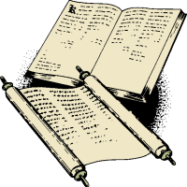
Name:
Date:
Global 10R/Period:

Imagine that you and all of the other students in your grade are going on a class trip to China. All of the students board a plane, but your teachers have to take another flight. When you’re flying over the middle of the Pacific Ocean the plane’s engines malfunction and you crash on a deserted island. The pilot and crew parachuted out of the plane before it landed, but miraculously all of the students survived.  The island has enough food and fresh water on it for everyone, but after a week of waiting it is clear that no one is going to come and rescue you. The lack of rules have created tension between your classmates and you decide that a government is needed. | Desert island that you now call home.  Source: https://commons.wikimedia.org/wiki/File:LakshadweepIsland.jpg

1. Why do you need a government? | Do you remember….?  What would Louis XIV, absolute monarch of France (r. 1654-1715) recommend?  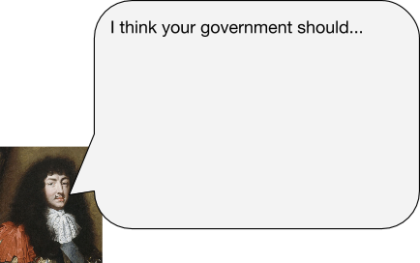
2. What should the government do for you and your classmates?
3. What limits should there be on the government?
The Age of Enlightenment began in Europe in the late 17th century. It would bring about fundamental changes in the way the world was understood and how societies were organized. Until then, the church had dictated [told people] what to think and how to live. Descent [disagreeing with those in power] was punished even by death. But with the Enlightenment, people began to embrace new ideas about freedom of expression and new rational methods to investigate the world. In England, Newton made the foundations of science as we know it by showing that the universe was governed by physical laws that could be discovered using observation and reason. In philosophy, Enlightenment thinkers like Voltaire and Diderot argued that man, not God, was at the center of the world. Ideas were beginning to change, but in the 18th century most of Europe was still [ruled by] absolute monarchs. Empowered by enlightenment thinking in both Europe and America people began to demand real change. | 1. Based on reading, what organization had the most influence on how people in Europe lived and what they thought?  2. What changes came about as a result of the Enlightenment?
What caused the Enlightenment? Why did it take place from the mid-1600s to the late 1700s?
1. Protestant Reformation and Scientific Revolution Influence | 2. Increased Book Production and Literacy | 3. Urbanization, Salons, and Coffee Houses
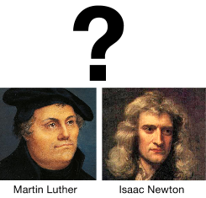 | 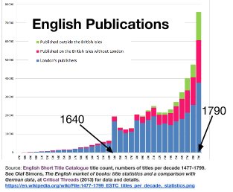 | 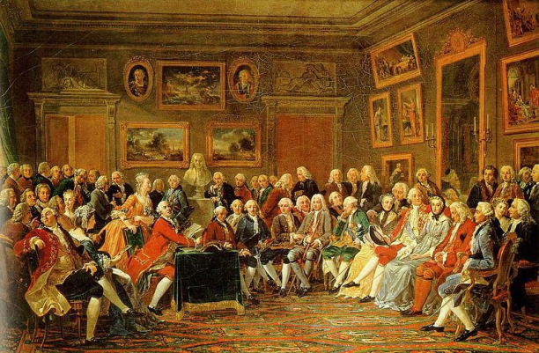  The picture shows a gathering of Enlightenment thinkers in the salon of French hostess Marie-Thérèse Rodet Geoffrin (1699-1777) for a reading of one of Voltaire’s writings. Voltaire was in exile in England so he is represented by the statue in the center-left of the painting.  Source: Anicet-Charles-Gabriel Lemonnier, 1812. https://en.wikipedia.org/wiki/File:Salon_de_Madame_Geoffrin.jpg
Martin Luther’s actions in the Protestant Reformation challenged the Catholic Church’s hold on power by translating the Bible into common languages and encouraging people to read it for themselves instead of having priests translate it for them.  Isaac Newton and other scientists used observation and reason to explain the true nature of the world which often proved the Catholic Church’s claims wrong. | Johannes Gutenberg invented his printing press around 1440. That invention made it easier and less expensive to produce books. It was very important in spreading Martin Luther’s ideas during the Protestant Reformation.  During the Enlightenment, book production increased even more and literacy rates, the percentage of people who were able to read, also increased. | During the 1700s, the process of urbanization (people moving to cities and the growth of those cities) increased in Europe. As more people moved to cities they found places to socialize and discuss ideas.  Coffee was a newly popular drink in Europe and intellectuals from the upper and middle classes like the philosophes came to coffee houses to drink it and discuss politics and religion.  Upper class intellectuals also exchanged ideas in salons, gatherings, usually at someone’s home where the guests came to listen to readings and discuss a specific topic.
Based on the information above, summarize what the mid-1600s to late 1700s were like in Western Europe and explain why this time period was ripe for the Enlightenment.

Enlightenment Thinker | Mnemonic  a helpful way to remember something | Most Famous Writing | Most Well-Known Ideas
John Locke (1632-1704)  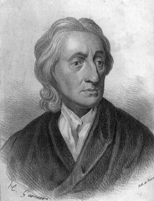 | Locke: Life, Liberty, and Land (Property)
Baron de Montesquieu (1689-1755)  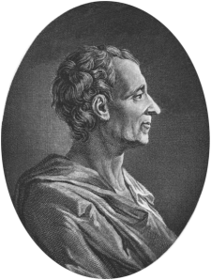 | Mont-es-quieu  Three Syllables! Three Branches of Government!
Jean-Jacques Rousseau (1712-1778)  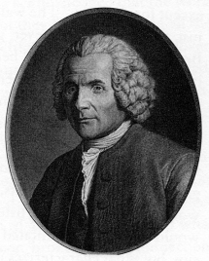 | Rousseau  His name has two s’s in it. His big idea starts with an s, Social Contract.
Voltaire (1694-1778)  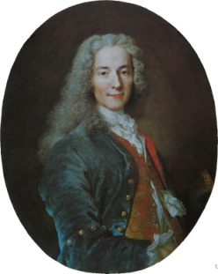 | Voltaire  His name starts with a “v” just like the word VOICE and Voltaire supported the freedom of expression.

