Name: Date:
Global 10/Period: Europe Face Rev. Notes
DIRECTIONS: Use the video found on my YouTube channel, my site or by scanning the QR code.
Europe Faces Revolution
The Effects of Nationalism

Liberal and Conservative Ideas in the 1800s
Liberals | Issue | Conservatives
 | Who should rule
 | Goals of Government
 | Form of Government
 | Economy
 | Religion

Rise of Nationalism
- Nationalism-
- Nation-state-
Bonds That Create a Nation-State

Greek Independence
- Balkans-

- 1821-Greeks demanded independence
- 1827- British, French & Russian fleets destroyed Ottoman fleet
- 1830-Treaty to guarantee independent kingdom of Greece
Revolutions of 1830s
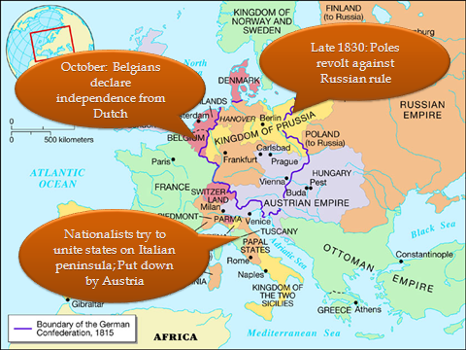
The big picture…
Revolutions basically UNSUCCESSFUL
Revolutions of 1848
More Revolution in France

- 1830-Charles X tried to return Fr. to an absolute monarchy
- Riots

- 1848-
- Monarchy

- One wants ONLY pol. reform; Other wants pol., soc. & econ. Reform
- Late 1848-Moderate constitution
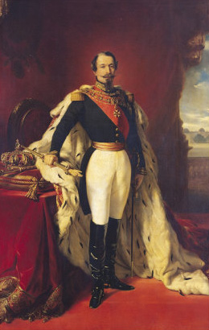
Another Napoleon?
- Dec. 1848-
- 1852-
- Fr. prospers
Russia’s Lack of Development Becomes Obvious
- 1800s-
- Feudal system

- Ex. Poles, Ukrainians, Jews, Romanians, Turks, etc
- Nationalistic feelings of these groups led to Russification
- Russification-
Issues Under Nicholas I
- 1825-Decembrist Revolt

- Extreme oppression by czar
- 1853-
- Loses in 1856
Alexander II’s Reform & Reaction

- 1861-
- Peasant communities-
- Nobles-

- 1881-Assassinated
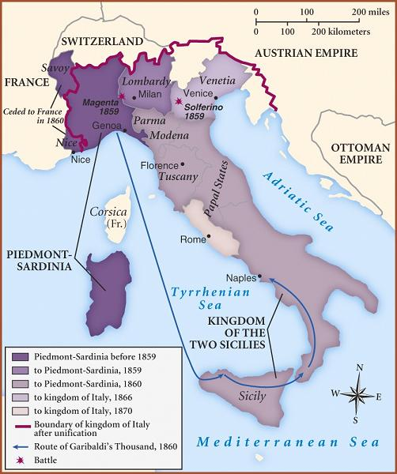
Unification of Italy
- 1850s-
- Lgst, most powerful of the Italian states
- Count Camillo di Cavour-
- Wanted control of n. Italy
- Sardinians w/ Fr. help to take n. Italy from Austria EXCEPT Venetia

- 1860-
- 1866-Venetia added
- 1870-Papal states added
Unification of Germany
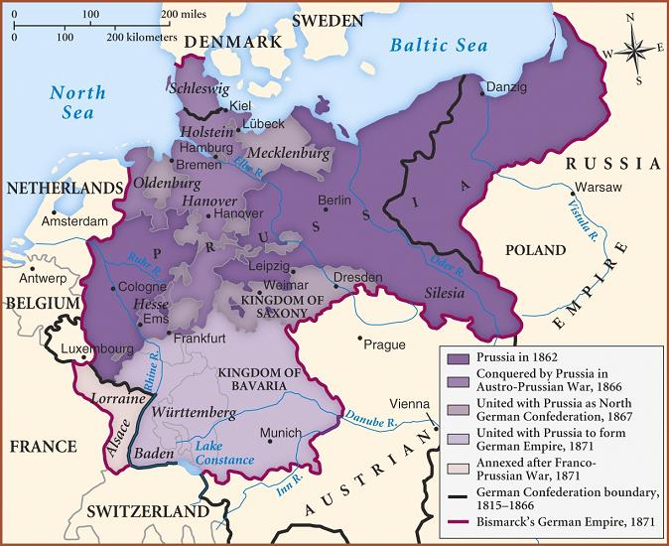
- 1815-
- Prussia wanted unification
- Otto von Bismarck-

- Realpolitik-
- Rules w/o Parl. Consent
- Seven Weeks War (1866) -Prussia wins victory against Austria over Schleswig & Holstein
Franco-Prussian War
- 1870-Bismarck implied that a Fr. Ambassador insulted the Prussian king
- July 19-
- Sept-Pr. takes 83000 Fr. prisoners inc. Nap. III
- January 18, 1871-

- Kaiser-
- German empire called the Second Reich

