**SOURCE 1**

First the economic factor …While the empire was expanding, its prosperity was fed by plundered wealth and by new markets in the semibarbaric provinces. When the empire ceased to expand, however, economic progress soon ceased…. The abundance of slaves led to growth of the *latifundia,* the great estates that … came to dominate agriculture and ruin the free *coloni* (farmers) who drifted to the cities, to add to the unemployment there. The abundance of slaves kept wages low.

**Source:**  *Uses of the Past* by Herbert J. Muller.

**SOURCE 2**

More important in initiating the process of decline was a series of plagues that swept over the empire… which brought diseases [from] southern Asia to new areas like the Mediterranean, where no resistance had been established even to contagions such as the measles. The resulting diseases decimated the population. The population of Rome decreased from a million people to 250,000. Economic life worsened in consequence. Recruitment of troops became more difficult, so the empire was increasingly reduced to hiring Germanic soldiers to guard its frontiers. The need to pay troops added to the demands on the state’s budget, just as declining production cut into tax revenues.

**Source:** Peter Stearns, Michael Adas, Stuwart Schwartz,

Marc Lason Gilbert, *World Civilizations: The Global Experience*, Pearson Education, 2000.

**SOURCE 3**



**SOURCE 4**



**SOURCE 5**

During the latter years of the empire farming was done on large estates called latifundia that were owned by wealthy men who used slave labor. A farmer who had to pay workmen could not produce goods as cheaply. Many farmers could not compete with these low prices and lost or sold their farms. This not only undermined the citizen farmer who passed his values to his family, but also filled the cities with unemployed people. At one time, the emperor was importing grain to feed more than 100,000 people in Rome alone. These people were not only a burden but also had little to do but cause trouble and contribute to an ever increasing crime rate.

**SOURCE 6**

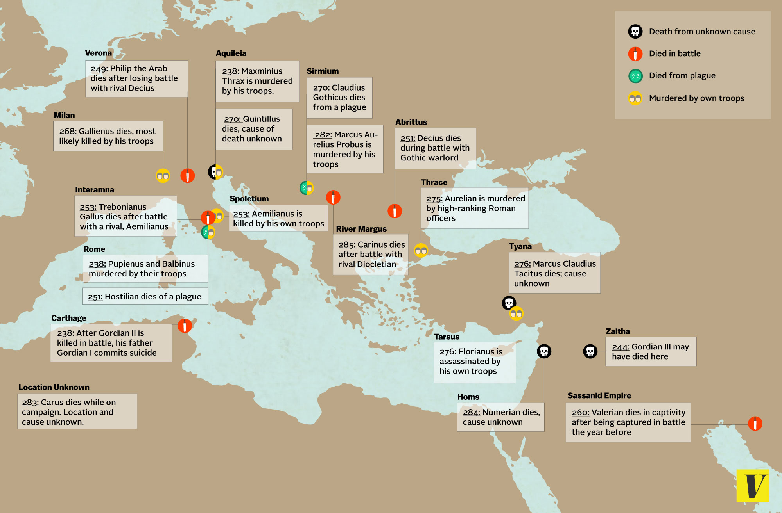

#### The third century AD was a bad time to be a Roman emperor

For the first two centuries after Augustus became emperor in 27 BC, the Roman Empire experienced a period of unprecedented political stability and economic prosperity. But the situation deteriorated rapidly in the third century AD. Between 235 and 285, Rome had more than 20 emperors, and as this map shows, most died violent deaths. Some were murdered by their own armies. Others died in civil wars against rival claimants to the throne. One died in battle against foreign foe; another was captured in battle and died in captivity. It wouldn't have been surprising if this cycle of bloodshed had led to the dissolution of the empire. But in 285, Emperor Diocletian took power and managed to get the empire out of its tailspin. In a 20-year reign, he (temporarily) ended the cycle of bloodshed and instituted reforms that allowed the empire to endure until the late 400s.

**SOURCE 7**

The Roman economy suffered from inflation (an increase in prices) beginning after the reign of Marcus Aurelius. Once the Romans stopped conquering new lands, the flow of gold into the Roman economy decreased. Yet much gold was being spent by the Romans to pay for luxury items. This meant that there was less gold to use in coins. As the amount of gold used in coins decreased, the coins became less valuable. To make up for this loss in value, merchants raised the prices on the goods they sold. Many people stopped using coins and began to barter to get what they needed. Eventually, salaries had to be paid in food and clothing, and taxes were collected in fruits and vegetables.

**SOURCE 8**

#### http://cdn3.vox-cdn.com/assets/4837836/dividedempire.jpg

#### The empire is divided between East and West

Constantine ruled over a unified Roman empire, but this would be increasingly rare. Upon Constantine's death in 337, the empire was divided among Constantine's three sons, who quickly began fighting among themselves. This cycle would repeat itself several times over the next half-century. It became clear that the empire was too big for any one man to rule. The last emperor to rule a united empire, Theodosius, died in 395. This map shows the result: an empire permanently divided between east and west. Why had the empire become too big to govern? The empire never fully recovered from the political crisis of the third century, or from a plague that began in 250 and killed millions of people. Rome's economy was hit hard. By 400, it simply wasn't possible for a single emperor to raise a large enough army to protect a domain that stretched from Spain to the Middle East.

**SOURCE 9**

Maintaining an army to defend the border of the Empire from barbarian attacks was a constant drain on the government. Military spending left few resources for other vital activities, such as providing public housing and maintaining quality roads and aqueducts. Frustrated Romans lost their desire to defend the Empire. The empire had to begin hiring soldiers recruited from the unemployed city mobs or worse from foreign counties, often the ones that the Romans were fighting. These were called mercenaries. Such an army was not only unreliable, but very expensive. The emperors were forced to raise taxes frequently which in turn led again to increased inflation.

**SOURCE 10**

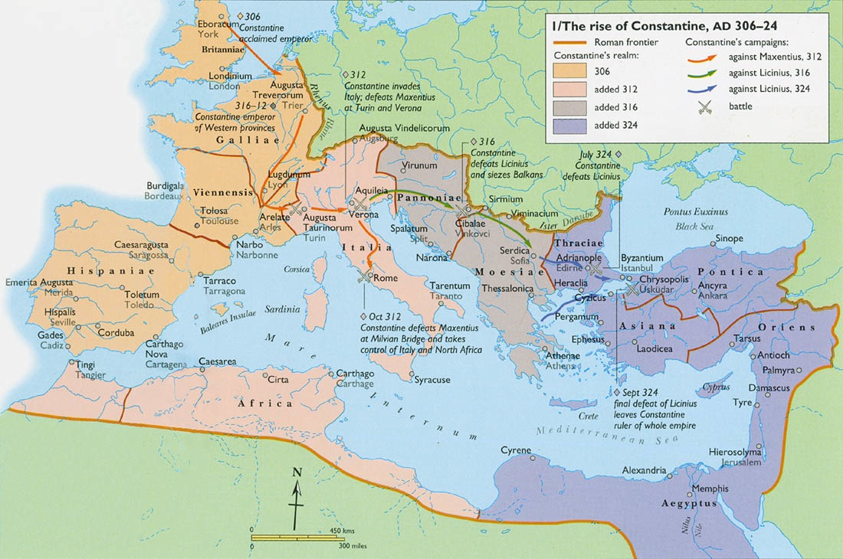

**Constantine takes power and Christianizes the empire**

Diocletian set up an imperial structure called a "tetrarchy," in which power was shared among four emperors. He wanted to provide more localized leadership for an empire that had become too sprawling and complex for any one man to manage. But after Diocletian's death in 311 AD, the tetrarchy became a bloody tournament bracket for choosing Rome's next emperor. The winner was Constantine, who made some profound changes to the empire after he became Rome's sole emperor in 324. He created a new imperial capital at Byzantium and renamed it Constantinople, laying the foundations for an Eastern Roman Empire that would endure long after the West fell. Even more important, Constantine was Rome's first Christian emperor. When he took the throne, he began the transformation of Rome into a Christian empire. While some of his subjects resisted Christianity, the change ultimately stuck. As a result, Christianity became the dominant religion of Europe for the next 1,500 years.

http://www.vox.com/2014/8/19/5942585/40-maps-that-explain-the-roman-empire

**SOURCE 11**

Emperors like Nero and Caligula became infamous for wasting money on lavish parties where guests ate and drank until they became ill. This became known as “Bread and Circuses” where the empire paid welfare and entertainment for the increasingly poor population.

The most popular amusement was watching the gladiatorial combats in the Colosseum. These were attended by the poor, the rich, and frequently the emperor himself. As gladiators fought, vicious cries and curses were heard from the audience. One contest after another was staged in the course of a single day. Should the ground become too soaked with blood, it was covered over with a fresh layer of sand and the performance went on.