Why did the Roman Empire fall? How did this lead
to the development of Medieval Europe and the Byzantine Empire?
Objective: Students will describe the causes for the fall of the Roman Empire and the emergence of divergent societies
(feudal Western Europe and Byzantine empire).

They Say | I Say (with sentence stems/questions)
- There were several reasons for the decline including: invasions, increased taxes, political instability | 1. Identify two causes for the decline of the Roman Empire.
- The Roman Empire did not just fall one day. Instead, it slowly declined over several hundred years. | 2. Given your knowledge of the Roman Empire, why did it take several hundred years for the Roman Empire to fall?
- During these years of decline, emperors attempted to make reforms or changes to make things better to prevent the Roman Empire from completely falling apart.  - Emperor Diocletian: In 284 CE, he decided that the empire was too large and should be split into an Eastern and Western province. Each province would have its own emperor. Diocletian kept the wealthy Eastern province for himself and gave the weaker and poorer province to another emperor. | 3. Describe Diocletian's reform.  4. Would this reform have a positive or negative effect on the Western province of the Roman Empire?
- During these years of decline, emperors attempted to make reforms or changes to prevent the Roman Empire from completely falling apart.  - Emperor Constantine: In 330 CE, he established the new Roman Empire capital called Constantinople in the Eastern province. The Eastern province of the empire became the center of power. | 5. Describe Constantine's reform.  6. Would this reform have a positive or negative effect on the Western province of the Roman Empire?
- Despite all these reforms, by 476 CE, the Western province of the Roman Empire fell. | 7. The Eastern province of the Roman Empire did not decline as drastically. Based on what you’ve read, why do you think the Western province fell?
Following the fall of the Western province of the Roman Empire, divergent societies emerged in Europe.
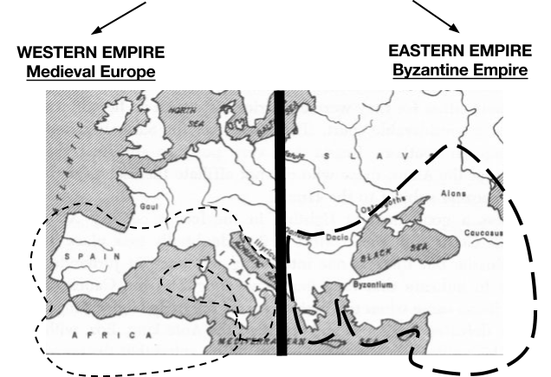

Brainstorm: What do you think life was like after 476 CE in Medieval Europe? Why? | Brainstorm: What do you think life was like after 476 CE in the Byzantine Empire? Why?

