Name: Date:
Global 9R/Period: European Feudalism
DIRECTIONS: Use the video found on my website or YouTube channel (https://youtu.be/BLewNBqhzpI) to complete the notes and then answer the questions at the end.
The Middle Ages
European Feudalism & the Age of Chivalry

Rise of Feudalism
- 800-1000 - Invaders destroy Carolingian Empire

Vikings

- Used sea to invade
- Warships
- 1000-
- ~500 yrs before Columbus
- End of raids due to:

- Warming trend in Scandinavia
Magyars & Muslims
- Magyars-

- Good horsemen
- Invaded in late 800s
- Sold captives as slaves
- Muslims-

- Attempt not only to conquer but also plunder

Effect of Invasion

- Kings were ineffective in defending their ppl

Leads to….

What is Feudalism?

- Based on obligations btw groups of ppl
There are Three Functions of Feudalism…
1. POLITICAL:

- Provides stability
How does Feudalism provide stability?
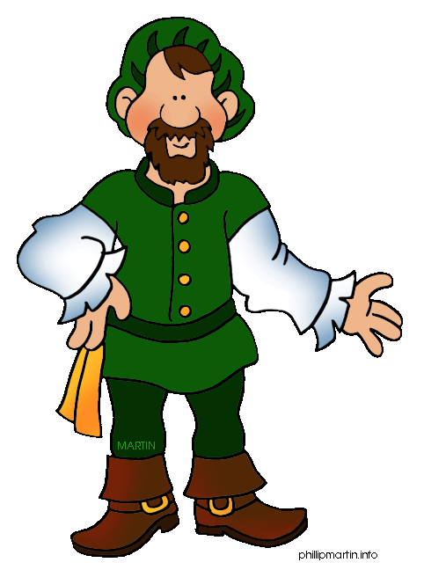

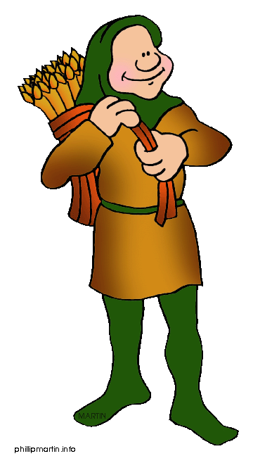
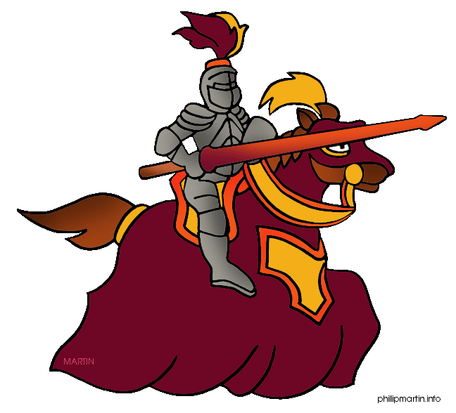

- Lord-
- Serf-
- Vassal-
- Fief-
2. SOCIAL:

The Feudal Pyramid
- King
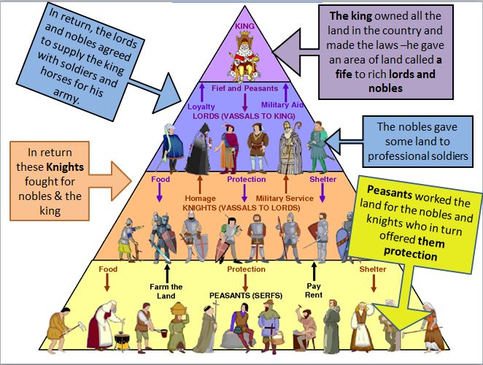
- Lords-
- Nobles
- Bishops
- Knights

- Peasants

- Serfs-

What was the Age of Chivalry?

- Required fighting bravely for three masters

- Protect the weak and poor
A Knight’s Training
- 7 yrs old-
- Waited on hosts
- Began to practice fighting skills
- 14 yrs old-
- Servant for a knight
- ~21 yrs old-
- Practiced fighting skills at tournaments
3. ECONOMIC:

- Manor-
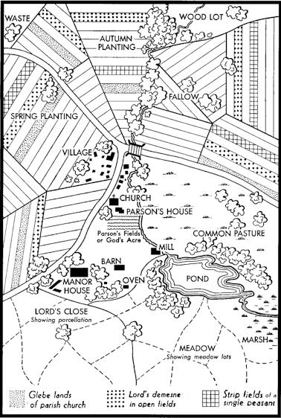
Manors: The Economic Side of Feudalism
- Usually consisted of

- 3 field system:

- Manor Taxes
- On all grain ground in the lord’s mill
- Tithe-

Life on the Manor
- Large families

- Lived in small two-room cottages

The big idea…

After watching the entire video, answer the following questions:
- Why did the people of western Europe turn to feudalism?

- What were the roles of each of the social classes in European feudalism?

