Name: Date:
Global 10/Period: Pre-revolutionary France Doc. Investigation

What were the social, economic, and political problems in pre-revolutionary France?
Objective: Describe the social, economic, and political problems in pre-revolutionary France.

Directions: As you examine the documents about pre-revolutionary France, take down notes, write down direct quotes from the documents, or paraphrase what you read in the chart below. Group the information into “social,” “economic,” and “political” categories

Social | Economic | Political
Document Set #1: The Estates System
The estates system was the class structure in France before the French Revolution. Though feudalism was no longer the organizing force in most of Europe in the 1700s, the same groups that held power during the Middle Ages still had control.

Vocabulary
clergy | people who work for the church like the Pope, bishops, and priests | commoners | people in a low social and/or economic class
nobility | wealthy landowners and people with high status in society | caricature | a picture, description, or imitation of a person or think that exaggerates certain features to be funny
bourgeoisie | the middle class; during the French Revolution this was a group in the Third Estate made up of educated professionals like lawyers and doctors

Document 1a  The Three Estates In Pre-Revolutionary France  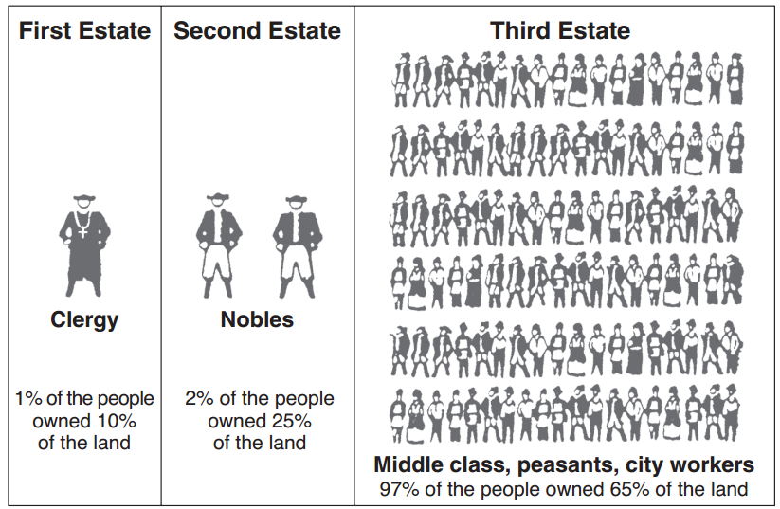  Chart showing the “estates,” classes in France before the French Revolution.  Source: Schwartz and O’Connor, Democracy and Nationalism, Globe Book Company (adapted) from the NYS Global History and Geography Regents Exam, August 2007 | 1a. Based on the chart, identify which groups of people make up each estate.  First Estate Second Estate Third Estate  1b. What percentage of the population of France made up the Third Estate?  1c. When combined, what percentage of France’s population were the First and Second Estates? How much of the land in France did they own?  1d. If you were a member of the Third Estate, how would you feel about the “estates system?” Why would you feel that way?
Document 1b  The Three Estates in Pre-Revolutionary France  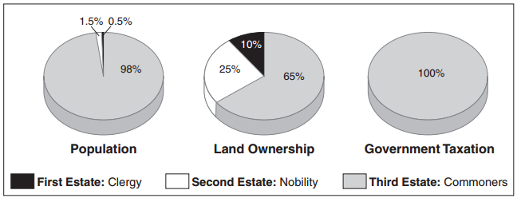  Source: Jackson J. Spielvogel, World History, Glencoe/McGraw-Hill, 2003 (adapted) from the NYS Global History and Geography Regents Exam, January 2007. | 1e. What does the amount of land that a group of people owns suggest about how wealthy they are?  1f. Based on the graphs to the left identify the percentage of the taxes collected by the French government that each of the estates paid in the table below.  First Estate Second Estate Third Estate  1g. If you were a member of the Third Estate, how would you feel about taxation in the “estates system?” Why would you feel that way?
Document 1c  Unknown artist, political cartoon about The Three Estates, You Should Hope this Game Will Be Over Soon, 1788  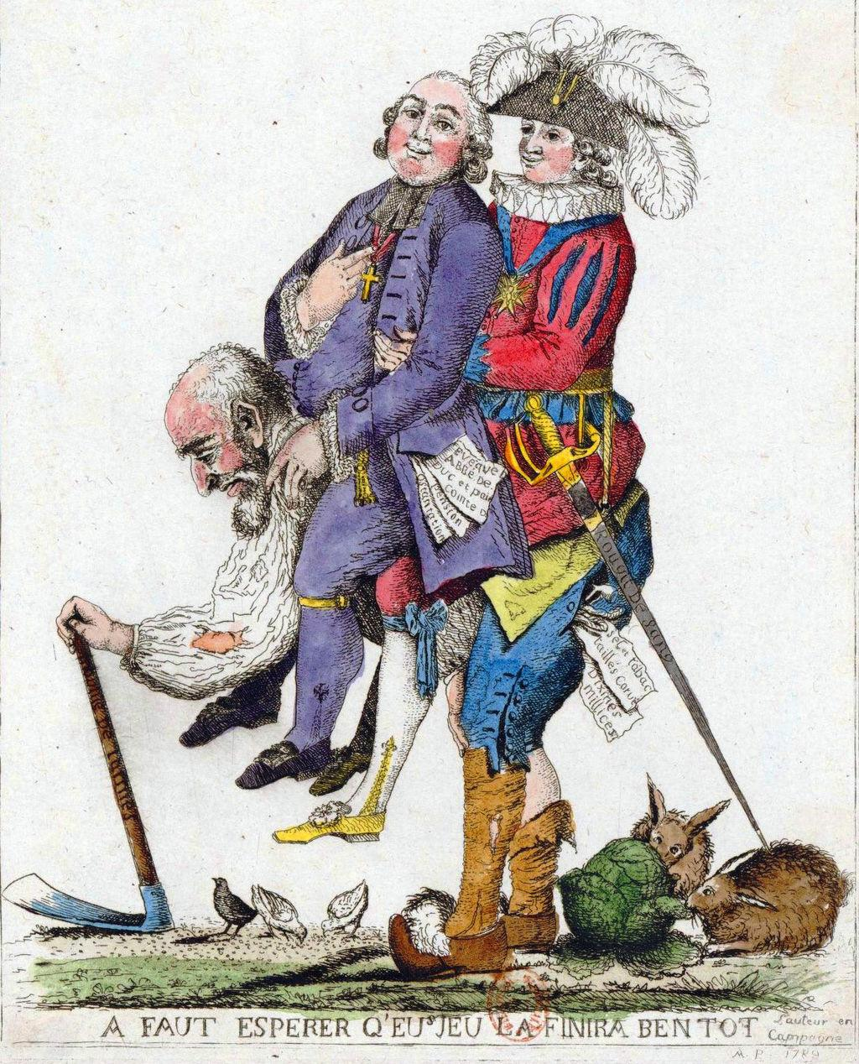  Source: Reproduced with permission from the National Museum of France from the NYS Social Studies ToolKit. http://www.c3teachers.org/inquiries/frenchrev/ | 1. Identify each of the figures from this cartoon below and provide your reasons why.  Who/what does this figure represent? Who/what does this figure represent? Who/what does this figure represent?  How do you know? How do you know? How do you know?  2. The title of this cartoon is “You Should Hope this Game Will Be Over Soon.” Who do you think you refers to in the title? Why?  3. Why is the old man carrying the two other men on his back? What does this represent?  4. How might someone from the First Estate, Second Estate, and Third Estate have reacted to this image in 1788? Would their reactions be different? If so, in what ways?
Document Set #2: Absolute Monarchy and Life at the Palace of Versailles
Document 2a  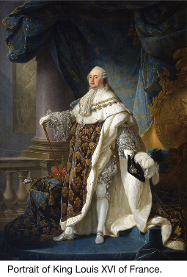  . . . Powers of the king.—The King, Louis XVI, was absolute. He ruled by the divine right theory which held that he had received his power to govern from God and was therefore responsible to God alone. He appointed all civil officials and military officers. He made and enforced the laws. He could declare war and make peace. He levied taxes and spent the people’s money as he saw fit. He controlled the expression of thought by a strict censorship of speech and press. By means of lettres de cachet (sealed letters which were really blank warrants for arrest) he could arbitrarily [without reason] imprison anyone without trial for an indefinite period. He lived in his magnificent palace at Versailles, completely oblivious to the rising tide of popular discontent [frustration]. . . .  Image source  Text source: Friedman & Foner, A Genetic Approach to Modern European History, College Entrance Book Co., 1938 from the NYS Global History and Geography Regents Exam, January 2007. | 2a. What was the divine right theory?  2b. List five of Louis XVI’s powers as the King of France and place a checkmark in the appropriate column for the powers that Enlightenment Thinkers would not support and those that might worry members of the Third Estate.  Powers Not supported by the Enlightenment Worrisome for the Third Estate  1.  2.  3.  4.  5.  2c. If you were a member of the Third Estate who read and agreed with the Enlightenment Thinkers, how would you feel about Louis XVI?
Document 2b  The Palace of Versailles was a royal château [castle] in Versailles and was the center of political power in France from 1682 until 1789. Louis XVI and his wife Marie Antoinette lived in the palace before the French Revolution. They were known for throwing lavish parties.  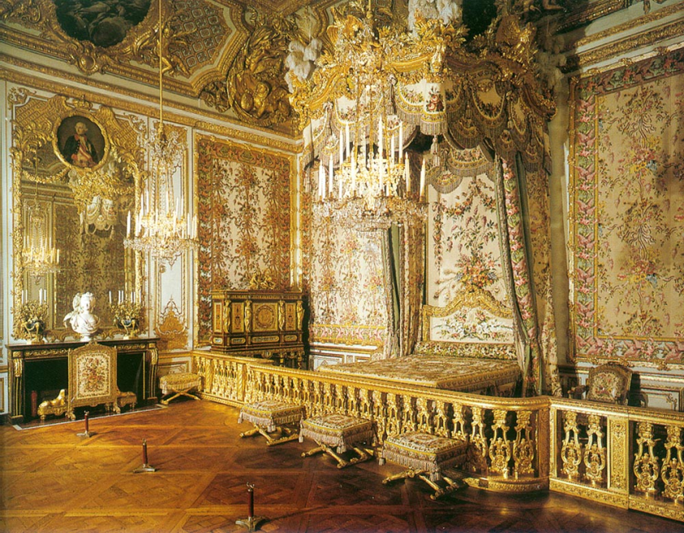  The Queen’s Chamber.  Source: https://en.wikipedia.org/wiki/File:Versailles_Queen%27s_Chamber.jpg  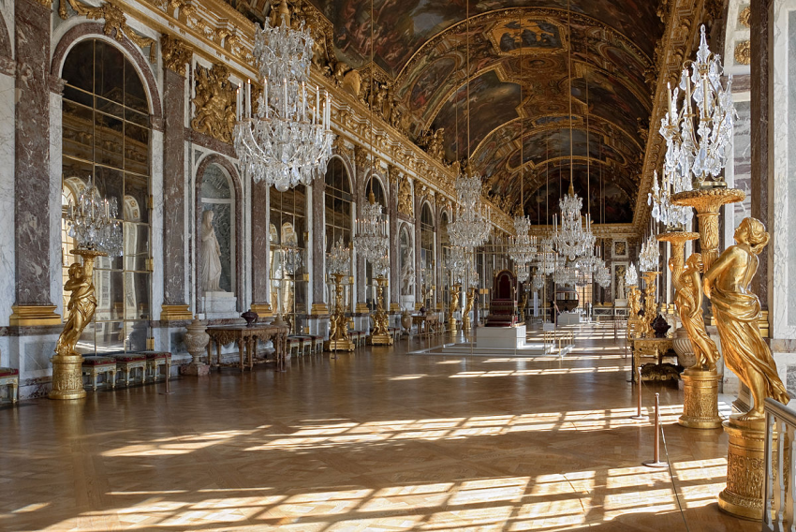  The Hall of Mirrors at the Palace of Versailles  Source: https://en.wikipedia.org/wiki/File:Chateau_Versailles_Galerie_des_Glaces.jpg | 2d. Based on the images of the Palace of Versailles, describe the lives of the royal family (Louis XVI, Marie Antoinette, and their children).

Document Set #3: The Lives of the Third Estate
Document 3: Travels in France (1792) by Arthur Young  Arthur Young was an English gentleman farmer who visited France at the start of the French Revolution. His goal was to determine "the cultivation, wealth, resources, and national prosperity" of France by describing what he witnessed.  July 12, 1789  . . . The 12th. Walking up a long hill, to ease my mare [female horse], I was joined by a poor woman, who complained of the times, and that it was a sad country; demanding her reasons, she said her husband had but a morsel of land, one cow, and a poor little horse, yet they had a franchar (42 lb.) of wheat, and three chickens, to pay as a quit-rent [a payment that allowed the husband and wife to continue to use their land] to one Seigneur [noble]; and four franchar of oats, one chicken and 1 sou [small unit of money] to pay to another, besides very heavy tailles [taxes on the land and its produce] and other taxes[…] It was said, at present, that something was to be done by some great folks for such poor ones, but she did not know who nor how, but God send us better, car les tailles & les droits nous ecrasent [because the taxes and laws are crushing us]. —This woman, at no great distance, might have been taken for sixty or seventy, her figure was so bent, and her face so furrowed [wrinkled] and hardened by labour, — but she said she was only twenty-eight. An Englishman who has not travelled, cannot imagine the figure made by infinitely the greater part of the countrywomen in France; it speaks, at the first sight, hard and severe labour[…] To what are we to attribute this difference in the manners of the lower people in the two kingdoms [England and France]? To Government . . . .  Source: Miss Betham-Edwards, ed., Arthur Young’s Travels in France During the Years 1787, 1788, 1789, G. Bell and Sons (adapted) from the NYS Global History and Geography Regents Exam, January 2007. | 3a. The “poor woman” that Arthur Young meets on the road says that France, or at least the region she lives in is “a sad country.” Identify two reasons why she says that.  3b. Arthur Young states that there is a great difference between the “lower people” in England and France. Who does he blame for that difference? Why?  3c. Compare the life of the woman Arthur Young met to the lives of Louis XVI, Marie Antoinette, and other members of the First and Second Estates.

Document Set #4: Bad Harvests, National Debt, and the calling of The Estates General
Vocabulary
grievance | a cause for complaint or protest especially for unfair treatment

Document 4a  On the eve of the French Revolution, France’s government was in enormous debt. King Louis XIV (1638-1715), Louis XV (1710-1774), and Louis XVI (1754-1793) added to the debt, borrowing money to finance the following:  Date Event that Increased the French Debt  1678-1789 Building of, additions to, and upkeep of the Palace of Versailles  1756-1763 Seven Years’ War Fought against their rivals at the time, Great Britain, and several other European powers in Europe and North America.  1775-1783 American Revolution France lended 1.3 billion livres, soldiers, and ships to the American colonists in their fight against the British.  1678-1789 Extravagant lifestyles of Louis XVI and Marie-Antoinette | 4a. What did the kings of France spend money on that put the country into debt?  4b. Often to pay back debt, a government will do two things. One, they will cut back on the amount of money they spend. Two, they will raise taxes. Based on Document 1b, if the king raised taxes in 1789, who would have to pay them?  4c. If you were a member of the Third Estate, how would you feel about the country’s debt problem? Who would you blame?
Document 4b  Watch The French Revolution Documentary from the History Channel (20:30-23:32) and read the transcript below then answer the questions to the right.  (20:02) Narrator: Versailles in the late seventeen hundreds is an oasis of extravagance [wealth]. Surrounded by a land in despair and with an uncertain king at the helm, France is charting a course for disaster.  (20:16) After nineteen years of marriage Louis has sired four children, yet as a king he remains impotent [unable to act]. As the financial crisis escalates all the king can do is hire and fire a succession of administrators, none of whom have the answers. By ancient privilege, the nobility and clergy are exempt from taxation and so as taxes rise to cover the government's mounting debt repayments the burden falls heavily upon the poorest.  20:49 To add to their misery, freakish weather arrives to decimate the harvest.  William Boyle: “If ever God had intervened to make a situation worse the summers or 1788 and spring of 1789 is a moment when that happens. By the summer of 1788, you already have a burgeoning political crisis and it's developing against the background of very serious food shortage.”  (21:13) Narrator: For the people of France in 1788, bread is the essence of life itself.  Lynn Hunt: “Most ordinary people in France ate at least two pounds a day of bread. Bread was all-important. Its price was immediately felt by everyone, if the price doubled you're in big trouble.” Under the financial mismanagement of Louis’ government, the cost of bread skyrockets. Food supplies are hoarded by profiteers and the cost of a loaf of bread can soon equal a month's wages.  (21:51) Hunger turns to rage. Bread riots break out across France. Bakeries are raided and shopkeepers suspected of hoarding bread are lynched on the spot. | 4a. How did King Louis XVI try to solve the country’s financial crisis?  4b. What happened in the summer of 1788 and spring of 1789 to make the financial situation worse? What were the effects of these events?  4c. Why was bread so important in France?  4d. What was the result of the rise in bread prices in 1788-1789?
Document 4c: Louis Calls the Estates General  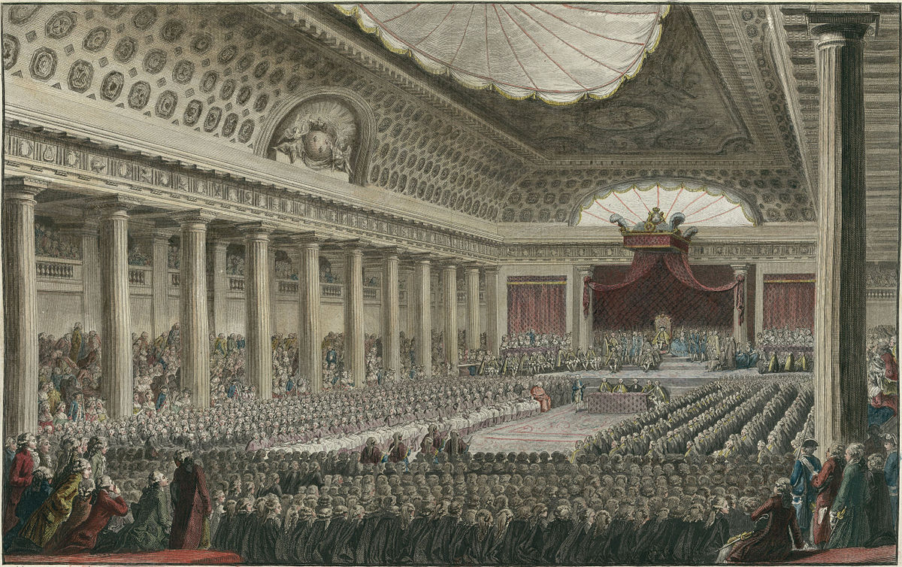  The opening of the Estates General May 5, 1789 in the Salle des Menus Plaisirs in Versailles.  Source: https://en.wikipedia.org/wiki/File:Estatesgeneral.jpg  Estates-General of 1789  In the late 1700s in France, the king needed approval from a group of noble judges called the Parlement of Paris to pass new taxes. In an attempt to solve the country's debt problems and larger financial crisis, Louis XVI proposed to tax the First and Second Estates for the first time. The Parlement was not in favor of the tax because its members were from those estates.  Since the King and Parliament could not come to an agreement, they decided to convene the Estates General, an old institution that had not been assembled since 1614, 175 years beforehand, to settle the issue.  The Estates General was an assembly of representatives from each of the three estates from areas all over France. When the Estates General met on May 5, 1789, one quarter of the representatives were from the First Estate, one quarter were from the Second Estate, and half were from the Third Estates, but each estate received only one vote. So, even though the Third Estate had half of the delegates, they were always outvoted by the First and Second Estates, 2 to 1.  Source: Adapted from “French Revolution.” New World Encyclopedia. http://www.newworldencyclopedia.org/entry/French_Revolution#Estates-General_of_1789 | 4e. What did King Louis XVI propose to solve the country’s debt problem?  4f. Why did the Parlement reject Louis’ idea?  4g. What was the Estates General? Who was a part of it?  4h. If you were a delegate at the Estates General from the Third Estate, what would you think of the voting system? Why?

Document 4d  The Cahiers de Doléances, better known simply as Cahiers, were lists of grievances written by the three Estates in France in 1789 for the convening of the Estates General. King Louis XVI asked each of the Estates to compile cahiers. Below is an excerpt of one of the cahiers from the district of Carcassonne.  The third estate of the electoral district of Carcassonne very humbly petitions his Majesty to take into consideration these several matters, weigh them in his wisdom, and permit his people to enjoy, as soon as may be, fresh proofs of that benevolence [goodwill; kindness] which he has never ceased to exhibit toward them and which is dictated by his affection for them...:  8. ...the nation should hereafter be subject only to such laws and taxes as it shall itself freely ratify [approve].  9. The meetings of the Estates General of the kingdom should be fixed for definite periods...  10. In order to assure to the third estate the influence to which it is entitled in view of the number of its members, the amount of its contributions to the public treasury, and the manifold[many] interests which it has to defend or promote in the national assemblies, its votes in the assembly should be taken and counted by head.  11. No order, corporation, or individual citizen may lay claim to any pecuniary [financial] exemptions. … All taxes should be assessed on the same system throughout the nation.  12. The due [tax] exacted from commoners holding fiefs [land] should be abolished, and also the general or particular regulations which exclude members of the third estate from certain positions, offices, and ranks which have hitherto [until now] been bestowed on [given to] nobles either for life or hereditarily [based on family relations]. A law should be passed declaring members of the third estate qualified to fill all such offices for which they are judged to be personally fitted.  14. Freedom should be granted also to the press, which should however be subjected, by means of strict regulations to the principles of religion, morality, and public decency. …  Source: Copyright © Hanover Historical Texts Collection. Used by permission of Hanover College, Hanover, IN from the NYS Social Studies ToolKit. http://www.c3teachers.org/inquiries/frenchrev/ | 1. What are the Cahiers de Doléances? Who were they written by? Why were they written?  2. Why do you think the authors of this cahier introduce the document with phrases like “very humbly petitions,” “weigh them in his wisdom,”and “fresh proofs of that benevolence [goodwill; kindness]?”  3. In grievance 10 the authors write that “its votes in the assembly should be taken and counted by head.” What do you think “by head” means in this context? Why would members of the Third Estate what this?
 | 4. Paraphrase each of the grievances listed below, then explain why members of the Third Estate would include that grievance in the cahiers.
 | Paraphrase of Grievance | Why would the Third Estate make this request?
 | 8.
 | 9.
 | 10.
 | 11.
 | 14.

