Who was Mohandas Gandhi and what did he believe?
Objective: Describe who Mohandas Gandhi was and what he believed, and identify what actions he took.

Who was Mohandas Gandhi? What were his political beliefs?
Watch the Biography.com Mini Bio on Mohandas Gandhi and answer the questions below.
Key Vocabulary In Mohandas Gandhi’s Biography
nonviolence
civil disobedience

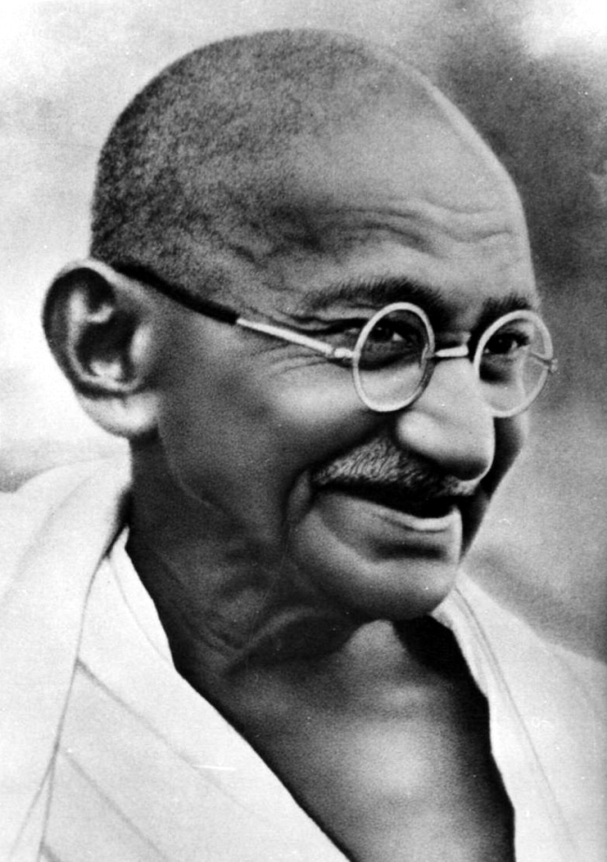  Mohandas Gandhi, 1946  Source: https://commons.wikimedia.org/wiki/File:Gandhi_smiling_R.jpg | 1. What was Gandhi’s profession? Where was he trained?
 | 2. Describe Gandhi’s experiences and actions in South Africa.
 | 3. Identify and describe three actions Gandhi took to support Indian Independence from Great Britain.

How did India gain independence?
Objectives: Explain how India gained its independence from Great Britain.

Directions: Examine each event on the timeline below and answer the questions embedded.

Timeline of India’s Independence Movement
 | - 1885 | Indian National Congress Founded  A group of seventy-three mostly well-to-do and western-educated Indians who were lawyers, teachers, and journalists, met in Bombay to form the Indian National Congress in 1885. At first, this group supported the British Raj and met to discuss issues that were concerns for urban and elite Indians but were not controversial. They wrote papers suggesting changes to the British colonial government and submitted them for review but they had little success.  In the early 1900s, a sense of nationalism grew in the members of the Indian National Congress. Some Congressmen supported the British but wanted more say in the government and administration in India. Others advocated for Swaraj, or self-rule. In the early 1900s, those still loyal to the British won out.  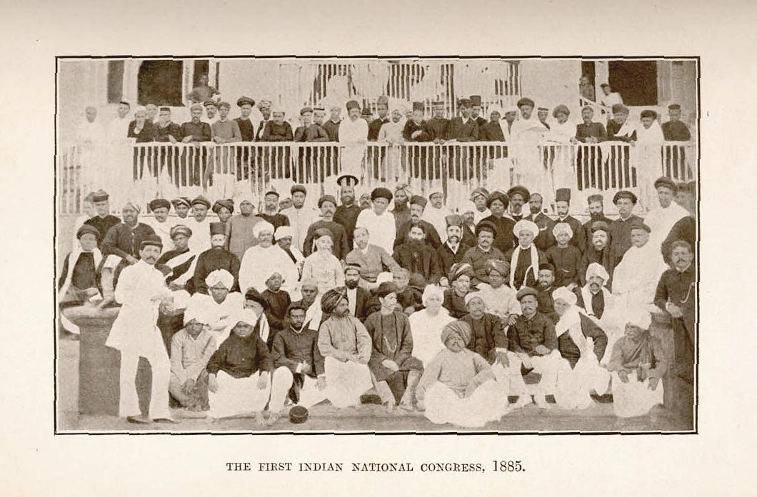  The delegates to the first meeting of the Indian National Congress in Bombay, 1885.  Source: https://en.wikipedia.org/wiki/File:1st_INC1885.jpg  1. Who was a part of the Indian National Congress?  2. What was the goal of the Indian National Congress in the early 1900s?
 | - 1906 | Muslim League Formed  The Indian National Congress was dominated by Hindu Indians and their concerns. In response to Hindu nationalism, leading members of the upper class Muslim community formed the Muslim League in 1906. Like the Indian National Congress, the Muslim League petitioned the British for more say in the government for Indian Muslims and for laws and policies that would favor the people they represented.  3. How was the Muslim League different than the Indian National Congress?  4. What was the purpose of the Muslim League?
 | - 1914-  1918 | World War I & the Rowlatt Acts  What promises did the British make during WWi? Did they follow through on those promises? Explain.  What were the Rowlatt Acts?
 | - April 1919 | Amritsar Massacre  Watch this dramatization of the Massacre of Amritsar from the film Gandhi (1982) and read the text below.  The Massacre of Amritsar, also called Jallianwalla Bagh Massacre, occurred on April 13, 1919. British troops fired on a large crowd of unarmed Indians in Amritsar in the Punjab region of India, killing several hundred people and wounding many hundreds more. It marked a turning point in India’s modern history, in that it left a permanent scar on Indo-British relations and was the prelude to Mohandas (Mahatma) Gandhi’s full commitment to the cause of Indian nationalism and independence from Britain.  The Rowlett Acts, initiated in 1919, were met by widespread anger and discontent among Indians, notably in the Punjab region. In early April, Gandhi called for a one-day general strike throughout the country. In Amritsar, the news that prominent Indian leaders had been arrested and banished from the city sparked violent protests in which soldiers fired upon civilians, buildings were looted and burned, and angry mobs killed several foreign nationals and severely beat a Christian missionary. A force of several dozen troops commanded by Brigadier General Reginald Edward Harry Dyer was given the task of restoring order. Among the measures taken was a ban on public gatherings.  On the afternoon of April 13, a crowd of at least 10,000 men, women, and children gathered in an open space known as the Jallianwalla Bagh, which was nearly completely enclosed by walls and had only one exit. It is not clear how many people there were protesters who were defying the ban on public meetings and how many had come to the city from the surrounding region to celebrate Baisakhi, a spring festival. Dyer and his soldiers arrived and sealed off the exit. Without warning, the troops opened fire on the crowd, reportedly shooting hundreds of rounds until they ran out of ammunition. It is not certain how many died in the bloodbath, but, according to one official report, an estimated 379 people were killed, and about 1,200 more were wounded. After they ceased firing, the troops immediately withdrew from the place, leaving behind the dead and wounded.  Source: "Massacre of Amritsar". Encyclopædia Britannica. Encyclopædia Britannica Online.  Encyclopædia Britannica Inc., 2016. Web. 29 Feb. 2016  <http://www.britannica.com/event/Massacre-of-Amritsar>.  8. Why were people protesting in Amritsar? Why were there troops in Amritsar?  9. Why is the Massacre of Amritsar historically important?
 | - 1920s-  1940s | Homespun Movement  Great Britain’s efforts to modernize the Indian economy brought industrial manufacturing to the colony through the building of textile factories. The move benefited British factory owners, but it greatly diminished India’s traditional economy. People who once made a living by making cloth could not compete with inexpensive machine-made British goods.  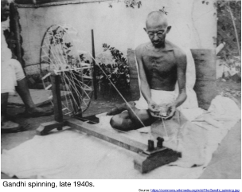  Gandhi argued that India needed to be self-sufficient and so they would not have to not rely on the British. One of way of doing this, he claimed was for Indians to make their own clothes. The push for Indians to give up buying British textiles and to make their own clothes was called the Homespun Movement. Gandhi led the movement by example. He made all of his own clothing and carried a portable spinning wheel with him so he could continue the practice while traveling.  11. Why did Gandhi encourage Indians to spin their own cloth?
 | - 1930 | The Salt March  Read the transcript below, then watch this dramatization of the Salt March from the film Gandhi (1982).  Video Transcript:  Violence begets violence, but a rebellion need not rely on guns to be successful, as Gandhi proved during his Salt March, the most peaceful rebellion.  The sea: the abundant, free resource at land's end. Among its potential gifts: untold quantities of salt waiting to be distilled, but for the poor of India in the early 20th Century, even this basic necessity of life-- salt-- was not a given.  [Salt} was being heavily taxed by their British rulers. Indians could even be thrown in jail for just making or selling this vital preservative. In 1930, Mahatma Gandhi saw this injustice as the perfect opportunity to practice the kind of passive resistance he called "satyagraha.” By satyagraha, Gandhi meant "truth force." He meant mobilizing the power of truth. So in other words, he had to find a way in which the people would free themselves, yet wasn't violent..  On March 12, the 61-year-old Gandhi set out with 78 followers on a 240-mile trek to the sea. For 23 days, they marched, thousands upon thousands of his countrymen joining along the way. Eventually, the throng of protesters reached over two miles.  GANZ: “Ultimately then, you reach the sea and, "What's he going to do? Is he going to break the law?" And sure enough, they go down and with this wonderful simplicity, they make salt. The law's been broken. Wait a second. You mean British law can be defied? Yes.”  Soon, people all over India were making their own salt. The authorities responded by imprisoning over 60,000 Indians for this illegal activity, including Gandhi himself, but that, too, was part of his plan to make the world aware of British oppression.  India would not gain independence for another years, but Gandhi proved that nonviolent methods on a vast scale could be used to achieve that most basic of human rights: freedom.  The modern and free state of India, the world's largest democracy, is the lasting legacy of Gandhi's Salt March,history's most peaceful rebellion.  Gandhi was assassinated in 1948, but his ideals of peaceful rebellion were passed on to other leaders in the fight for human freedom, including Dr. Martin Luther King. Sadly, he, too, met with an assassin's bullet.  Additional Information:  Soon after the Salt March ended, Gandhi was arrested. The protest against the salt tax continued. Gandhi’s followers nonviolently marching toward the British Salt Works in Gujarat where they were beaten by soldiers employed by the British army.  The Salt March and protests that followed it brought worldwide attention to the Indian Independence movement and British cruelty. The media attention turned public opinion in Great Britain in Gandhi’s favor and led to his release from prison, negotiations with the British government in India, and more support for Indian self-rule.  12. Why did Gandhi lead the Salt March?  13. What did Gandhi achieve through the Salt March?
 | - 1930s | Government Act of 1935 and Elections of 1937  14. What benefits did Indians gain from the Government Act of 1935?
 | - 1939-  1945 | World War II, the Quit India Movement, and Indian National Army  At the outbreak of WWII, the British pulled India into the conflict without consulting the elected Indian representatives. In response, all of the elected Indian officials resigned from the government.  In 1942, Gandhi and the Indian National Congress launched the Quit India Movement, demanding immediate independence for India. In a speech entitled, "Do or Die," given on August 8, 1942, Gandhi urged the masses to act as an independent nation and not to follow the orders of the British. His call found support among a large number of Indians, including revolutionaries who were not necessarily party to Gandhi's philosophy of non-violence. Almost the entire Congress leadership, both at the national and local levels, was put into confinement less than twenty-four hours after Gandhi's speech, and the greater number of the Congress leaders spent the rest of the war in jail. Despite lack of direct leadership, large-scale protests and demonstrations were held all over the country. The British responded with mass detentions, making over 100,000 arrests.  The Quit India Movement died down in a few months, but other groups of Indians started to rebel against the British. A group of Indian soldiers that once fought for the British, switched sides during WWII to fight with the Japanese in an attempt to invade India from the Southeast, defeat the British, and declare India independent. They were unsuccessful, but the attempt showed how deeply Indians disliked British rule. In addition, in 1946 sailors in the Royal Indian Navy revolted against the British, refusing to work, carrying on violent protests, and in some instances taking over ships.  The pressure from the Quit India Movement, recognition that the armed forces were opposed to British rule, and the drain on resources from WWII and the recovery from the that war, led the British to give up their control of India. Soon, they started negotiations with the Indian National Congress and Muslim League to transfer power to India.  16. Identify and explain three reasons the British gave up power in India.
 | - August, 14 1947 | Independence, the Partition of India, and the death of Gandhi  Watch this an excerpt of this documentary on Gandhi (31:52-end) and read the text below.  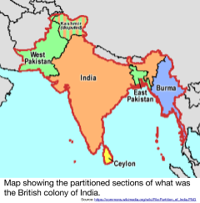  Despite Gandhi’s desire to keep India together, the decision was made to divide the colony into two separate and independent nations: India and Pakistan (more on this in a later lesson). This separation of India and Pakistan is known as the Partition of India.  Pakistan gained its independence on August 14, 1947 and was led by Muhammad Ali Jinnah.  India gained its independence on August 15, 1947 and was led by Prime Minister Jawaharlal Nehru.  17. Why was Gandhi unhappy with the result of India’s Independence Movement?  18. How did Gandhi react to violence between Hindus and Muslims after Partition  19. How did Gandhi die? What reason was given for his death?

Summary Task
In the space below answer the question:
Why did British Rule of India end in 1947?

How did the Partition of India effect the people of India and Pakistan?
Objectives: Explain the effects of the Partition of India on the people of India and Pakistan.

Introduction
Directions: Examine the maps below and answer the questions that follow.
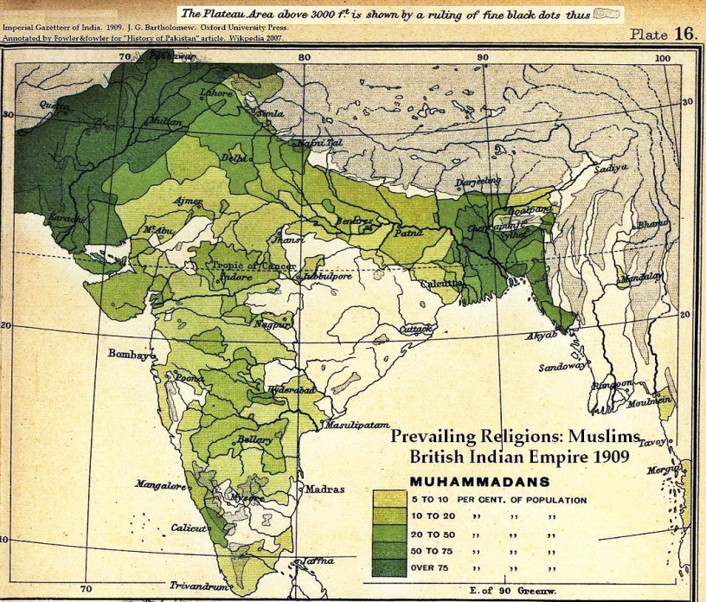  Map A. Prevailing Religions of the British Indian Empire, 1909: Muslims from the Imperial Gazetteer of India, Oxford University Press, 1909.  Source: https://en.wikipedia.org/wiki/File:Muslim_percent_1909.jpg | 1. Where did most Muslims live (provide relative directions like “in the southeast” or “in the western region of India)?  2. If you were to divide India up into a country that is predominantly Muslim and a country that is predominantly Hindu, draw on the map below where you would make the two countries.  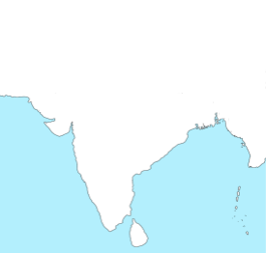  3. Why did you draw the borders of these two countries where you did?  4. What issues might arise if you were to declare the creation of two different countries in this area, each based on a religion?
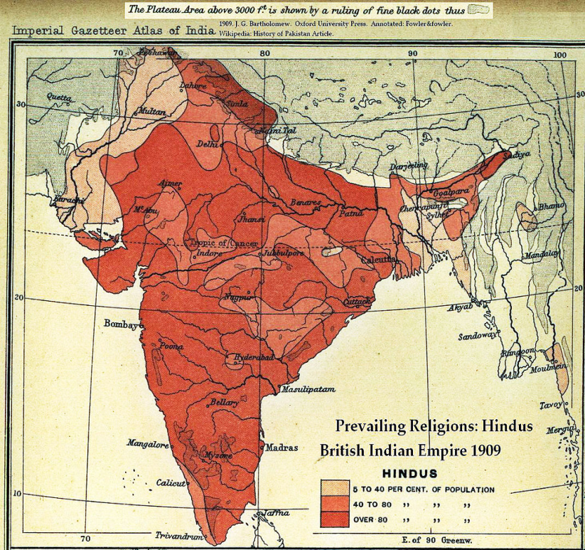
Map B. Prevailing Religions of the British Indian Empire, 1909: Hindus from the Imperial Gazetteer of India, Oxford University Press, 1909.
Source: https://en.wikipedia.org/wiki/File:Muslim_percent_1909.jpg

