Causes of the Industrial Revolution:
Why did the Industrial Revolution start in Great Britain in the 1750s?

The Industrial Revolution (1750 -1850)
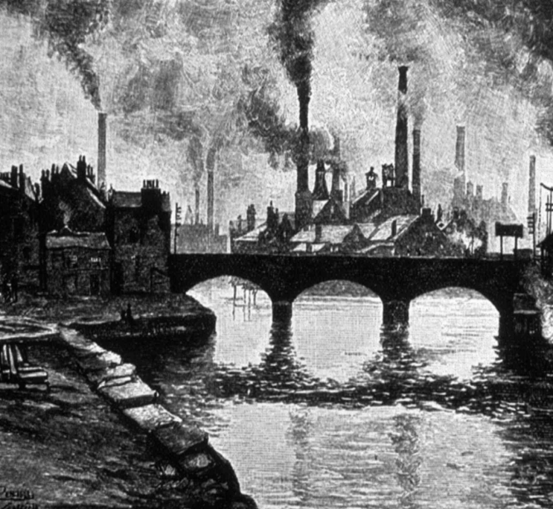 | The Industrial Revolution was the period in which the production of goods shifted from hand production methods to complex machines. This period of industrialization resulted in social and economic changes.  The Industrial Revolution started in Great Britain around 1750. The process of industrialization spread throughout the world in the following centuries. | 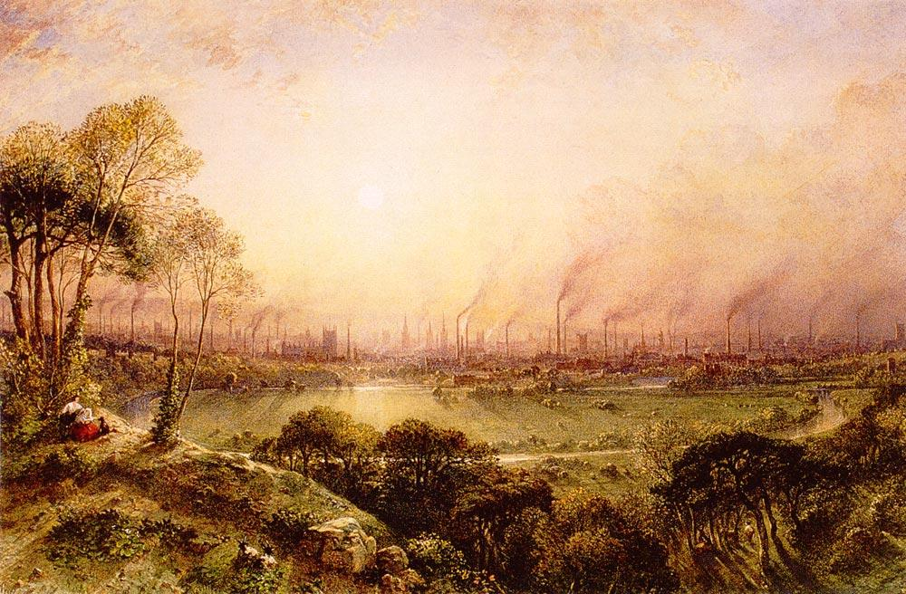

Cause #1: Geography- Location, Geographic Features, and Natural Resources
Geographic Features and Natural Resources
. . .Great Britain...has been fortunate in possessing the natural conditions necessary to success. ... Modern manufactures cluster round coal-fields [and iron mines], where power can be had cheaply; the possession of good harbours is essential to maritime trade; a country where broad and gently-flowing rivers act as natural canals will have advantages in internal communications over a country broken up by mountain ranges. . . and that no part of the country is farther than some seventy miles from the sea....  Source: George T. Warner, Landmarks in English Industrial History, Blackie & Son Limited from the NYS Global History and Geography Regents Exam, January 2003. | 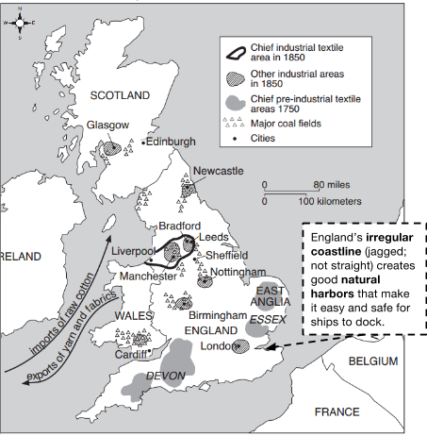  Source: Adapted from Holt and O’Connor, Exploring World History Workbook, Globe Book Company (adapted) from the NYS Global History and Geography Regents Exam, August 2007.
Location
In comparing the advantages of Great Britain for manufactures with those of other countries, we can by no means overlook the excellent commercial position of the country — intermediate between the north and south of Europe; and its insular situation [island location], which, combined with the command of the seas, secures our territory from invasion or annoyance. The German ocean, the Baltic [sea], and the Mediterranean [sea] are the regular highways for our ships; and our western ports command an unobstructed [clear] passage to the Atlantic, and to every quarter [part] of the world.

Source: Edward Baines, History of the Cotton Manufacture in Great Britain, A.M. Kelly from the NYS Global History and Geography Regents Exam, January 2003.
1a. Based on the documents above and map to the right, identify three reasons why Great Britain benefited from its geography?

 | 1b. Predict: Why might Great Britain’s geography have contributed to the start of the Industrial Revolution in Great Britain?

Cause #2: Agricultural Revolution
New tools, fertilizers and harvesting techniques during from the Agricultural Revolution increased productivity which resulted in an increase in population. Innovations, such as the seed drill, made the process of planting seeds easier and more efficient which meant that fewer farmers were needed to produce the same amount of food. Consequently, many farmers migrated to cities which supplied factories with the large labor force they needed to industrialize.
... Many landowners, seeking to increase their income, began experimenting with improved methods of cultivation and stock raising. They made more use of fertilizers (mainly animal manure); they introduced new implements (such as the drill seeder and horse-hoe); they brought in new crops, such as turnips, and a more scientific system of crop rotation; they attempted to breed larger sheep and fatter cattle.  Source: R. R. Palmer, et al., A History of the Modern World, 9th edition, McGraw-Hill from the NYS Global History and Geography Regents Exam, January 2010. | . . . Industrialization transformed the agricultural sector as well...Overall, the trend toward mechanization in agriculture reduced human work in the countryside, leading to greater migration to the cities. . .  Source: Paul V. Adams, et al., Experiencing World History, New York University Press from the NYS Global History and Geography Regents Exam, January 2010.
2a. What were two changes in the methods of food production that occurred during the Agricultural Revolution in Britain? | 2b.What was one effect of the mechanization of agriculture on people?
2c. Predict: Why might the Agricultural Revolution have contributed to the start of the Industrial Revolution in Great Britain?

Cause #3: New Technology
New technological innovation in machinery meant that factories could produce more goods in less time, for less money. The cheaper goods were produced, the more money factory owners made and the faster the Industrial Revolution grew and spread.
. . . Four great inventions altered [changed] the character of the cotton manufacture; the spinning jenny, patented by Hargreaves in 1770; the water-frame, invented by Arkwright the year before; Crompton’s mule [spinning machine] introduced in 1779, and the self-acting mule, first invented by Kelly in 1792, but not brought into use until Roberts improved it in 1825. None of these by themselves would have revolutionised the industry. But in 1769...James Watt took out his patent for the steam-engine. Sixteen years later it was applied to the cotton manufacture. In 1785 Boulton and Watt made an engine for a cotton-mill at Papplewick in Notts, and in the same year Arkwright’s patent expired. These two facts taken together mark the introduction of the factory system.  Source: Arnold Toynbee, Lectures on the Industrial Revolution of the 18th Century in England, Humboldt (adapted) from the NYS Global History and Geography Regents Exam, June 2006. | 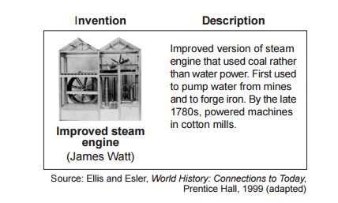  Source: Ellis and Esler, World History: Connections to Today, Prentice Hall, 1999 (adapted) from the NYS Global History and Geography Regents Exam, January 2013.
3a. What was the result of new technology in cotton manufacturing [production]? | 3b. How did the steam engine promote the growth of the factories?
3c. Predict: Why might technological innovation have contributed to the start of the Industrial Revolution in Great Britain?

Cause #4: Colonial Markets for Raw Materials and Goods
As a result of the Age of Exploration, Great Britain became wealthy and powerful, and gained colonies in North and South America, Africa, and South Asia. During the Industrial Revolution, English traders brought raw materials like cotton from its colonies to the factories in Great Britain where they were turned into finished goods. These manufactured goods were then sold throughout Great Britain, Europe, the United States, and back to people living in the British colonies.
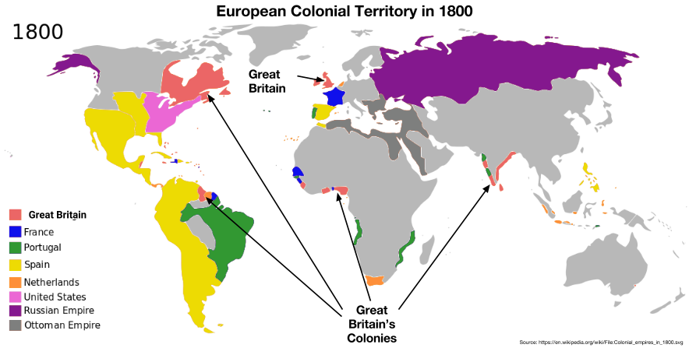
4a. Identify two ways Great Britain benefited from its colonies. | 4b. Predict: Why might Great Britain’s colonies have contributed to the start of the Industrial Revolution in Great Britain?

