What is a GOLDEN AGE?

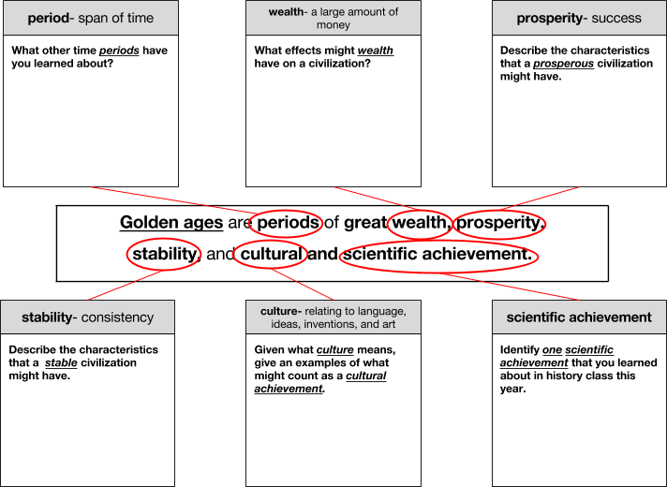
Golden Age | ACHIEVEMENTS and INNOVATIONS
 | Prosperity and Stability | Visual Arts and Architecture |  | Literature, Music, and  Philosophy |  | Science, Mathematics, and  Technology

Gupta Empire (320-

550 CE)

Han Dynasty
(206 BCE - 220 CE)

Golden Age | ACHIEVEMENTS and INNOVATIONS
 | Prosperity and Stability |  | Visual Arts and Architecture |  | Literature, Music, and  Philosophy |  | Science, Mathematics, and  Technology
Greece
(480-
408 BCE) “Age of Pericles”
Rome
(27 BCE- 180 CE)
“Pax Romana”

