Putting into context the Golden Age of Athens (Age of Pericles)

Directions: Examine the timeline, read the text, and watch an excerpt of Secrets of the Parthenon from NOVA [https://vimeo.com/23914660] (14:00- ~18:00) to get an introduction to the Golden Age of Athens, then answer the questions that follow.
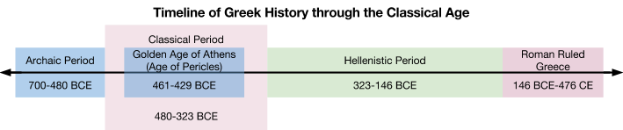

Ancient Greece was divided into many city-states, each with their own culture that often warred with one another. So, it should not be surprising that the golden age of the Greek civilization was not shared between them. Instead, Athens, from 461-429 BCE, dominated the other city-states and prospered as a result. The Golden Age of Athens took place during the rule of a man named Pericles. Through his leadership, Athens experienced a period of artistic and scientific growth, so the golden age is often referred to as the “Age of Pericles.”

1. Who did the Greeks defeat in 480 BCE?

2. What is the name of the military leader who “ushered in the Golden Age of Greece”?

3. What type of government was established in Athens during its golden age?

4. Why was this time period considered a “golden age”?

