How did its geography impact Ancient Greece?
Objective: Describe how geographic factors encouraged
or hindered expansion and interactions within Ancient Greece.
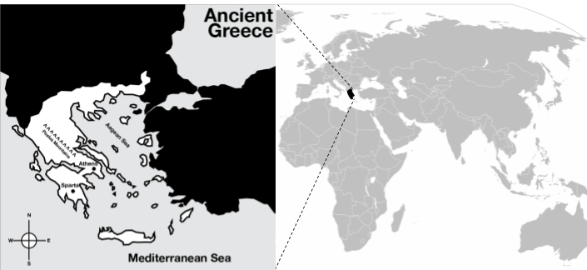

1. Which continent was Greek civilization located on? | 2. Which sea is to the east of Greek civilization? __________________________ | 3. Which sea is south of the Greek civilization? ___________________________
4. What do you know about the area of the world where Ancient Greece was located? Identify any historical or modern-day civilizations or countries in that region or events that have taken place.

Greek civilization began in 1750 BC north of the Mediterranean Sea in Europe.
Greece is in southeastern Europe and consists of a mainland and an archipelago [chain of islands]. Mainland Greece is a large peninsula surrounded on three sides by the Mediterranean Sea (branching into the Ionian Sea in the west and the Aegean Sea in the east).

The geography of Greece greatly influenced the culture in that, with few natural resources and surrounded by water, the people eventually took to the sea for their livelihood. Mountains cover eighty percent of Greece which provides little opportunity for agriculture. As a result, the early Greeks colonized neighboring islands and founded settlements along the coast of Anatolia (also known as Asia Minor, modern day Turkey). The Greeks became skilled ship builders, sailors, and traders to acquire resources they did not have. One benefit of Greece’s trade with other nations was that they encountered the Phoenician alphabet, which they adapted and became the basis for Latin and many other languages including English.

The mountains that covered Greece and the seas between islands also isolated the people of Greece. As a result, Greeks developed individual polis, also known as city-states. City-states were cities with surrounding land and villages. Each city-state was independent and located in an isolated valley. While the Greeks spoke the same language, they had different cultures and government and social structures because they were divided. The mountains separating the city-states were barriers to cultural diffusion and unity. In addition, a lack of resources and differences between the city-states led to rivalry and antagonism that led to wars. The two most well-known city-states were Sparta and Athens.
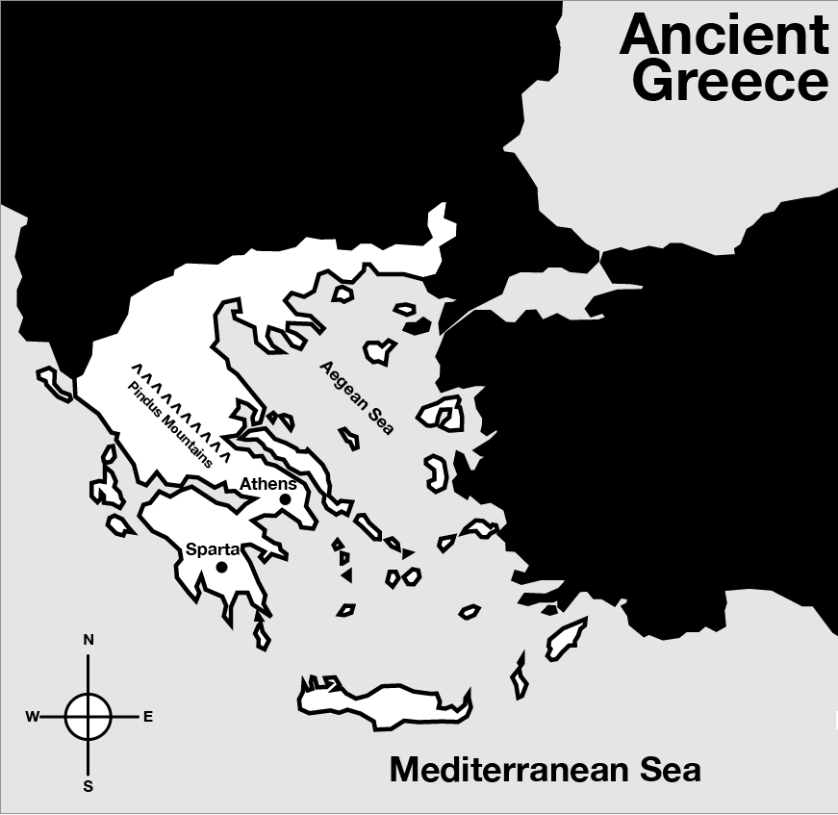
Source: “Ancient Greece.” Ancient History Encyclopedia. http://www.ancient.eu/greece/
- Identify two geographic features that separated the Greek city-states. | - Describe two ways that mountains in Greece affected the Ancient Greeks.
3. Describe two ways that water surrounding Greece affected the Ancient Greeks.
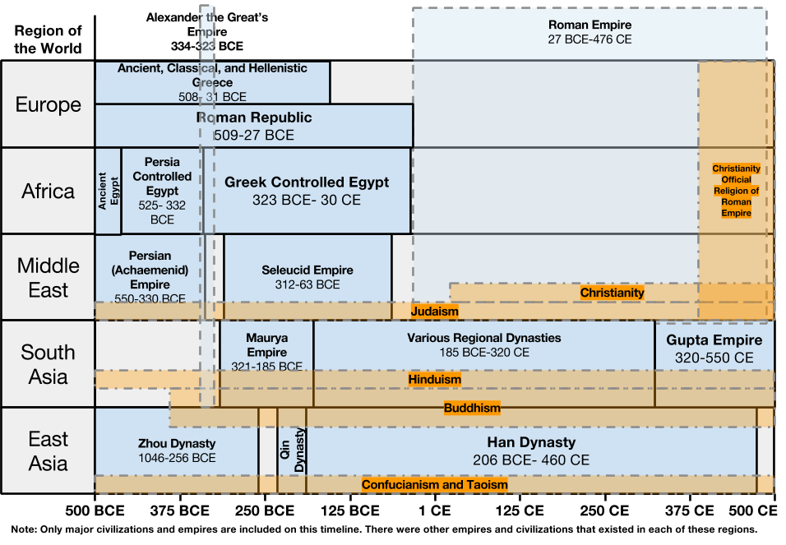
- According to the timeline, how long did the Greek civilization rule? | - What other civilization was ruling in the same area and at around the same time as the Greeks?
- What area did Greece rule outside of Europe? | - List any other civilizations that existed during the time of the Greeks?

