Name: Date:
Global 9/Period: Ottomans & Mughals

The Rise of the Gunpowder Empires
What role did gunpowder play in the development and control of the Ottomans and Mughals?
Connections to Old Knowledge | Information Source | New Knowledge
 | What is a Gunpowder Empire?  The term "gunpowder empire" is usually traced to the work of historian Marshall G. Hodgson, who sought to explain the rise of empires in the Islamic world. He used the term to describe new forms of states that appeared in Turkey, Persia, and Mughal India. According to Hodgson, artillery and other firearms had wide social and political consequences for these states. Because acquiring and maintaining guns demanded a highly developed government administration and extensive financial resources, the use of gunpowder tended to produce highly centralized governments that could buy large quantities of tin and copper, manufacture weapons, and train soldiers in the use of firearms. Other historians have adopted this term to refer to states outside the Islamic region that used gunpowder technology to extend their control over territories that were less advanced technologically.  Gunpowder Empires in History  The Chinese appear to have been the earliest people to make use of gunpowder for warfare. In the thirteenth century, the Chinese developed gunpowder that was high in nitrates and made use of it in cylindrical metal barrels. By the end of the thirteenth or beginning of the fourteenth century, the Chinese were making use of small handguns. The technology quickly made its way to Europe, and the Europeans improved on it to create large cannon. The effectiveness of cannon in warfare led others to take them up eagerly.  The Turkish Ottoman Empire was one of the earliest and longest-lasting of the gunpowder empires promoted by the spread of cannon and other firearms. The Turks had been pushed into the Near East from the eighth century onward by Mughal expansion in their original territory, around what is now Turkestan. At the beginning of the fourteenth century, the Turkish leader Osman I (c. 1258-1326) declared himself sultan, founding the Ottoman Empire. The Ottomans spread their control over the area formerly held by the Eastern Roman Empire, also known as the Byzantine Empire. In 1453, Sultan Mehmed II (r. 1444-1446 and 1451-1481) conquered Constantinople, bringing the Byzantine Empire to an end.  The most well-known sultan of the Ottoman Empire was Sulieman the Magnificent. In addition to bringing the Ottoman Empire to its geographic height, helped to bring order and structure to society. He created a law code to handle both criminal and civil actions. He also used a policy known as devshirme, a policy in which slaves for use in the sultan’s palace were acquired young boys from conquered people whom they converted to Islam and trained to be soldiers in the sultan’s army. Through this they were able to create an elite infantry corps known as the Janissaries. The Janissaries were child slaves taken from Christian parents and raised as Muslims. They were trained to be expert in the use of firearms.  With its capital now in Istanbul, as Constantinople became known, the Ottoman Empire under powerful sultans like Sulieman developed into a centralized government. With the use of firearms to spread its power through most of the Middle East and north and west into the Balkan Peninsula of Europe for a time, it looked as if the guns of the Ottomans would carry them even farther as they attempted sieges into Europe. Although the Turks continued to hold much of the territory they had taken in Europe by the end of the seventeenth century and fought other wars against the Europeans to extend their territory, their empire was in a state of decline until its end in the early twentieth century.  To the east of the Ottomans, the Mughals shaped an Indian empire. The founder of this empire was Bābur (1483-1530), a Turkic prince of Central Asia said to be descended from the conquerors Tamerlane (Timur) and Genghis Khan. Bābur was driven out of Central Asia and descended into northern India, where he established Mughal rule. Bābur's grandson, Akbar, is considered the greatest of the Mughals. Akbar extended his empire to include all of northern and part of central India. His ability to do this resulted from the centralized organization of his political and military structures. The emperor ruled through high officials known as mansabs, who were top administrative or military officials who governed provinces, occupied key bureaucratic positions, or recruited and trained soldiers. Akbar's army relied heavily on the infantry, which was supplied with muskets, and on heavy artillery, using cannon. Much of his success came from the inability of competing powers in India to afford artillery or to train and maintain armed infantry.  Akbar was also well known for being a liberal ruler. Being a Muslim leader in a primarily Hindu region, Akbar was a genius at cultural blending. Despite the fundamental differences between the two religions, he allowed the Mughal people to practice their faiths. He even went so far as to end the tax placed on practicing Hindus and married Hindu princesses without forcing them to convert. Additionally, Akbar welcomed influences of the cultures that he conquered in art, literature and architecture.  Akbar was succeeded by his son Jahāngīr and his grandson Shāh Jahān, builder of the famous Taj Mahal. The Taj Mahal was built over a 22 year period by over 20,000 artisans for the Shah Jahan’s deceased wife. These two rulers maintained the army and administration created by Akbar. Under Jahān, the Mughal Empire is said to have reached its highest point culturally.  SIGNIFICANCE  By the seventeenth century, the advancement of firearms technology by well-organized military forces enabled a small number of states to spread their power over vast portions of the globe. The Ottoman Empire came to dominate much of the Islamic world. Even after centuries of decline, at the beginning of World War I, in 1914, the Ottoman Empire still controlled or influenced much of the Middle East. | Artillery-guns used in warfare on land  According to the paragraph, what is a “gunpowder empire”?  Cylindrical-tube shaped  The Ottoman Empire  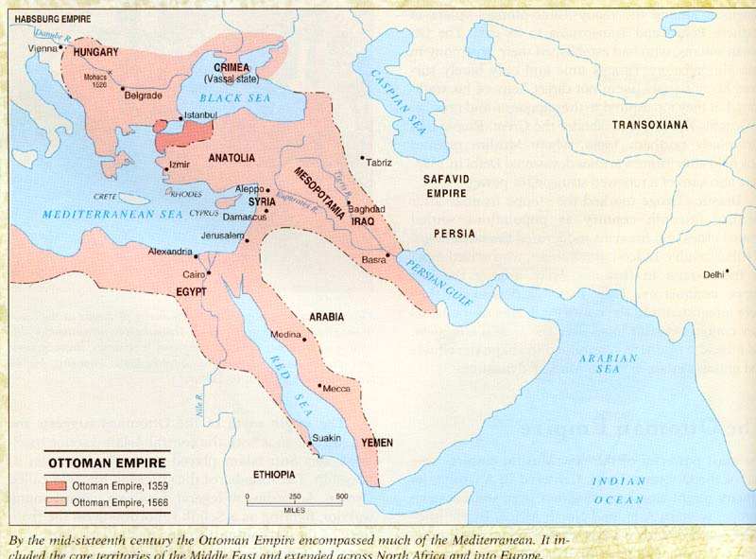  Why is the conquering of the Byzantine Empire in 1453 by Ottomans important?  What did Sulieman the Magnificent do for the Ottoman Empire?  Devshirme-  Janissaries-  Centralized government-unified under a single ruling power  Siege-military operation in which enemy forces surround an area, cutting them off from supplies with the aim of getting their opponent to surrender  The Mughals  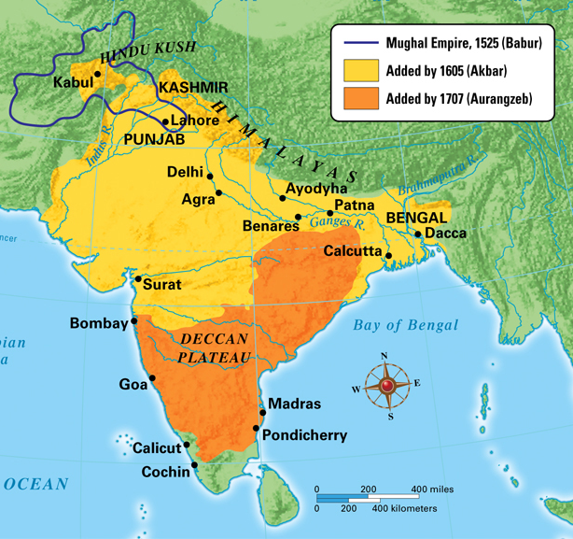  What did Akbar do for the Mughal Empire?  Liberal-going against traditionally held beliefs  Convert-to change

