What can we as historians learn about
Babylonian society from Hammurabi’s Code?

Where was the Babylonian Empire located?
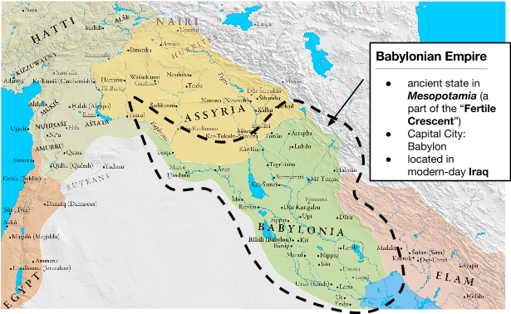
Source: Adapted from http://sitemaker.umich.edu/mladjov/files/mesopotamia1200.jpg
Who was Hammurabi (1795-1750 BCE)?
Hammurabi was the sixth king of Babylon. He became the first king of the Babylonian Empire, extending Babylon's control over Mesopotamia by winning a series of wars against neighboring kingdoms. He was a very efficient ruler, giving the region stability after turbulent times, and transforming what had been an unstable collection of city-states into an empire that spanned the fertile crescent of Mesopotamia.
Source: http://www.newworldencyclopedia.org/entry/Hammurabi
Identify one way Hammurabi established control over Mesopotamia.

An Introduction to The Code of Hammurabi
- The Code of Hammurabi was written around 1780 BCE
- The Code of Hammurabi is the earliest example of written laws
- In 1901 CE, archeologists discovered The Code of Hammurabi

Hammurabi is best known for the promulgation [publishing] of [...] The Code of Hammurabi. This was written on a stele, a large stone monument, and placed in a public place so that all could see it, although it is thought that few were literate. The code of Hammurabi contained 282 laws, written by scribes on 12 tablets. Unlike earlier laws, it was written in Akkadian, the daily language of Babylon, and could therefore be read by any literate person in the city. The Code consists of rules and punishments if those rules are broken. The structure of the code is very specific, with each offense receiving a specified punishment.

[...] A carving at the top of the stele portrays Hammurabi receiving the laws from the god Shamash, and the preface states that Hammurabi was chosen by the gods of his people to bring the laws to them.
Source: http://www.newworldencyclopedia.org/entry/Hammurabi

1a. Pre-Reading Questions: Contextualization
Who wrote The Code of Hammurabi?
When was The Code of Hammurabi written?
Where was The Code of Hammurabi written?
Where was The Code of Hammurabi located? Why was it located there?
Who was the audience for The Code of Hammurabi?
What was the perspective of the author?
(Hint: What is the main interest or goal of the author?)

1b. Why was The Code of Hammurabi written?

1c. Who gave Hammurabi the authority to write and enforce The Code of Hammurabi written?

1d. Why is the The Code of Hammurabi an important historical document?

Document 1: The Code of Hammurabi—Economy
Pre-Reading Task: Babylonia was located in the Fertile Crescent between the Tigris and Euphrates Rivers. This land was excellent for agriculture. Society depended on these crops for trade and feeding the people. As you read, pay attention to how agriculture impacts punishments and rules.

1  2  3  4  5  6  7  8  9 | 53. If any one be too lazy to keep his dam in proper condition, and does not so keep it; if then the dam break and all the fields be flooded, then shall he in whose dam the break occurred be sold for money, and the money shall replace the corn which he has caused to be ruined.  54. If he be not able to replace the corn, then he and his possessions shall be divided among the farmers whose corn he has flooded.  59. If any man, without the knowledge of the owner of a garden, fell [cause to fall] a tree in a garden he shall pay half a mina in money.
Source: “Code of Hammurabi.” Translated by L.W. King. The Eleventh Edition of the Encyclopaedia Britannica. 1915. Found on the Fordham University’s Ancient History Sourcebook: http://www.fordham.edu/halsall/ancient/hamcode.asp

1a. What were the occupation(s) [jobs] of the Babylonians mentioned in Document 2?

1b. Who was punished for the damage caused by flooding if a dam breaks?

1c. Based on Document 2, identify one consequence for damaging someone else’s property in Babylonia.

1d. Explain what this excerpt of Hammurabi’s Code suggest about the economy in Babylonia.

Document 2: The Code of Hammurabi—Social Classes
Pre-Reading Task: As you read, pay attention to how social classes impact punishments and rules.

1  2  3  4  5  6  7  8 | 199. If [a free-born man] put out the eye of a man's slave, or break the bone of a man's slave, he shall pay one-half of its value.  202. If any one strike the body of a man higher in rank than he, he shall receive sixty blows with an ox-whip in public.  203. If a free-born man strike the body of another free-born man of equal rank, he shall pay one gold mina.
Source: “Code of Hammurabi,” 1780 BCE. adapted from STANFORD HISTORY EDUCATION GROUP sheg.stanford.edu

2a. What is the punishment if a man “strike the body” of “another free-born man?”
2b. What is the punishment if a man “strike the body” of a “man higher in rank than he?”
2c. How do the punishments differ if a man “strike the body” of “another free-born man” or a “man higher in rank than he?” Which punishment is more severe?
2d. According to this document, was everyone equal in Babylonia?
Provide two pieces of evidence from the text and explain how they support your claim in 2d.

Evidence | How it Supports Your Claim

2e. Explain what this excerpt of Hammurabi’s Code reveals about social class in Babylonia. _____________________________________________________________________________________________
Document 3: The Code of Hammurabi—Women
Pre-Reading Task: As you read, pay attention to gender impacts punishments and rules.

1  2  3  4  5  6  7  8  9  10  11  12  13  14  15 | 138. If a man wishes to separate from his wife who has borne him no children, he shall give her the amount of her purchase money and the dowry [money or property that a wife’s family gives to her husband when they marry] which she brought from her father's house, and let her go.  141. If a man's wife, who lives in his house, wishes to leave it, plunges into debt, tries to ruin her house, neglects her husband, and is judicially convicted: if her husband offer her release, she may go on her way, and he gives her nothing as a gift of release. If her husband does not wish to release her, and if he take another wife, she shall remain as servant in her husband's house.  143. If she is not innocent, but leaves her husband, and ruins her house, neglecting her husband, this woman shall be cast into the water.  148. If a man take a wife, and she be seized by disease, if he then desire to take a second wife he shall not put away his wife, who has been attacked by disease, but he shall keep her in the house which he has built and support her so long as she lives.
Source: “Code of Hammurabi,” 1780 BCE. adapted from STANFORD HISTORY EDUCATION GROUP sheg.stanford.edu

3a. According to law 141, what happens if a woman wants to leave her marriage but her husband refuses to release her?

3b. According to law 138, what happens to a dowry if a man leaves his wife?
3c. Explain what this excerpt of Hammurabi’s Code reveals about the position of women in Babylonia.

What can we as historians learn about
Babylonian society from Hammurabi’s Code?

Directions: Using information from the documents, respond to the task with regards to excerpts of Hammurabi’s Code addressed in the documents.

Task: Using the information from Hammurabi’s Code and your knowledge of global history complete the follow writing task in paragraph form.

- describe what Babylonian society must have been like based on Hammurabi’s Code
- explain how you came to those conclusions
- use evidence from the text to support your argument

In developing your answer be sure to keep these general definitions in mind:
- describe means “to illustrate something in words or tell about it”
- explain means “to make plain or understandable; to give reasons for or causes of; to show the logical development or relationships of”

