Think  Like a Geographer | 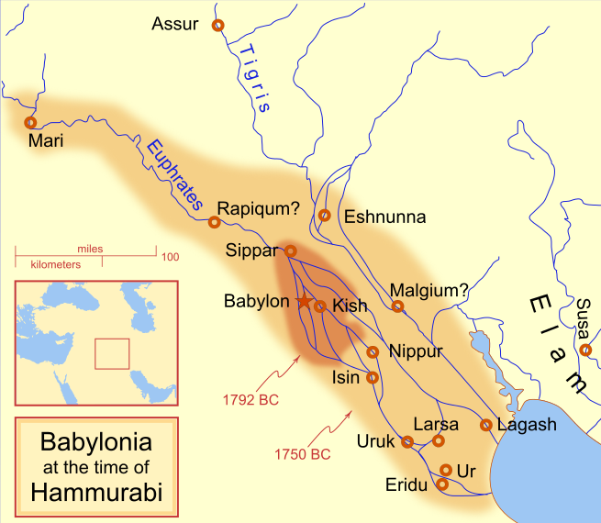  Hammurabi's Babylonia 1.svg by MapMaster is published under the CC BY-SA 4.0 International license | 1. Which geographic feature are most Babylonian cities located near? Why?  2. Did Hammurabi’s territory grow or shrink by 1750 BC? What strategies may have Hammurabi used to cause this change in territory?
What does Hammurabi's Code reveal about
Mesopotamian society under the Babylonian empire?
- Describe what Hammurabi's Code reveals about Mesopotamian society under the Babylonian empire.

Annotate | Who is Hammurabi?  ➡ Directions: As you read, annotate the short excerpt below. Respond to the question below.
diplomacy: the practice negotiating with other nations  empire: several states under the rule of an emperor or empress  kingdom: a country, state, or territory ruled by a king or queen  city-state: a city and its surrounding land and villages | The known history of Babylon begins with its most famous king: Hammurabi (1792-1750 BCE). Hammurabi was the sixth king of Babylon. He made diplomacy, or international affairs, an important part of his administration. He was so effective at diplomacy and war that by 1755 BCE, he had united all of Mesopotamia under the rule of Babylon. At this time, Babylon was the largest city in the world. He created a powerful empire by extending Babylon's control over Mesopotamia through series of wars against neighboring kingdoms. He was an efficient ruler. He created stability after turbulent times and transformed disconnected city-states into an empire that spanned the fertile crescent of Mesopotamia. Hammurabi’s law codes are a well-known example of the many policies he implemented to maintain peace and encourage prosperity. Other policies included enlarging and heightening the walls of the city, and great public works projects such as building temples and canals.  Adapted by New Visions from Hammurabi by Joshua J. Mark which is published on Ancient History Encyclopedia under the CC BY-NC-SA 3.0 Unported license i/
Identify three ways Hammurabi united Mesopotamia, consolidated power, and/or created stability.

Introduction
➡ Directions: Respond to the questions below. Then, turn to your partner and share your responses
 | Your response: | Partner Response:
1. Are laws and rules necessary? Explain.

2. Are punishments for laws necessary ? Explain.

3. Who should be able to write laws and rules?
4. Who should be able to enforce laws?

5. Are all laws and rules fair? Explain.

6. If a law or rule is unfair, what should happen?

What is Hammurabi’s Code?
Watch the Turning Points in Law: Hammurabi’s Code of Law (https://goo.gl/UIpJRo), video and respond to the questions below. (0:00-1:55)
What did you learn about the Code of Hammurabi from the video excerpt?

➡ Directions: Read the excerpt below, then respond to the questions.
literate: able to read | scribes: a person who copies out documents | offense: an illegal act
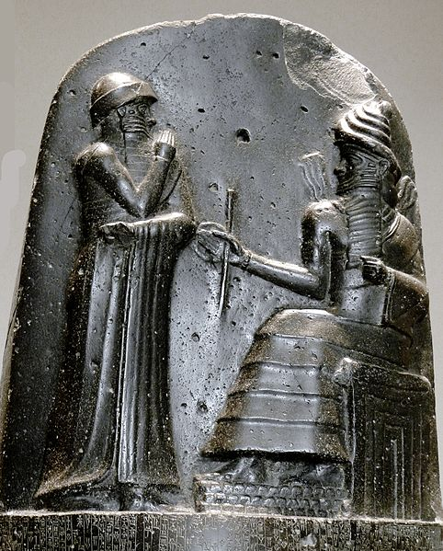
Hammurabi is best known for The Code of Hammurabi. This was one of the first codified or written law codes. It was written around 1754 BC. It was written on a stele, or a large stone monument, and placed in a public place so that all could see it. Even though it was visible for all to see, few were literate enough to read the cuneiform writing. A carving at the top of the stele shows King Hammurabi receiving the laws from the god Shamash. The inscription states that King Hammurabi was chosen by the gods of his people to bring the laws to them.
The code of Hammurabi contained 282 laws. These laws were written by scribes on 12 tablets. The Code consists of rules and the punishments for if those rules were broken. The structure of the code is very detailed: each offense receiving a particular punishment.
Hammurabi’s law code set the standard for future codes because it dealt with the evidence of the crime. What decided one’s guilt or innocence was something called the Ordeal. During the Ordeal, the accused person was sentenced to perform a certain task such as being thrown into a river or swimming a certain distance across a river and, if they succeeded, they were innocent. If they did not survive the ordeal, they were considered guilty.
Adapted by New Visions from Hammurabi by Joshua J. Mark which is published on Ancient History Encyclopedia under the CC BY-NC-SA 3.0 Unported license

Who wrote The Code of Hammurabi? |  | When was The Code of Hammurabi written? Where was The Code of Hammurabi written? | What type of source is The Code of Hammurabi? | Where was The Code of Hammurabi placed? Why was it placed there?
Why was The Code of Hammurabi written? |  | Who gave Hammurabi the authority to write and enforce The Code of Hammurabi written? | How might the Code of Hammurabi be useful evidence in determining what life was like under the Babylonian empire in Mesopotamia? How might it be not useful?
Close Read |  | What can we as historians learn about Babylonian society from the  Code of Hammurabi?
Document 1: The Code of Hammurabi—Economy
Context: Babylonia was located in the Fertile Crescent between the Tigris and Euphrates Rivers. This land was excellent for agriculture. Society depended on these crops for trade and feeding the people.
1  2  3  4  5  6  7  8  9 | 53. If any one be too lazy to keep his dam in proper condition, and does not so keep it; if then the dam break and all the fields be flooded, then shall he in whose dam the break occurred be sold for money, and the money shall replace the corn which he has caused to be ruined.  54. If he be not able to replace the corn, then he and his possessions shall be divided among the farmers whose corn he has flooded.  59. If any man, without the knowledge of the owner of a garden, fell [cause to fall] a tree in a garden he shall pay half a mina in money.
Source: “Code of Hammurabi.” Translated by L.W. King. The Eleventh Edition of the Encyclopaedia Britannica. 1915. Found on the Fordham University’s Ancient History Sourcebook: http://www.fordham.edu/halsall/ancient/hamcode.asp

1a. What were the occupation(s) [jobs] of the Babylonians mentioned in Document 1? | 1b. Who was punished for the damage caused by flooding if a dam breaks? | 1c. Based on Document 1, identify one consequence for damaging someone else’s property in Babylonia. | 1d. Explain what this excerpt of Hammurabi’s Code suggest about the economy in Babylonia.

Citation 5 | Document 2: The Code of Hammurabi—Social Classes

1  2  3  4  5  6  7  8 | 199. If he put out the eye of a man's slave, or break the bone of a man's slave, he shall pay one-half of its value.  202. If any one strike the body of a man higher in rank than he, he shall receive sixty blows with an ox-whip in public.  203. If a free-born man strike the body of another free-born man or equal rank, he shall pay one gold mina.
Source: “Code of Hammurabi.” Translated by L.W. King. The Eleventh Edition of the Encyclopaedia Britannica. 1915. Found on the Fordham University’s Ancient History Sourcebook: http://www.fordham.edu/halsall/ancient/hamcode.asp

2a. What is the difference between a free-born man and a slave? |  | 2b. What is the punishment if a free-born man “strike the body” of “another free-born man?” | 2c. What is the punishment if a man “strike the body” of a “man higher in rank than he?” | 2d. How do the punishments differ if a man “strike the body” of “another free-born man” or a “man higher in rank than he?” Which punishment is more severe? | 2e. According to this document, was everyone equal in Babylonia? Explain.
Citation 6  Citation 7 | Document 3: The Code of Hammurabi—Women

1  2  3  4  5  6  7  8  9  10  11  12  13  14  15 | 138. If a man wishes to separate from his wife who has borne him no children, he shall give her the amount of her purchase money and the dowry which she brought from her father's house, and let her go.  141. If a man's wife, who lives in his house, wishes to leave it, plunges into debt, tries to ruin her house, neglects her husband, and is judicially convicted: if her husband offer her release, she may go on her way, and he gives her nothing as a gift of release. If her husband does not wish to release her, and if he take another wife, she shall remain as servant in her husband's house.  143. If she is not innocent, but leaves her husband, and ruins her house, neglecting her husband, this woman shall be cast into the water.  148. If a man take a wife, and she be seized by disease, if he then desire to take a second wife he shall not put away his wife, who has been attacked by disease, but he shall keep her in the house which he has built and support her so long as she lives
Source: “Code of Hammurabi.” Translated by L.W. King. The Eleventh Edition of the Encyclopaedia Britannica. 1915. Found on the Fordham University’s Ancient History Sourcebook: http://www.fordham.edu/halsall/ancient/hamcode.asp
3a. According to law 141, what happens if a woman wants to leave her marriage but her husband refuses to release her? | 3b. According to law 138, what happens to a dowry if a man leaves his wife? | 3c. How do the punishments differ for a man and a woman?

