Judaism
Geographic Context
Directions: Use the text, video, and maps below to the answer the questions that follow.

The Israelites were a group of people who lived in Middle East. They established a kingdom starting around 1030 BCE-1020 BCE that lasted until it was conquered by the Assyrian empire in 722 BCE. The Israelites were the first people to practice a religion that became known as Judaism.

Source: Adapted from “Kingdom of Israel.” New World Encyclopedia. http://www.newworldencyclopedia.org/entry/Kingdom_of_Israel
Watch IsraelPalestine for Critical Thinkers: #1 Ancient Roots
[https://youtu.be/S2jnvsdF38k]
(start-2:33).

1. Based on the map above, which region of the world was Ancient Israel in? | 2. Describe the relative location of Ancient Israel. Use three other locations to describe where Ancient Israel was.
3. Based on the video, what geographic features were located in Ancient Israel? | 4. Based the video and on your knowledge of Early River Valley Civilizations, why might the Ancient Israelites have settled in the location identified on the map?
5. Based on the “Note” in the map, identify two sources that were used to create this map. What different information do the sources provide about the location and size of Ancient Israel?
Most civilizations in the Middle East at the time of the Ancient Israel practiced polytheistic religions.
Judaism was the first monotheistic religion that continued to exist and impact world history.

Word | Polytheism |  |  | Monotheism
Prefix and Root | Poly | + | theism | Mono | + | theism
Meaning
Examples | Animism is a belief system in which people worship many different natural spirits. For example, some Animistic religions might worship a god of the sun, a volcano, or of the forest. |  |  | Judaism, Christianity, and Islam all worship the same singular god who the Jewish people call “Yahweh,” Christians call “God,” and Muslims refer to as “Allah.”

The Covenant
A covenant is an agreement. Jewish people believe that God made covenants with several figures mentioned in the Torah. The covenants below are between God and the father of Judaism, Abraham.

Now the LORD had said unto Abram, Get thee out of thy country [Egypt], and from thy kindred [relatives], and from thy father's house, unto a land that I will shew [show] thee:
And I will make of thee a great nation, and I will bless thee, and make thy name great; and thou shalt be a blessing:
And I will bless them that bless thee, and curse him that curseth thee: and in thee shall all families of the earth be blessed.[...]
In the same day the LORD made a covenant with Abram, saying, Unto thy seed have I given this land, from the river of Egypt unto the great river, the river Euphrates[...]
And God said unto Abraham, Thou shalt keep my covenant therefore, thou, and thy seed after thee in their generations.
Source: Genesis 12:1- 3; Genesis 15:18- 21; Genesis 17:9- 12; King James Version of the Holy Bible. Retrieved July 28, 2015, from http://www.sacred-texts.com/bib/kjv/gen.htm

1. Based on this section of the Torah, God promised Abraham...

The Ten Commandments
Most belief systems have ethical/moral codes of conduct that describe how one should live their life based on the beliefs of that religion. For Judaism, the Ten Commandments, that appear in the Torah, are the clearest code of conduct. According to the Torah, God inscribed the commandments on two stone tablets and gave them to Moses to share with the rest of the Israelites.

The Ten Commandments
And God spake all these words, saying,
(1) I am the LORD thy God[...]
(2) Thou shalt have no other gods before me. Thou shalt not make unto thee any graven [engraved] image, or any likeness of anything that is in heaven above, or that is in the earth beneath, or that is in the water under the earth. Thou shalt not bow down thyself to them, nor serve them[…]
(3) Thou shalt not take the name of the LORD thy God in vain[…]
(4) Remember the sabbath day, to keep it holy[....] in it thou shalt not do any work, thou, nor thy son, nor thy daughter, thy manservant, nor thy maidservant, nor thy cattle, nor thy stranger that is within thy gates[....]
(5) Honour thy father and thy mother: that thy days may be long upon the land which the LORD thy God giveth thee.
(6) Thou shalt not kill.
(7) Thou shalt not commit adultery [cheat on one’s husband or wife].
(8) Thou shalt not steal.
(9) Thou shalt not bear false witness [lie] against thy neighbour.
(10) Thou shalt not covet [want] thy neighbour's house, thou shalt not covet thy neighbour's wife, nor his manservant, nor his maidservant, nor his ox, nor his ass, nor any thing that is thy neighbour's[....]

Source: Exodus 20: 1-21, King James Version of the Holy Bible. Retrieved July 29, 2014, from http://www.sacred-texts.com/bib/kjv/exo020.htm

2. What is the purpose of the Ten Commandments?

Major Figures of Judaism
Abraham  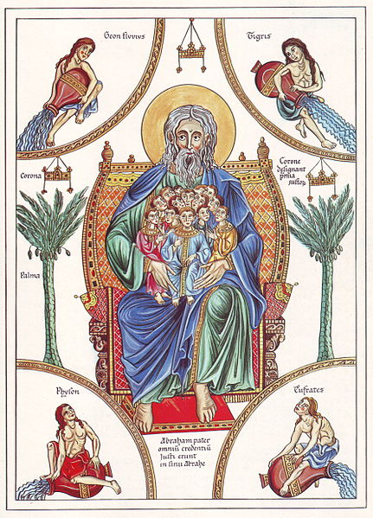  Depiction of Abraham circa 1180 by Herrad von Landsberg  Source | - Father of Judaism  - Life story is told in the book of Genesis in the Hebrew Bible  - God made a covenant with Abraham promising to bless him with descendants “like the sands of the sea” and a nation for him and the Israelites  Source: Adapted from “Abraham.” New World Encyclopedia. http://www.newworldencyclopedia.org/entry/Abraham  3. Why was Abraham important to Judaism?
Moses  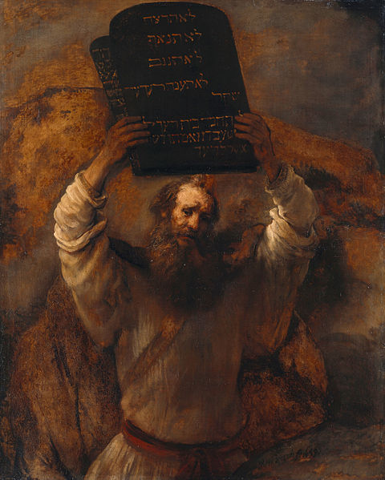  Moses with the Tablets of the Law. Rembrandt, 1695.  Source | - Life story told in the Torah  - Freed the Israelite slaves from Egypt  - God gave Moses the Ten Commandments  - Many Jewish people believe he wrote the Torah  Source: Adapted from “Moses.” New World Encyclopedia. http://www.newworldencyclopedia.org/entry/Moses  4. Why was Moses important to Judaism?

Enduring Issues Check-In

Conflict | Cooperation | Power |  | Inequality | Innovation
 | Interconnectedness | Ideas and Beliefs | Environmental Impact | Scarcity

Historical Topic | Related Enduring Issue | How is that Enduring Issue Related to the Historical Topic?
Code of Hammurabi
The Ten Commandments

Document 1
The Code of Hammurabi
The Code of Hammurabi was one of the first written law codes. It was written around 1754 BC by Hammurabi, the king of Babylon. It was written on a stele, or a large stone monument, and placed in a public place so that all could see it. A carving at the top of the stele shows King Hammurabi receiving the laws from the god Shamash. The inscription states that King Hammurabi was chosen by the gods of his people to bring the laws to them.  Excerpt from the first lines of the Code of Hammurabi:  When Anu the Sublime, King of the Anunaki, and Bel, the lord of Heaven and earth, who decreed the fate of the land...called Babylon by his illustrious name, made it great on earth, and founded an everlasting kingdom in it, whose foundations are laid so solidly as those of heaven and earth; then Anu and Bel called by name me, Hammurabi, the exalted prince, who feared God, to bring about the rule of righteousness in the land, to destroy the wicked and the evil-doers; so that the strong should not harm the weak; so that I should rule over the black-headed people like Shamash, and enlighten the land, to further the well-being of mankind. | 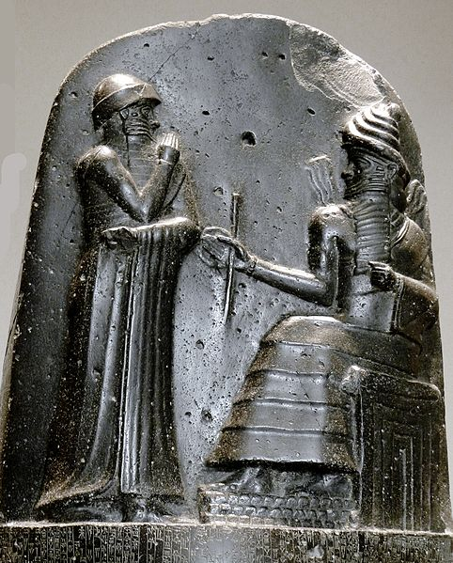  Carving on the top of a stele with the Code of Hammurabi inscribed below it.  P1050771 Louvre code Hammurabi bas relief rwk.JPG by Mbzt is published under the CC BY 3.0 Unported license
Source: Adapted by New Visions from Hammurabi by Joshua J. Mark which is published on Ancient History Encyclopedia under the CC BY-NC-SA 3.0 Unported license.
Source: “Code of Hammurabi.” Translated by L.W. King. The Eleventh Edition of the Encyclopaedia Britannica. 1915. Found on the Fordham University’s Ancient History Sourcebook: http://www.fordham.edu/halsall/ancient/hamcode.asp
Document 2
The Ten Commandments
And God spake all these words, saying,
(1) I am the LORD thy God[...]
(2) Thou shalt have no other gods before me. Thou shalt not make unto thee any graven [engraved] image, or any likeness of anything that is in heaven above, or that is in the earth beneath, or that is in the water under the earth. Thou shalt not bow down thyself to them, nor serve them[…]
(3) Thou shalt not take the name of the LORD thy God in vain[…]
(4) Remember the sabbath day, to keep it holy[....] in it thou shalt not do any work, thou, nor thy son, nor thy daughter, thy manservant, nor thy maidservant, nor thy cattle, nor thy stranger that is within thy gates[....]
(5) Honour thy father and thy mother: that thy days may be long upon the land which the LORD thy God giveth thee.
(6) Thou shalt not kill.
(7) Thou shalt not commit adultery [cheat on one’s husband or wife].
(8) Thou shalt not steal.
(9) Thou shalt not bear false witness [lie] against thy neighbour.
(10) Thou shalt not covet [want] thy neighbour's house, thou shalt not covet thy neighbour's wife, nor his manservant, nor his maidservant, nor his ox, nor his ass [donkey], nor any thing that is thy neighbour's[....]

Source: Exodus 20: 1-21, King James Version of the Holy Bible. Retrieved July 29, 2014, from http://www.sacred-texts.com/bib/kjv/exo020.htm

