Name: Date:
Global 10R/Period: Indian Independence & Partition
DIRECTIONS: Use the video to complete the following.

INDIA
Independence and Partition
WWI & Indian Independence
- 1914-WWI
- 1918-Indian troops return home

Indians Respond
- 1919-GB passes Rowlatt Act

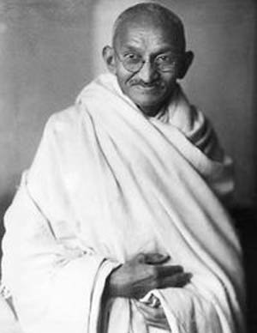
- 400 killed, 1200 wounded
What role did Mohandas Gandhi play in India’s independence?

- Used religious approach to politics

Gandhi’s Tactics
- Used non-cooperation & civil disobedience-
- Civil disobedience-
- “Satyagraha”-
- Boycott GB goods
- Boycotts=
- Refuse to attend govt schools, pay taxes & vote
What was the Salt March?
- Salt Acts-
- 1930-
- Marched 240+ miles to coast
- Some marched to salt works
- GB police beat demonstrators

How is this event being captured by the media going to have an effect on Gandhi’s independence movement?

Gradual Changes & More Problems
- 1935-Government of India Act

BUT THEN…
- 1939-
WWII Moves India Toward Independence
- Indians are angry about involvement in WWII
- 1942-
- Called for GB to leave & grant independence
- 1945-end of WWII

- Colony =
Internal Issues
Who would take over at independence?
- Indian Nat’l Congress=
- Muslim League=

- 1946-riots b/t Hindus & Muslims
India is Granted Independence
- July 16th 1947- GB passed Indian Independence Act

- Partition-
How was India divided?
- India & Pakistan divided on religious basis
- Hindus and Sikhs
- Muslims
- Summer of 1947-10m ppl move
- ~1m refugees killed

India-Before and After Partition
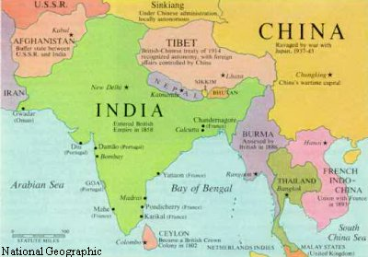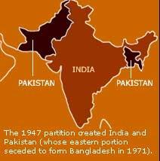
Before partition After partition
New Leaders
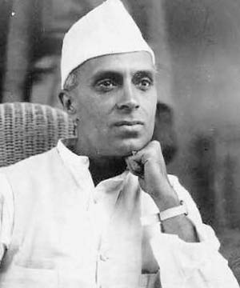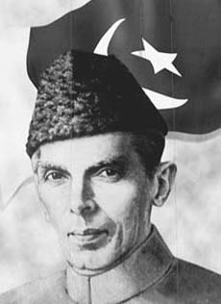

Kashmir

- Hindu ruler w/ Muslim pop.
- Indian & Pakistan began fighting over region immediately

The Death of Gandhi
- Gandhi asked for fair treatment of Muslims in India
- January 30th, 1948 –

