Innovations in Energy Sources: Human, Animal, Wood and Water Power to Coal & Steam
Before the Industrial Revolution |  |  | Industrial Innovation: Coal
Before the Industrial Revolution, the main sources of energy were human, animal, wood, and water power. In addition to using animals to push and pull, they were also used to power machines. A modern version can be seen in the video below. Water power had been used for centuries to power mills, but this limited where someone could put a factory because it needed to be near fast moving water. In the early years of the Industrial Revolution, factories were located near rivers and streams to use the water power to move gears that powered the machines inside. Wood was also used as fuel once steam engines were invented but it took time to replenish after the trees were harvested and it was heavy and bulky to transport.  Click to watch a modern animal-powered sawmill in Belize. Click to watch a restored water-powered sawmill in Ireland. |  |  | Watch this BBC Video on the Industrial Revolution (2:22- 5:08) to learn about the importance and power of coal as source of energy.
Coal is a black or brownish-black sedimentary rock. It is extracted from the Earth by underground mining or open-pit mining. Coal is a common rock in many parts of the world and with improved mining technology in the 18th century it became easy to get. Because it can be set on fire and it burns at a high temperature for a long period of time, it is an extremely powerful fuel for the generation of heat and electricity. Today, approximately 40 percent of the world's electricity production depends on coal, making it the largest single source of electricity worldwide.
Sources: “Coal.” New World Encyclopedia. http://www.newworldencyclopedia.org/entry/Coal; https://en.wikipedia.org/wiki/File:Baureihe52Heizer.jpg, https://commons.wikimedia.org/wiki/File:Coal_bituminous.jpg
1a. What were the disadvantages to using wood and water power? |  | 1c. Predict- What are the possible positive and negatives effects of the use of coal for energy?
1b. Why was the use of coal an improvement on using human, animal, wood or water power for energy?
Innovations in Engines: Steam Engines, Turning Energy into Motion
Industrial Innovation: James Watt’s Steam Engine
James Watt | How do steam engines work?
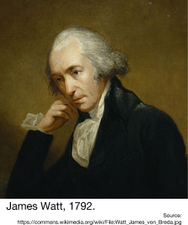  James Watt (January 19, 1736 – August 25, 1819) was a Scottish inventor and engineer whose improvements to the steam engine provided much of the force behind the Industrial Revolution. His invention turned heat from burning coal into movement through a series of valves and gears. His invention made it possible to use coal for energy in areas far away from coal fields. The steam engine was used in manufacturing to run machines at great speeds for long periods of time so work could be performed on large scales, almost year-round, with vastly higher efficiency. The steam engine was also used in the locomotive [train] and steamboat, thus leading to the revolution in transportation. | To learn how the steam engine works watch this series of short videos below:  How a Steam Engine Works Animation  A Working Glass Model of a Steam Engine  History Channel's Steam Engine History (4:02-8:07)
2a. What uses did Watt’s steam engine have during the Industrial Revolution?
2b. How did the steam engine improve manufacturing and transportation? | 2b. Predict- What are the possible positive and negatives effects of using the steam engine as a source of energy?

Innovations in Manufacturing: Putting Out System to the Factory Model
Before the Industrial Revolution: Domestic/Putting Out System
The Domestic system, also called the Putting-out System, was a production system that was widespread in 17th-century western Europe in which merchant-employers “put out” materials, like cotton, to rural producers who usually worked in their homes producing goods like clothing. Workers returned finished products to the employers for payment on a piecework or wage basis. The domestic system differed from the handicraft system of home production in that the workers neither bought materials nor sold products. The business owners bought the raw materials like cotton and then sold the finished products, so they only paid workers for their labor. The advantages to the merchant-employer were the lower wage costs and increased efficiency due to a more extensive division of labor within the craft. Division of labor is the separation of steps in the process of making something into different jobs. For example, the merchants were in charge of getting cotton, and the rural workers were responsible for turning the cotton into yarn.
Source: Encyclopædia Britannica Online, s. v. "domestic system", accessed November 19, 2015, http://www.britannica.com/technology/domestic-system.
Illustration of two women working at home to make finished goods as part of the domestic system. | Source: Farah and Karls, World History: The Human Experience, Section Focus Transparencies, Glencoe McGraw-Hill (adapted) from the NYS Global History and Geography Regents Exam, January 2009.

3a. Describe the Domestic System of manufacturing goods. | 3b. Who benefited the most from the Domestic System (merchant or rural worker)? Why?
Industrial Innovation: Factory System
The factory system of manufacturing that began in the early 18th century was based on 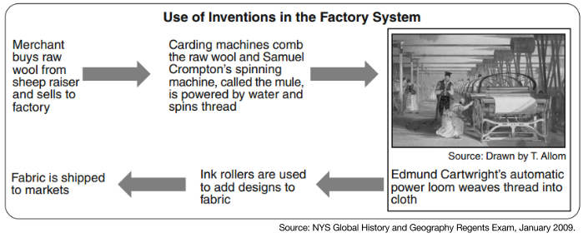
- requiring workers to come to one place, a factory, to produce goods
- division of labor (separating the steps of making something into separate jobs)
- keeping the cost of making something as low as possible
- mass production (making a lot of the same good)

The factory system replaced the domestic system, in which individual workers used hand tools or simple machinery to make goods in their own homes or in workshops attached to their homes. The use of waterpower and then the steam engine to mechanize processes such as cloth weaving in England in the second half of the 18th century marked the beginning of the factory system. This system was enhanced at the end of the 18th century by the introduction of interchangeable parts in the manufacture of muskets [a type of gun] and, subsequently, other types of goods. Prior to this, each part of a musket (or anything else assembled from multiple components) had been individually shaped by a workman to fit with the other parts. In the new system, the musket parts were machined to such precise specifications that a part of any musket could be replaced by the same part from any other musket of the same design. This advance signaled the start of mass production, in which standardized parts could be assembled by relatively unskilled workmen into complete finished products.

The resulting system, in which work was organized to utilize power-driven machinery and produce goods on a large scale, had important social consequences: formerly, workers had been independent craftsmen who owned their own tools and designated their own working hours, but in the factory system, the employer owned the tools and raw materials and set the hours and other conditions under which the workers labored. The location of work also changed. Whereas many workers had inhabited rural areas under the domestic system, the factory system concentrated workers in cities and towns, because the new factories had to be located near waterpower and transportation (alongside waterways, roads, or railways). Moreover, many of the new unskilled jobs could be performed equally well by women, men, or children, thus tending to drive down factory wages. Factories tended to be poorly lit, cluttered, and unsafe places where workers put in long hours for low pay.
Source: Adapted from Encyclopædia Britannica Online, s. v. "factory system", accessed November 19, 2015, http://www.britannica.com/topic/factory-system.

3c. What are the differences between the Domestic System and the Factory System? | 3d. Predict- What are the possible positive and negatives effects of the Factory System?

3e. Identify three innovations in manufacturing that took place during the Industrial Revolution? | 3f. Predict- What are the possible positive and negatives effects of the innovations in manufacturing described above?

Innovations in Transportation
Industrial Innovation in Transportation: Turnpikes | Industrial Innovation in Transportation: Canals
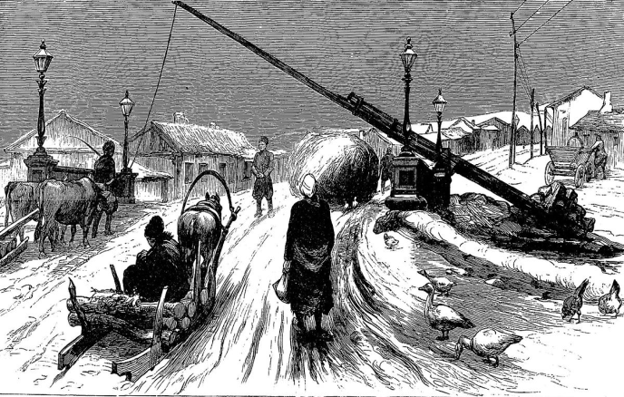  Turnpike in Romania (1877)  Source: https://en.wikipedia.org/wiki/File:A_toll_bar_in_Roumania,_1877.jpg  As trade increased in the mid-1700s, merchants needed better roads to travel on. To pay for new and improved roads, the Parliament in England started to issue local governments the right to create turnpikes, roads that required users to pay tolls. The tolls were used to pay for road repairs and upgrades. A pike was a barrier laid across the road that prevented people from using it until they paid. The operator then turned the pike to allow them to pass. | 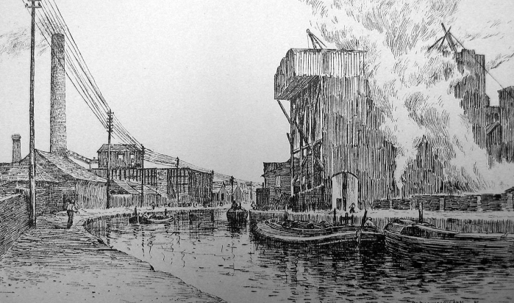  The Bridgewater Canal in England (1887)  Source: https://en.wikipedia.org/wiki/File:Runcorn_soapworks.jpg  Canals are man-made waterways used to transport people and goods from one place to another that usually connect to a larger body of water like a river, lake, or sea. As manufacturing increased during the industrial revolution, the need to transport heavy fuel like coal and more finished products made transporting over land less effective. As a result, large canal systems were built all over England and other countries.
4a. Explain how turnpikes and canals improved transportation during the Industrial Revolution? | 4b. Predict- What are the possible positive and negatives effects of using turnpikes and canals to transport goods and people?
Industrial Innovation in Transportation: Locomotives (Trains)
Watch an excerpt from History Channel's Steam Engine History (15:56- 27:35) for a brief history of early trains in Great Britain and this video of 19th century steam engines to see what it was like to be near a passing train later in the Industrial Revolution.
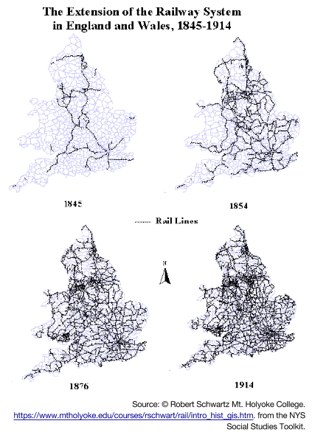
In the 1500s, 1600s, and for most of the 1700s, railroad tracks were used to move goods from one place to another over short distances but they were pushed or pulled using human muscle or animal power. James Watt’s steam engine (1774) breathed new life into the railroad when it was adapted to pull railcars for the first time by English inventor Richard Trevithick’s locomotive in 1804. Innovators throughout Great Britain, the United States, and Europe improved upon Watts and Trevithick's technology creating faster, more powerful, more efficient, and safer trains.

The speed and power of trains transformed the lives of those who used them to travel and ship goods. Before the locomotive, the fastest way to travel overland was on horseback which averaged around 30 mph, but was uncomfortable, required frequent stops for rest, and could carry very little weight. In contrast, by 1829 George Stephenson’s locomotive, Rocket, could travel 29 mph and one hundred years later trains were traveling at speeds over 120 mph. Locomotives only required fuel, like coal to keep moving and could pull massive loads.

Railroad lines quickly spread throughout Great Britain and all over the world bringing people and goods closer to one another than they had ever been before.

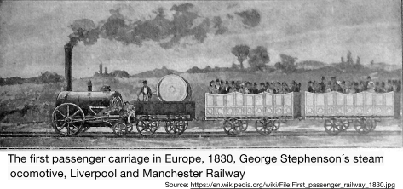
4a. What earlier innovation of the Industrial Revolution was used to create the first locomotive? | 4c. Based the map of the railway system in England and Wales (1845-1914), how did the state of rail lines change during the period represented in the maps?
4b. What were the benefits of using locomotives to transport people and goods over horse power? | 4b. Predict- What are the possible positive and negatives effects of using locomotives to transport goods and people?

