Name: Date:
Global 10R/Period: Imperialism Map

IMPERIALISM

DIRECTIONS: Use page 682-683 & A26-A27 to complete the map.

Imperial Territory

Using a key and several different colors, identify the areas controlled by the different imperial nations.

Label the following:

- Afghanistan
- Africa
- Arabian Peninsula
- Asia
- Atlantic Ocean
- Australia
- China
- Dutch East Indies
- Europe
- India
- Indian Ocean
- Ottoman Empire
- Pacific Ocean
- Persia
- Philippines
- Russian Empire

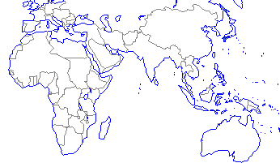

What do you remember?
The Ottoman Empire (Ch 18-1)
- The Ottomans followed what religion?
- The Ottoman Empire took over what previously very powerful empire?
- Who was the Ottoman Empire’s most well-known leader? Why?
Africa
(Ch 15)
- Name the three West African trading kingdoms.
- Trade in West Africa was dominated by the trade of what two products?
- Who was Mansa Musa and what was his impact?
- What is Swahili?
(Ch 20-3)
- List some of the causes of the Atlantic Slave Trade.
China
(Ch 7-3)
- What is the dynastic cycle and how is it connected to the Mandate of Heaven?
- Explain the major ideas of the following philosophies:
  - Confucianism-
  - Daoism-
  - Legalism-

(Ch 12-2 & 12-3)
- What foreign group established the Yuan Dynasty and what effect did they have?
- Describe the Silk Road and its impact.
Japan (Ch 12-4)
- Define archipelago.
- How did Japan’s geography affect its culture and history?

- Complete the feudal pyramid to the right.

- In Japanese feudalism, who/what group held the true power and who/what group was the figurehead?
- What is bushido?
India
(Ch 3-2)
- What two major world religions developed in India?
- What social system dominates life in India?
(Ch 7-1)
- What was Asoka known for?

