How did its geography impact Ancient Greece?
Objective: Describe how geographic factors encouraged
or hindered expansion and interactions within Ancient Greece.

Greek civilization began in 1750 BC north of the Mediterranean Sea in Europe.
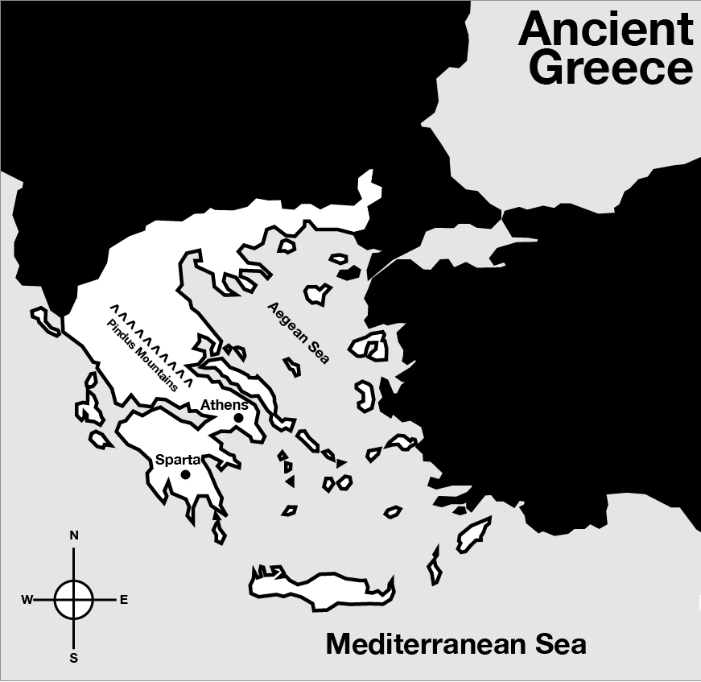
Greece is in southeastern Europe and consists of a mainland and an archipelago [chain of islands]. Mainland Greece is a large peninsula surrounded on three sides by the Mediterranean Sea (branching into the Ionian Sea in the west and the Aegean Sea in the east).

The geography of Greece greatly influenced the culture in that, with few natural resources and surrounded by water, the people eventually took to the sea for their livelihood. Mountains cover eighty percent of Greece which provides little opportunity for agriculture. As a result, the early Greeks colonized neighboring islands and founded settlements along the coast of Anatolia (also known as Asia Minor, modern day Turkey). The Greeks became skilled ship builders, sailors, and traders to acquire resources they did not have. One benefit of Greece’s trade with other nations was that they encountered the Phoenician alphabet, which they adapted and became the basis for Latin and many other languages including English.

The mountains that covered Greece and the seas between islands also isolated the people of Greece. As a result, Greeks developed individual polis, also known as city-states. City-states were cities with surrounding land and villages. Each city-state was independent and located in an isolated valley. While the Greeks spoke the same language, they had different cultures and government and social structures because they were divided. The mountains separating the city-states were barriers to cultural diffusion and unity. In addition, a lack of resources and differences between the city-states led to rivalry and antagonism that led to wars. The two most well-known city-states were Sparta and Athens.
Source: “Ancient Greece.” Ancient History Encyclopedia. http://www.ancient.eu/greece/
1. Identify two geographic features that separated the Greek city-states. | 2. Describe two ways that mountains in Greece affected the Ancient Greeks.
3. Describe two ways that water surrounding Greece affected the Ancient Greeks.
How did Athens and Sparta differ?
Objective: Explain how Athens and Sparta differed.

Directions: Use the videos and text below to compare and contrast life in Athens and Sparta.
ATHENS | vs. | SPARTA
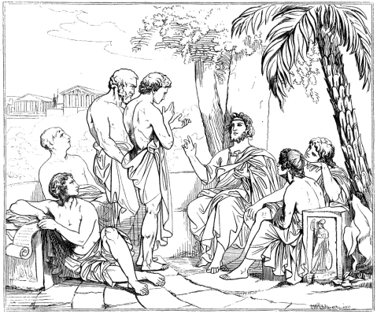 |  | 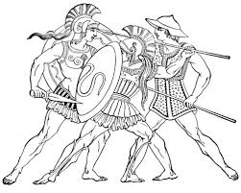

The rivalry between Athens and Sparta, two of the Greek city-states greatly affected Ancient Greece and has now become legendary. Feuding between Sparta and Athens eventually led to a twenty-seven year long civil war called the Peloponnesian War in 431 BC which led to the decline of Greece. Historians use primary sources and secondary sources to identify causes for the rivalry between Sparta and Athens.

Daily Life
Watch this video on Athens and Sparta, then describe what life was like for Athenians and Spartans below.
Life in Athens | Life in Sparta

Core Values
Athens | Sparta
If we look to the laws, they afford equal justice to all despite their differences. If a man is able to serve the state, he is not hindered by his condition. The freedom we enjoy in our government extends to our ordinary life. There…we do not feel called upon to be angry with our neighbor for doing what he likes...  Advancement in politics is about potential, social class is not allowed to determine merit. Our ordinary citizens, though occupied with personal business, are still fair judges of public issues. At Athens we live exactly as we please, and yet are just as ready to encounter every legitimate danger.  To be happy means to be free. We throw open our city to the world, and never...exclude foreigners from any opportunity of learning or observing.  -Pericles, Funeral Oration | “Instead of softening their feet with shoe or sandal, his [king of Sparta] rule was to make them hardy through going barefoot. He believed this would allow them to climb hills and run. In fact, with his feet so trained the young Spartan would leap and spring and run faster without shoes than another in the ordinary way. Instead of making them effeminate (lady-like) and spoiled with a variety of clothes, the rule was to give them one piece of clothing the entire year. They would wear the same piece of clothing whether it was hot or cold. This taught them to be brave in all weather. With regards to food, young boys received small amounts of food. It was believed that young boys needed to know the pains of starvation.”  - Xenophon, Constitution of the Lacedaemonians  From childhood until age 30, a Spartan prepared to be part of the military state. Officials examined every newborn and sickly children were abandoned to die. At the age of seven, boys moved to military camps and began training for the military. At the age of 20, a man could marry, but he could not leave the military camp until he was 30.  -Prentice Hall: World History (Ellis & Esler, 2007)
Based on Pericles’ speech, describe what Athenians valued most. | Based on the text above, describe what Spartans valued most.
Lives of Women
Athens | Sparta
Unlike girls, who received little or no formal education, boys attended school if their families could afford it. Besides learning to read and write, they studied music, memorized poetry, and studied public speaking because, as citizens in a democracy, they would have to voice their views. Although they received military training and participated in athletic contests, unlike Sparta, which put military training above all else, Athens encouraged young men to explore many areas of knowledge.  -Prentice Hall: World History (Ellis & Esler, 2007) | ...The truth is, he [king of Sparta] took in their [women] case, also, all the care that was possible; he ordered the maidens to exercise themselves with wrestling, running, throwing, the quoit [a ring thrown toward a peg in the ground], and casting the dart, to the end that the fruit they conceived might, in strong and healthy bodies, take firmer root and find better growth, and withal that they, with this greater vigor, might be the more able to undergo the pains of childbearing. And to the end he might take away their over great tenderness and fear of exposure to the air, and all acquired womanishness, he ordered that the young women should go naked in the processions, as well as the young men, and dance, too, in that condition, at certain solemn feasts, singing certain songs, whilst the young men stood around, seeing and hearing them.  From Lycurgus by Plutarch written 75 C.E. Translated by John Dryden
Based on the text, what was life like for women in Athens? | Based on this observation by Lycurgus, what was life like for women in Sparta?
If you were a woman, in which city-state would you prefer to live? Explain.

How did trade influence Mycenaean society?

What evidence do we now have that the Trojan War actually took place?

