Where is India? What is its geography?
When did ancient civilizations exist in India?
Objective: Locate India and its geographic regions. Identify the ancient civilizations that existed in India.

Introduction
Directions: In the chart below, write down everything you think you know about India right now and questions about India that you’d like to know the answers to.
India
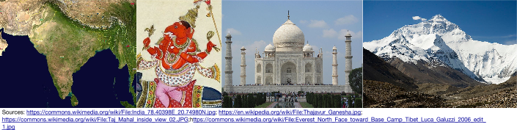

What do you already know about India?

India’s Location and Geography
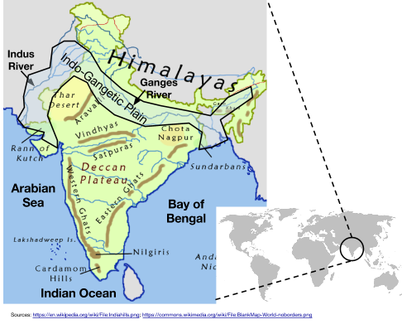
Directions: Examine the map below and read the brief description of India’s geography, then answer the questions that follow.
India is a modern-day country located in the region of Asia known as South Asia. Historically, the area referred to as “India” was larger than the country today and included the land northwest of the Indus River Valley which is now part of Pakistan. The landmass that India is on is a peninsula. A peninsula is a piece of land almost surrounded by water. India is sometimes referred to as a “subcontinent” because it is large and juts out from Asia into the Indian Ocean.

India’s many regions have very different climates. The Himalaya Mountains, the world’s tallest mountain range, are in the north. The Deccan Plateau is an area of high altitude with hardy plant life.
Finally, the Indo-Gangetic Plain is home to India’s most important rivers. It is a vast area of fertile soil where many of India’s civilizations began.

1. Which continent is India located on?
2. What is the name of the large mountain range to the northeast of India? How do you think the presence of that mountain range may have affected interaction between Indians and people from North or East of the mountain range?
3. Identify two rivers that are located in the Indo-Gangetic Plain.
4. Why do you think many of India’s civilizations began in the Indo-Gangetic Plain?
5. Which bodies of water border India?
A Brief History of India from the Neolithic Revolution to the Mauryan Empire
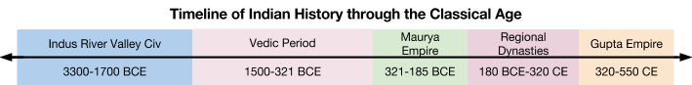

The Indus Valley Civilization (3300-1700 BCE)  The first confirmed permanent settlements of humans in India appeared 9000 years ago and by 5100 B.C.E., people in the Indus Valley were farming and establishing permanent settlements.  The Indus River Valley Civilization was the first civilization in India. It developed along the Indus River on the Indo-Gangetic Plain. The civilization was well-known for sophisticated cities like Harappa and Mohenjo-Daro that included a grid street pattern and drainage systems. The Indus Civilization may have had a population of over five million. Over 2500 cities and settlements have been found. Around the middle of the second millennium B.C.E., the Indus River basin dried up, and the sites were abandoned.  Vedic Civilization and Hinduism (1500 BCE- 320 BCE)  After the fall of the Indus River Valley civilization, new settlements called the Vedic Civilization took root in India. Some scholars believe that the people who founded these civilizations migrated into India from the northwest. Several small kingdoms and tribes, which were often at war with each other, merged to form a few large ones.  The belief system that dominates India today, Hinduism, developed at this time. The most important texts of Hinduism including the Vedas and the Mahabharata (a part of which is called the Bhagavad Gita) were written down during the Vedic Period after being passed down orally through generations.  The Mahajanapadas  The Mahajanapadas were the sixteen most powerful kingdoms and republics of the era, located mainly across the fertile Ganges River plains, however there were a number of smaller kingdoms stretching the length and breadth of India that also existed during the late Vedic period. These kingdoms existed until the Maurya Empire unified much of India in 320 BCE.  Buddhism  In 537 B.C.E., another major belief system, named Buddhism, was founded by a prince named Siddhartha Gautama (later known as “Buddha”) in India. Buddhism is related to Hinduism but rejects many of Hinduism’s most important beliefs. Buddhism was embraced by the Maurya Empire and spread throughout Asia.  Source: Adapted from “India.” New World Encyclopedia. http://www.newworldencyclopedia.org/entry/India | Which historical turning point led to the creation of permanent settlements in India?
 | Where did the first civilization in India develop? Why did it develop there?
 | What made Harappa and Mohenjo-Daro “sophisticated?
 | What belief system originated in India and still dominates it today?
 | What were the great accomplishments of the Maurya Empire?
 | Which religion did the Maurya empire support?

