Judaism: Historical Development & Beliefs

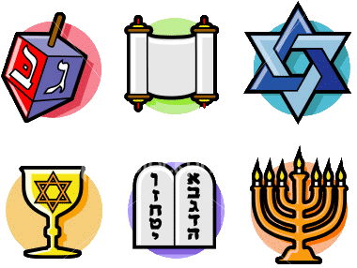

Name:
Date:
Period:

Geographic Context
Directions: Use the text, video, and maps below to the answer the questions that follow.

The Israelites were a group of people who lived in Middle East. They established a kingdom starting around 1030 BCE-1020 BCE that lasted until it was conquered by the Assyrian empire in 722 BCE. The Israelites were the first people to practice a religion that became known as Judaism.
Source: Adapted from “Kingdom of Israel.” New World Encyclopedia. http://www.newworldencyclopedia.org/entry/Kingdom_of_Israel

Watch IsraelPalestine for Critical Thinkers: #1 Ancient Roots
[https://youtu.be/S2jnvsdF38k] (start-2:33).
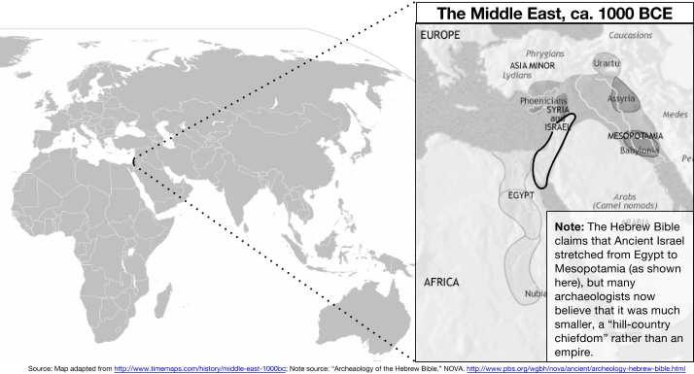
1. Based on the map above, which region of the world was Ancient Israel in? | 2. Describe the relative location of Ancient Israel. Use three other locations to describe where Ancient Israel was.
3. Based on the video, what geographic features were located in Ancient Israel? | 4. Based the video and on your knowledge of Early River Valley Civilizations, why might the Ancient Israelites have settled in the location identified on the map?
5. Based on the “Note” in the map, identify two sources that were used to create this map. What different information do the sources provide about the location and size of Ancient Israel?
How do we know what we know about Ancient Israel?
How is our knowledge limited?

Directions: Read about each of the following sources and answer the questions that follow.

Much of what we know about Ancient Israel and the Israelites comes from Judaism’s sacred text, the Hebrew Bible, also known as the Torah. Christians know the Torah as the “Old Testament.” Many Jewish people believe that the words in the Torah came from the God they believe in and as a result, are true.

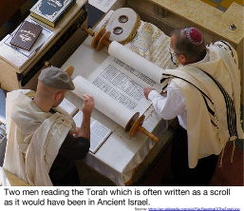
Historians examine the Torah as a source. They investigate how it was created, who wrote it, when they wrote it, and any bias the writers might have had. Historians try to corroborate the information in the Torah using archaeological evidence from where the Israelites lived and the records left by other civilizations at the time.

The Torah (Hebrew Bible)

The Torah consists of five books titled Genesis, Exodus, Leviticus, Numbers, and Deuteronomy. It includes an origin story of the world in which the god, called Yahweh, created everything for humans. The books tell of God’s agreement with Abraham to favor the Jewish people (identified as the covenant), describes the Israelites’ escape from slavery in Egypt led by Moses, and their long journey to the “promised land.” The Torah also contains the Ten Commandments, and other lessons on how to live one’s life according to God.

Traditionally, it is believed that the five books of the Torah were written by Moses, but because of many repetitions, inconsistencies, and a description of Moses’ death, many scholars believe that the Torah was compiled by multiple writers, or groups of writers, between the 10th and 6th centuries BCE.

Depending on the perspective with which you read the Torah, it can be a historical text (or primary source) which provides clues about how the Israelites lived or it can be a religious text which provides rules to govern people's spiritual lives.
Source: Adapted from “Writers of the Bible.” NOVA. http://www.pbs.org/wgbh/nova/ancient/writers-bible.html
1. What can historians learn from the Torah? | 2. What limits does the Torah have as a historical source?

Archaeological Evidence
For the last 150 year archaeologists interested in the Bible have combed the Middle East looking for evidence to corroborate the stories in the Torah.

Archaeologists have yet to find evidence of Abraham, Moses, or the exodus of the Israelites out of Egypt in the records and remains left by the Egyptians or other civilizations, but other discoveries have been made.
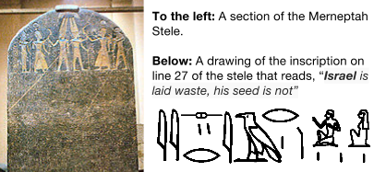
The Merneptah Stele
An inscription on a stele (large stone monument) that lists all of the areas conquered by the Pharaoh Merneptah around 1206 BCE mentions people called the “Israelites.” This shows that the Israelites lived in the area that the Torah says they lived at around the time it claims they were there.

How large was the kingdom of Israel?
The Torah states that Israel was a large kingdom that ruled from Egypt to Mesopotamia and was ruled by the kings named Saul, David, and Solomon. In 1993, archaeologists discovered an inscription which dates about 840 B.C.E. that mentions a “House of David,” which supports the Torah’s claim. In addition, the Torah describes a construction project that Solomon undertook to erect gates in the Israelite towns. Archaeologists have found gates matching the description in three settlements and dated those gates in the 10th-century BCE. These two pieces of evidence suggest that the kingdom of Israel existed and that David and Solomon were rulers of it.

Other evidence though suggests that the kingdom was not nearly are large and powerful as the Hebrew Bible claims. Most of the Israelite settlements found in the Middle East were small communities, not large cities and not spread over as large an area as the books of the Torah suggest.

Source: Adapted from “Archaeology of the Hebrew Bible.” NOVA. http://www.pbs.org/wgbh/nova/ancient/archeology-hebrew-bible.html
3. What can historians learn from archeological evidence? | 4. What limits does archeological evidence have as a historical source?

What are the major beliefs of Judaism?
How does Judaism impact the lives of Jewish people?

Directions: As you read about the following beliefs of Judaism, answer the questions that accompany each section and fill out this graphic organizer.

1. Monotheism
Most civilizations in the Middle East at the time of the Ancient Israel practiced polytheistic religions.
Judaism was the first monotheistic religion that continued to exist and impact world history.

Word | Polytheism |  |  | Monotheism
Prefix and Root | Poly | + | theism | Mono | + | theism
Meaning | “many” |  | “having to do with god” | “one” |  | “having to do with god”
Examples | Animism is a belief system in which people worship many different natural spirits. For example, some Animistic religions might worship a god of the sun, a volcano, or of the forest. |  |  | Judaism, Christianity, and Islam all worship the same singular god who the Jewish people call “Yahweh,” Christians call “God,” and Muslims refer to as “Allah.”

2. The Covenant
A covenant is an agreement. Jewish people believe that God made covenants with several figures mentioned in the Torah. The covenants below are between God and the father of Judaism, Abraham.

Now the LORD had said unto Abram, Get thee out of thy country [Egypt], and from thy kindred [relatives], and from thy father's house, unto a land that I will shew [show] thee:
And I will make of thee a great nation, and I will bless thee, and make thy name great; and thou shalt be a blessing:
And I will bless them that bless thee, and curse him that curseth thee: and in thee shall all families of the earth be blessed.[...]
In the same day the LORD made a covenant with Abram, saying, Unto thy seed have I given this land, from the river of Egypt unto the great river, the river Euphrates[...]
And God said unto Abraham, Thou shalt keep my covenant therefore, thou, and thy seed after thee in their generations.
Source: Genesis 12:1- 3; Genesis 15:18- 21; Genesis 17:9- 12; King James Version of the Holy Bible. Retrieved July 28, 2015, from http://www.sacred-texts.com/bib/kjv/gen.htm

1. Based on this section of the Torah, God promised Abraham...

3. The Ten Commandments
Most belief systems have ethical/moral codes of conduct that describe how one should live their life based on the beliefs of that religion. For Judaism, the Ten Commandments, that appear in the Torah, are the clearest code of conduct. According to the Torah, God inscribed the commandments on two stone tablets and gave them to Moses to share with the rest of the Israelites.

The Ten Commandments
And God spake all these words, saying,
(1) I am the LORD thy God[...]
(2) Thou shalt have no other gods before me. Thou shalt not make unto thee any graven [engraved] image, or any likeness of anything that is in heaven above, or that is in the earth beneath, or that is in the water under the earth. Thou shalt not bow down thyself to them, nor serve them[…]
(3) Thou shalt not take the name of the LORD thy God in vain[…]
(4) Remember the sabbath day, to keep it holy[....] in it thou shalt not do any work, thou, nor thy son, nor thy daughter, thy manservant, nor thy maidservant, nor thy cattle, nor thy stranger that is within thy gates[....]
(5) Honour thy father and thy mother: that thy days may be long upon the land which the LORD thy God giveth thee.
(6) Thou shalt not kill.
(7) Thou shalt not commit adultery [cheat on one’s husband or wife].
(8) Thou shalt not steal.
(9) Thou shalt not bear false witness [lie] against thy neighbour.
(10) Thou shalt not covet [want] thy neighbour's house, thou shalt not covet thy neighbour's wife, nor his manservant, nor his maidservant, nor his ox, nor his ass, nor any thing that is thy neighbour's[....]

Source: Exodus 20: 1-21, King James Version of the Holy Bible. Retrieved July 29, 2014, from http://www.sacred-texts.com/bib/kjv/exo020.htm

2. Identify one piece of evidence from the Ten Commandments that suggests that Judaism is a monotheistic religion.
3. Based on the Ten Commandments, describe a person who lives their life according to God’s laws.

4. Major Figures of Judaism
Abraham  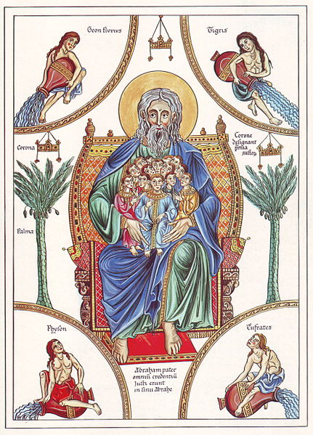  Depiction of Abraham circa 1180 by Herrad von Landsberg  Source | - Father of Judaism  - Life story is told in the book of Genesis in the Hebrew Bible  - God made a covenant with Abraham promising to bless him with descendants “like the sands of the sea” and a nation for him and the Israelites  Source: Adapted from “Abraham.” New World Encyclopedia. http://www.newworldencyclopedia.org/entry/Abraham
Moses  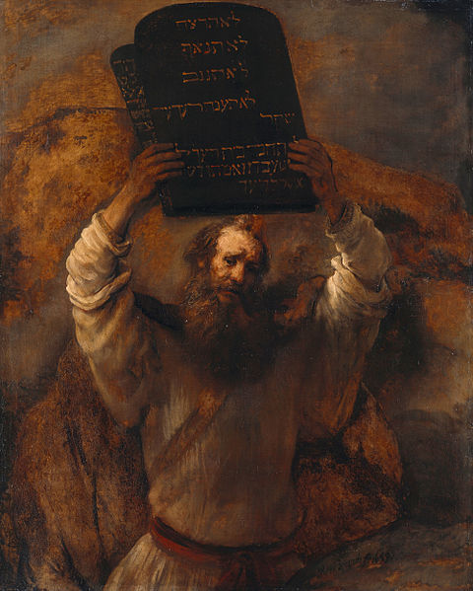  Moses with the Tablets of the Law. Rembrandt, 1695.  Source | - Life story told in the Torah  - Freed the Israelite slaves from Egypt  - God gave Moses the Ten Commandments  - Many Jewish people believe he wrote the Torah  Source: Adapted from “Moses.” New World Encyclopedia. http://www.newworldencyclopedia.org/entry/Moses

How did Judaism impact the lives of Ancient Israelites?

That Babylonian Exile (Captivity)
➡ Directions: Watch this History Channel video clip, Exile of the Jews [https://youtu.be/tK2Kw0Qagww] and read the excerpt below, then answer the questions that follow.
Starting around 597 BCE, the Babylonian Empire, centered in the city of Babylon in the Fertile Crescent, conquered the Kingdom of Judah. The upper class Jewish people, Israelites who lived in Judah, were ordered by the Babylonian King, Nebuchadnezzar II, to leave Jerusalem and live in captivity in Babylon.

The period of time from 597 to 539 BCE, which ended when the Persian king Cyrus the Great took over Babylon and allowed the Jews to return to Judah, is known as the Babylonian Exile or Captivity.
This period had a great effect on the Jewish people. They wondered how such a terrible thing could happen to god’s “chosen people.” In addition, their sacred temple where they worshiped their god was destroyed.

As a result, some of the Jewish people in Babylon became more religions. They commemorated the fall of Jerusalem with days of prayer and celebrated the Sabbath (day of rest set aside for religious reasons). The profession of the scribes, people who copied religious documents, grew in importance. Historical writings and religious teachers were compiled and revised by the scribes to create the Torah. The writers viewed the recent events as punishment for their sins, especially the sin of worshipping gods other than Yahweh. At the same time, the scribes and others in exile hoped that the Jewish faith would bring the Israelites together and that they would be able to rebuild the Temple once the exile was over.

The Babylonian exile represents both one of Judaism's darkest hours and also the beginning of its history as an enduring universal religion that gave birth to the later monotheistic traditions of Christianity and Islam.
Adapted from “Babylonian Exile.” New World Encyclopedia. http://www.newworldencyclopedia.org/entry/Babylonian_Exile
Based on the video and reading above identify two pieces of evidence that show that Judaism unified the Jewish people.

The Jewish Diaspora
Directions: Read the text and analyze the map below, then answer the questions that follow.
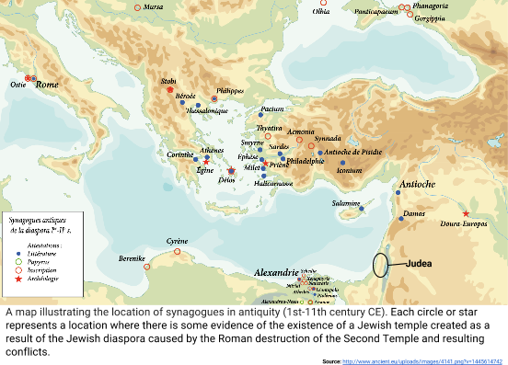
The term diaspora (in Ancient Greek, διασπορά – "a scattering or sowing of seeds") refers to any people or ethnic group forced to leave its traditional homeland, and the spreading out of those people that results from it. It is especially used to with reference to the Jewish people, who have lived most of their historical existence as a diasporan people.
The Jewish diaspora began with the Babylonian Exile. Although some of the captives that were forced to live in Babylon returned to Judea after they were released by the Persian King Cyrus the Great, others settled elsewhere. They were dispersed in lands around the Mediterranean Sea. Major centers of Jewish diasporan culture emerged in such places as Alexandria, Asia Minor, and Babylonia.
A second major expulsion and diaspora of the Jewish people from Judea took place between 66 CE and 136 CE. In 66 CE, the Roman Empire had been in control of Judea for some time, but had mostly respected the rights of the Jewish people to practice their religion. Due to Roman administrators who were disrespectful towards their religion, and disagreements over taxes, the Judeans rebelled against the Romans. In response, the Roman military destroyed most of Jerusalem including the Second Temple to the Jewish God. For the next 66 years tensions between the Judeans and Romans intensified with riots and wars and calmed. At the end of this period, much of the Jewish population had either chosen to leave Judea or were forced out.
Some Jewish people remained in Judea or the surrounding area, but most left. In the sixth century there were 43 Jewish communities in Palestine, scattered along the coast, in the Negev, east of the Jordan, and in villages in the Galilee region, and in the Jordan River valley. Jewish communities expelled from Judea were sent, or decided to go, to various Roman provinces in the Middle East, Europe, and North Africa.
Source: Adapted from “Diaspora” New World Encyclopedia. http://www.newworldencyclopedia.org/entry/Diaspora

1. Why did the Jewish diaspora occur? | 2. Where did Jewish people spread their religion after they were expelled from Judea?

