How did the French Revolution impact the growth of nationalist feeling and revolutionary movements?
Objective: Students will analyze how the French Revolution impacted the growth of nationalist feeling and revolutionary movements.

Below, you will be exploring the external impacts of the French Revolution. External impacts are the effects on the French Revolution on countries and people outside of France.

Directions: Read the excerpts and respond to the corresponding questions.
. . However, the majority of Europeans and non-Europeans came to see the Revolution as much more than a bloody tragedy. These people were more impressed by what the Revolution accomplished than by what it failed to do. They recalled the Revolution’s abolition of serfdom, slavery, inherited privilege, and judicial torture; its experiments with democracy; and its opening of opportunities to those who, for reasons of social status or religion, had been traditionally excluded. One of the most important contributions of the French Revolution was to make revolution part of the world’s political tradition. The French Revolution continued to provide instruction for revolutionaries in the 19th and 20th centuries, as peoples in Europe and around the world sought to realize their different versions of freedom. Karl Marx would, at least at the outset, pattern his notion of a proletarian revolution on the French Revolution of 1789. And 200 years later Chinese students, who weeks before had fought their government in Tiananmen Square, confirmed the contemporary relevance of the French Revolution when they led the revolutionary bicentennial parade in Paris on July 14, 1989. . . .  Source: Thomas E. Kaiser, University of Arkansas, encarta.msn.com/encyclopedia from the NYS Global History and Geography Regents Exam, June 2007. | - What does the excerpt, “One of the most important contributions of the French Revolution was to make revolution part of the world’s political tradition. The French Revolution continued to provide instruction for the revolutionaries in the 19th and 20th centuries…” mean?  - Given your prior knowledge of the French Revolution, what treatises, decrees, declarations, and constitutions from the French Revolution may have “provide[d] instruction for revolutionaries in the 19th and 20th centuries…”?  - What specific rights or conditions did these treatises, decrees, declarations and constitutions ask for?  - How might having the example of the French Revolution encourage other nations to mount their own revolutions?
In addition to providing instructions and guidelines for other societies who wanted to revolt against their governments, the French Revolution also impacted the growth of Nationalism. Nationalism is understood as strong feelings or support for one’s nation. The French Revolution influenced people to have a sense of belonging to and protection of their nation.

Directions: Read the excerpt below. Respond to the corresponding questions.
The French Revolution (1789–1799) was a period of political and social upheaval in France and Europe, during which the French government structure, previously an absolute monarchy, underwent radical change to forms based on Enlightenment principles of republic, citizenship, and inalienable rights.  This revolution sparked five wars between the well-trained armies of Napoleonic France and neighbors including Prussia and Austria. From 1803 to 1814, Napoleon ruled over a large section of Europe. During that time he and the ideals of the French Revolution greatly affected the regions he controlled. The revolution’s nationalistic call for “liberty, equality, and fraternity” and a government ruled by the will of the French people, instead of a royal family with connections outside of France, inspired similar feelings in regions occupied by Napoleon’s troops. The famous slogan “liberty, equality, fraternity” and the Declaration of the Rights of Man and of the Citizen were thought valid not only for the French people but for all peoples.  Modern nationalism began in France during the revolutionary decade and was spread by revolutionary and Napoleonic armies to the rest of Europe. Many Europeans adopted this idea because nationalism defended the right of a nation to resist French control. After the fall of Napoleon and the remaking of European boundaries at the Congress of Vienna in 1815, nationalists turned their ire on foreign rulers: the Austrians in Italy, the Russians in Poland, and so on. From Derry (Northern Ireland) to Danang (Vietnam) and from Helsinki to the Cape of Good Hope, this struggle for national liberation became one of the most important themes of nineteenth- and twentieth-century European and world politics. Nationalism meant the adherence to a universal progressive idea, looking toward a common future of freedom and equality, not toward a past characterized by authoritarianism and inequality.  Adapted from https://chnm.gmu.edu/revolution/chap10c.html, http://www.britannica.com/topic/nationalism#ref539449 | According to this excerpt, how did the French Revolution encourage nationalism?

How did the French Revolution impact the revolutionary movements in Haiti and Latin America?
Objective: Students will analyze how the French Revolution impacted resistance and revolutionary movements in Latin America.

French, Latin American and Haitian Revolutions: A Timeline
1789-1799 | 1791-1804 | 1810-1818 | 1820 | 1821-1824
French  Revolution | Haiti fights independence war and wins independence from France | Argentina fights independence war and wins independence from Spain | Columbia fights independence war and wins independence from Spain | Venezuela, Peru, Ecuador and Bolivia fights independence war and wins independence from Spain
 |  | 1810-1820
 |  | Mexico fights independence war and wins independence from Spain

The Haitian Revolution
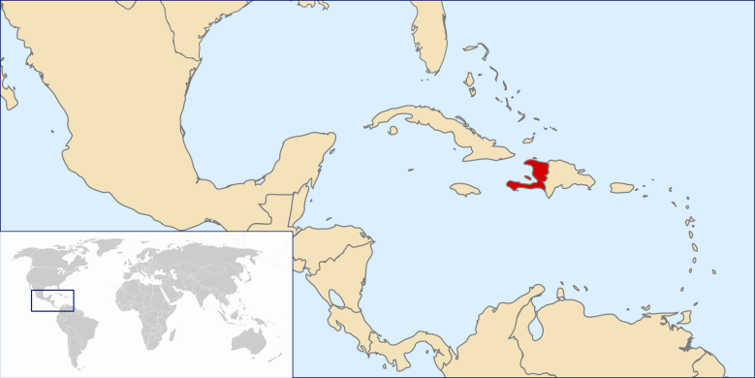
Prior to its independence, Haiti was a French colony known as St. Domingue. St. Domingue’s slave-based sugar and coffee industries had been fast-growing and successful, and by the 1760s it had become the most profitable colony in the Americas. With the economic growth, however, came increasing exploitation of the African slaves who made up the overwhelming majority of the population.

The Haitian Revolution was the result of a long struggle on the part of the slaves in the French colony of St. Domingue, but was also initiated by the free Mulattoes who had long faced the trials of being denoted as semi-citizens. This revolt was not unique, as there were several rebellions of its kind against the institution of plantation slavery in the Caribbean, but the Haitian Revolution the most successful. This had a great deal to do with the influence of the French Revolution, as it helped to inspire events in Haiti. The Haitian Revolution would go on to serve as a model for those affected by slavery throughout the world.

There were three distinct classes in St. Domingue. First, there were the Whites, who were in control. Then there were the free Mulattoes, who straddled a very tenuous position in Haitian society. While they enjoyed a degree of freedom, they were repressed by the conservative White power structure that recognized them only as being people of color. Free Mulattoes were being outlawed from holding office and were totally excluded from Haitian society. Mulattoes were allowed to own land but society’s restraints on Mulattoes made it highly unlikely that they could do anything with that land. Next came the slaves who, in Haiti, suffered under some of the harshest treatment found in the Caribbean. Slaves in Haiti were legally considered to be property of the public and with little choice, yielded obedience.

The French Revolution provided the Mulattoes and slaves with an opportunity and an inspiration after having witnessed the successful insurrection in France against the government’s long-standing denial of equal representation of the Commons to that of the Nobility and Clergy. This was such a revolution in the structure of French society that its news spread like wildfire and was exactly the stimulus the slaves and Mulattoes in Haiti needed to inspire their revolt.
Adapated from:http://www.unesco.org/new/en/culture/themes/dialogue/the-slave-route/resistances-and-abolitions/toussaint-louverture/, https://history.state.gov/milestones/1784-1800/haitian-rev
Based on the excerpt above, why did the mulattoes resent the French?

Based on the excerpt above, why did the enslaved Africans resent the French?

What impact did the French Revolution have on the start of the Haitian revolution?

Revolutionary Leader: Toussaint L'Ouverture
Years: 1743-1803
Country: Haiti
Colonial Power Fought: France

Toussaint L'Ouverture was one of the leaders of the Haitian revolution and the first black man to become governor of a colony.

Toussaint-Louverture was born into slavery in approximately 1743 in the French colony of Saint Domingue. He belonged to a small and privileged class of slaves employed by masters as personal servants. The Count de Breda, Toussaint’s owner, actively encouraged him to learn to read and write. He developed a passion for books and his readings were to become a great influence in his political life. Toussaint was freed from slavery at around the age of 33 and colonial records show that he became a land and slave owner himself.
How did Toussaint L'Ouverture learn to read?

The French Revolution of 1789 had a powerful impact on Saint Domingue. A complex civil war broke out in 1790 when free men of color claimed that they too were French citizens and should be allowed to enjoy the rights proclaimed in the Declaration of the Rights of Man.

A complex civil war broke out in 1790 when free men of color claimed that they too were French citizens. What does this reveal about the influence of the French Revolution on Haitians?

The following year, on 22 August 1791, Toussaint was one of the main organizers of a slave revolt that would eventually be known as the Haitian Revolution, the first and only victorious slave revolt in history.
In 1793, representatives of the French revolutionary government in Paris offered freedom to slaves who joined them in the fight against counter-revolutionaries and foreign invaders. The following year these orders were ratified by the revolutionary legislature in Paris, which abolished slavery throughout all French territories. This was a determining factor in Toussaint’s decision to join the French army. Under his increasingly influential leadership, the French defeated the British and Spanish forces.
Why did the French revolutionary government offer freedom to slaves in Haiti?

What impact did this decision have on Toussaint? What role did Toussaint play in the French revolutionary wars against the British and Spanish?

Having made himself ruler of the island, Toussaint did not wish to surrender power to Paris and ruled Saint Domingue as an autonomous entity. In 1801 he issued a Constitution for the island, which provided for autonomy and established Toussaint as governor for life. It abolished slavery and aspired to put in place a multiracial society composed of blacks, whites and mulattos.
What was significant about the constitution that Toussaint created for his Island? How did the rights promised differ from life under French rule?

When Napoleon Bonaparte came to power in France he aimed to return the Caribbean colonies to their earlier profitability as plantation colonies. In 1802, he dispatched an expedition of French soldiers to the island, lead by his brother in law Charles Leclerc, to reestablish French authority and slavery. Leclerc arrested Toussaint and deported him to France where he was imprisoned in Fort de Joux and died on April 7, 1803.
What happened to Haiti when Napoleon Bonaparte came into power?

For a few months the island remained under Napoleonic rule. However, the French soldiers soon fell victim to weapons and disease and surrendered to the indigenous army in November 1803. On January 1, 1804, the colony became the first black republic under the name of Haiti.

Adapated from:http://www.unesco.org/new/en/culture/themes/dialogue/the-slave-route/resistances-and-abolitions/toussaint-louverture/, https://history.state.gov/milestones/1784-1800/haitian-rev

Document 1
Revolt on the Island of Saint-Domingue (present-day Haiti), 1791
. . . The seeds of independence were first sown among free black soldiers sent by the white French governors to fight against the British in the American War of Independence, where they were exposed to anti-colonial ideas. Later, the French Revolution’s notions of liberty, equality, and brotherhood inspired an independence movement among the minority white settlers and a highly fragmented socioeconomic mix of free blacks. When the white population defied an order from France to enfranchise [give rights to] free blacks, it triggered a violent revolt that involved changing alliances among free blacks and the large slave population. After promulgating [announcing] a constitution in 1801 and overcoming a military force sent by Napoleon (First Consul, 1799–1804; Emperor, 1804–1814/1815), Haiti successfully declared its independence. Its success, along with that of the American War of Independence, inspired a number of anticolonial struggles throughout Latin America. . . .
Source: New York Public Library, Russia Engages the World, online exhibition (adapted) from the NYS Global History and Geography Regents Exam, January 2009.

1a. Based on this document, identify one situation that led to Haiti’s declaration of independence from France.

1b. Identify one impact the Haitian revolt had on global history as stated in this document.

Document 2
Toussaint L’Ouverture used this letter to rally the blacks in San Domingo (Haiti).
August 29, 1793
Brothers and friends.
I am Toussaint L’Ouverture, my name is perhaps known to you. I have undertaken vengeance. I want Liberty and Equality to reign in San Domingo. I work to bring them into existence. Unite yourselves to us, brothers, and fight with us for the same cause, etc. . . .
Source: C. L. R. James, Lettres de Toussaint L’Ouverture, The Black Jacobins, The Dial Press (adapted) from the NYS Global History and Geography Regents Exam, January 2009.

2a. According to this letter, what did Toussaint L’Ouverture want to achieve in San Domingo?

Document 3
C. L. R. James has stated that the success of the Haitian Revolution was almost entirely the result of the leadership of Toussaint L’Ouverture
. . . The work of Toussaint, Dessalines, Christophe, and Pétion endures in Hayti [Haiti], but what they did went far, far beyond the boundaries of the island. The Haytian revolution has had a profound influence on the history of the nineteenth century. . . .

[...] There were others more positive. Hayti gave the impulse to and subsidised [supported] the first national revolutions in Spanish America. When the Spanish American colonies saw that such a small and weak community could win and keep its freedom, they took courage to fight for their own emancipation from European imperialism. In dark days, Bolivar the Liberator, ill and in distress, was welcomed by Pétion, nursed to health and given courage to lead the struggling nationalities against Spain. He failed and returned to Hayti. He was once again befriended. Pétion supplied him with arms, munitions, men, money, and printing material, and thus fortified he left Hayti to begin the campaign which ended in the emancipation of the Five States. Pétion asked nothing in return but the freedom of the slaves. . . .
Source: C. L. R. James, The Black Jacobins, The Dial Press from the NYS Global History and Geography Regents Exam, January 2009.

3a. What were two ways that the work of Toussaint L’Ouverture and his successors influenced global history according to C. L. R. James?

Synthesis:
- How did the French Revolution impact the Haitian Revolution?

- Why is the Haitian Revolution considered a turning point in world history?

Discontent in Latin America
How did the social and ethnic structures in Spanish colonies lead to discontent?

- Creoles → resented being treated as second class citizens by the Peninsulares
- Mestizos and Mulattoes → angered that they were not treated as citizens and did not have the same power as whites
- Native Americans and Africans → angered by enslavement and inhumane treatment

Was everyone in the Spanish colonies angry for the same reasons? Explain.

In the 1700s, educated creoles read the work of Enlightenment thinkers. Many creoles were sent to Europe to study as well. While there, young creoles like Simon Bolivar were inspired by the ideals of a revolution and national sovereignty or the authority of a state to govern itself or another state. | How did many creoles like Simon Bolivar come into contact with ideas of revolution and freedom?
As we learned earlier, Napoleon invaded Spain in 1808, ousted the Spanish king and placed his brother Joseph in control of Spain and its colonies. Many in Latin America saw this as a moment of weakness and an opportunity to reject foreign rule and demand freedom from the colonial crown. | Why did Latin American leaders decide to fight for their freedom after 1808 versus than at an earlier point?
- José de San Martín: Revolutions in Argentina, Chile and Peru
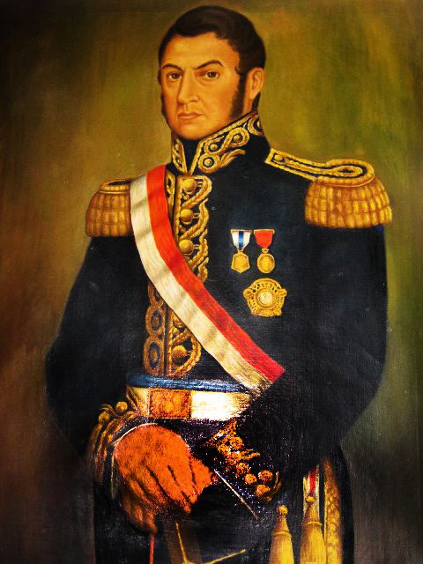  José de San Martín  https://commons.wikimedia.org/wiki/File:Jose_San_Martin_1.JPG | Revolutionary Leader: José de San Martín  Years: 1778-1850  Country: Argentina, Chile, Peru  Colonial Power Fought: Spain  José de San Martín was a South American soldier and statesman who played an important role in winning the independence of several South American countries from Spain. José de San Martín was born at Yapeyú, a village on the northern frontier of Argentina, where his father was an official of the Spanish colonial government. At the age of 7, San Martín returned to Spain with his parents. He entered the Royal Academy as a cadet and was educated there with sons of the nobility of Spain. As a member of the Spanish army, he fought in some of the campaigns against French forces in the Peninsular War and by 1811 had acquired the rank of lieutenant colonel.  Hearing of the revolt against Spain in his native Argentina, San Martín resigned from the Spanish army in 1812 and sailed for Buenos Aires to join the patriot forces. He took a prominent part in organizing Argentine troops and soon became military governor of the north to organize defense against Spanish troops in Upper Peru. In 1814, he secured the governorship of the province of Cuyo at the foot of the Andes. Here for 3 years he recruited and trained his Army of the Andes, since he believed that Argentina could not be safely independent unless Spanish forces were dislodged from Chile, Peru, and Bolivia.  Why is it significant that San Martín resigned from the Spanish army? How might his military training become useful later?  In January 1817, San Martín led his army of Argentines and fugitives from Chile over the Andes and surprised the Spanish army in Chile. He made Chile completely free of Spanish troops by May 15, 1818, and began planning for an invasion of Peru. Within a year San Martín was able to occupy the capital, and on July 28, 1821, he proclaimed the independence of Peru from Spain. On August 3rd, he accepted the position of supreme protector of Peru.  What impact did San Martín have on Latin American Independence movements?
- Simón Bolivar: Revolutions in Venezuela, Ecuador, Bolivia, Peru & Colombia (1810-1824)
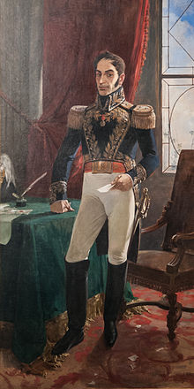  Simon Bolivar  https://en.wikipedia.org/wiki/Sim%C3%B3n_Bol%C3%ADvar#/media/File:Bolivar_Arturo_Michelena.jpg | Revolutionary Leader: Simón Bolivar  Years: 1783 – 1830  Country: Venezuela, Ecuador, Bolivia, Peru and Colombia  Colonial Power Fought: Spain  Simón Bolívar was a Venezuelan military leader who was instrumental in the revolutions against the Spanish empire. Born into wealth, Bolívar was sent to Spain for his education and quickly got involved in political life in Europe. After France invaded Spain in 1808, he became involved in the resistance movement and played a key role in the Spanish American fight for independence. When Napoleon named Joseph Bonaparte King of Spain and its colonies, which included Venezuela, Bolívar joined the resistance movement. The resistance group based in Caracas gained independence in 1810, and Bolívar traveled to Britain on a diplomatic mission.  Finally, Bolívar returned to Venezuela and began a campaign to wrest control of that country from the Spanish. He and his followers invaded Venezuela on May 14, 1813. Bolívar was hailed as El Libertador (The Liberator), though civil war soon erupted in the republic, forcing him to flee to Jamaica and seek foreign aid. There he wrote his famous "Letter From Jamaica," detailing his vision of a South American republic with a parliamentary setup modeled after England and a life-long president. In 1825, the "Republic of Bolivia" was created in honor of the inspirational leader, hailed by many as El Libertador (The Liberator).  Adapated from: http://www.biography.com/people/simon-bolivar-241196

Jamaica Letter (Carte de Jamaica), Simón Bolívar (1815)  Context: In this letter Bolívar analyzes what until that time had been considered the historical successes in the struggle for liberty in the Americas, justifies the "Spanish Americans" in their decision for independence, and addresses the necessity for the union of the countries of the Americas.  _____________________________________________________________________  My dear Sir:  The veil has been torn asunder. We have already seen the light, and it is not our desire to be thrust back into darkness. The chains have been broken; we have been freed, and now our enemies seek to enslave us anew. For this reason America fights desperately, and seldom has desperation failed to achieve victory.  [...]  Europe could do Spain a service by dissuading her from her rash obstinacy, thereby at least sparing her the costs she is incurring and the blood she is expending. And if she will fix her attention on her own precincts she can build her prosperity and power upon more solid foundations than doubtful conquests, precarious commerce, and forceful exactions from remote and powerful peoples.  [...]  The role of the inhabitants of the American hemisphere has for centuries been purely passive. Politically they were nonexistent. We are still in a position lower than slavery, and therefore it is more difficult for us to rise to the enjoyment of freedom … a people is therefore enslaved when the govemment, by its nature or its vices, infringes on and usurps the rights of the citizen or subject. Applying these principles, we find that America was denied not only its freedom but even an active and effective tyranny. Let me explain. Under absolutism there are no recognized limits to the exercise of governmental powers.  [...]  We have been harassed by a conduct which has not only deprived us of our rights but has kept us in a sort of permanent infancy with regard to public affairs. If we could at least have managed our domestic affairs and our internal administration, we could have acquainted ourselves with the processes and mechanics of public affairs.  [...]  So negative was our existence that I can find nothing comparable in any other civilized society, examine as I may the entire history of time and the politics of all nations. Is it not an outrage and a violation of human rights to expect a land so splendidly endowed, so vast, rich, and populous, to remain merely passive?  I am, Sir, etc., etc.  Source: http://faculty.smu.edu/bakewell/BAKEWELL/texts/jamaica-letter.html | 1. What does Bolívar mean when he writes, “The veil has been torn asunder. We have already seen the light, and it is not our desire to be thrust back into darkness. The chains have been broken…”?  2. When Bolívar writes that “our enemies seek to enslave us anew”, what is he referring to?  3. What does Bolívar suggest that Spain stop doing?  4. What grievances does Bolívar have against the Spanish government?  5. How are these grievances similar to the grievances expressed during the French Revolution?  6. What does it mean that the Spanish that “kept us in a sort of permanent infancy”?
3. Father Hidalgo: The Mexican Revolution (1810-1820)
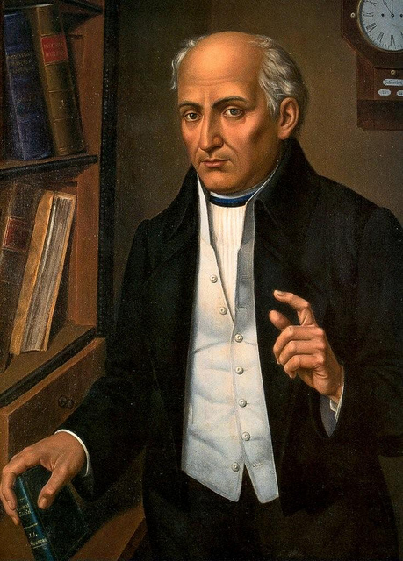  Father Hidalgo  https://en.wikipedia.org/wiki/Miguel_Hidalgo_y_Costilla#/media/File:Miguel_Hidalgo_y_Costilla.png | Revolutionary Leader: Father Hidalgo  Years: 1753-1811  Country: Mexico  Colonial Power Fought: Spain  Miguel Hidalgo y Costilla led the Mexican independence movement against Spanish rule in 1810 and unleashed a torrent of political passions that rocked Mexico for the first sixty years of its history as a nation. Born in May 1753 in Guanajuato, Hidalgo entered the priesthood in 1779. For the next quarter of a century, he performed his duties as a spiritual shepherd, but also read texts on political theory.  How might reading political texts influence his future role as a revolutionary leader?  In 1808, Hidalgo became a leader of an underground independence movement centered around literary clubs where the talk centered on emerging ideas on nationalism and political liberty.  Using your prior knowledge of major events in 1808, why do you think Hidalgo chose to join an underground independence movement at this point?  When authorities moved to arrest him, he gathered together his followers and his parishioners and issued the “Grito de Dolores” on September 16, 1810, a de facto declaration of independence. He quickly gathered an insurgent army that rampaged through central Mexico. Almost immediately the violence turned on issues of race, and his high-minded revolution turned bloody and excessive.  Adapted from:http://www.pbs.org/kera/usmexicanwar/biographies/hidalgo_costilla.html

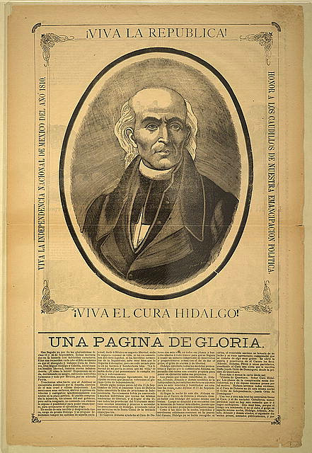  Source: http://www.loc.gov/wiseguide/sept09/images/Mexican_A.jpg | The Grito de Dolores ("Cry of/from Dolores") was the battle cry of the Mexican War of Independence, uttered on September 16, 1810, by Miguel Hidalgo y Costilla, a Roman Catholic priest from the small town of Dolores, near Guanajuato, Mexico. Shortly before dawn on September 16, 1810, Miguel Hidalgo y Costilla made a decision that revolutionized the course of Mexican history. Within hours, Hidalgo, a Catholic priest in the village of Dolores, ordered the arrest of Dolores- native Spaniards. Then Hidalgo rang the church bell as he customarily did to call the indians to mass. The message that Hidalgo gave to the indians and mestizos called them to retaliate against the hated gachopines or native Spaniards who had exploited and oppressed Mexicans for ten generations.  “My Children, a new dispensation comes to us today…Will you free yourselves? Will you recover the lands stolen 300 years ago from your forefathers by the hated Spaniards? We must act at once.”  The Grito de Dolores is considered the beginning of the Mexican War of Independence.  Adapted from: http://www.tamu.edu/faculty/ccbn/dewitt/adp/archives/documents/hidalgo.html, http://www.loc.gov/wiseguide/sept09/independence.html  - Why was the Grito de Dolores an important event?  - Why might Hidalgo have delivered the Grito de Dolores in a public setting?

Synthesis:

- Why was Napoleon’s 1808 invasion of Spain a trigger that encouraged Latin Americans to revolt?

- How did the French Revolution impact the Latin American revolutions?

Regents Multiple Choice Check for Understanding
Directions: Circle the choice that answers each question or complete the sentences below.
1. A lasting result of colonial rule in many Latin American nations has been the  (1) elimination of national debts  (2) control of power by wealthy landowners  (3) decrease in the power of the Catholic Church  (4) creation of industrial economics | A. Toussaint L’Ouverture declares Haiti independent.  B. Declaration of the Rights of Man and the Citizen is written in France.  C. The thirteen colonies gain independence from Great Britain.  D. Simón Bolívar frees Colombia from Spanish rule.  4. What is the correct chronological order for these events?  (1) A → B → D → C  (2) C → B → A → D  (3) A → D → C → B  (4) D → C → B → A
2. One way in which Toussaint L’Ouverture, Simón Bolívar, and José de San Martín are similar is that they  (1) supported the Reconquista  (2) led independence movements  (3) fought for Native American suffrage  (4) defended the encomienda system | 5. Which geographic factor most limited the growth of Latin American unity of the early 19th century?  (1) the region’s diverse landforms  (2) most of the region’s rivers flowed north to south  (3) the region’s location close to the equator  (4) the region’s lack of natural resources
3. The struggles for political independence in Latin America during the early 1800s were most directly influenced by the  (1) Berlin Conference  (2) doctrine of liberation theology  (3) American and French Revolutions  (4) writings of Count Camillo di Cavour | 6. The Andes Mountains and the Amazon River basin affected Simón Bolívar’s efforts to bring about  (1) economic imperialism  (2) political unification  (3) religious solidarity  (4) technological improvements
“. . . Give Venezuela such an executive power in the person of a president chosen by the people or their representatives, and you will have taken a great step toward national happiness. No matter what citizen occupies this office, he will be aided by the Constitution, and therein being authorized to do good, he can do no harm, because his ministers will cooperate with him only insofar as he abides by the law. If he attempts to infringe upon the law, his own ministers will desert him, thereby isolating him from the Republic, and they will even bring charges against him in the Senate. The ministers, being responsible for any transgressions committed, will actually govern, since they must account for their actions. . . .”
- Simón Bolívar, 1819
NYS Global History and Geography Regents Exam, August 2003

7. In this passage, which type of government is Simón Bolívar proposing for Venezuela?
(1) theocracy (2) monarchy
(3) democracy (4) dictatorship

