Historical Thinking:
The Lunchroom Fight

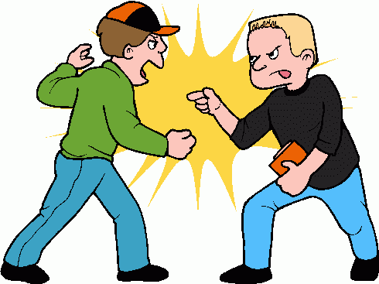

Name:
Global 9/Period:
Date:
Objective: | What is history? How does perspective affect it?  - Explain how perspective affects the histories of two people involved in the lunchroom fight.

Introduction: The Lunchroom Fight
Directions: Read the situation described below. Respond to the questions below. Then, share with your partner and write their responses.

Imagine that you are the principal of a school and you just found out that there was a fight in the lunchroom. You’ve asked many students and teachers who witnessed the fight what they saw so you can figure out who started it. Unfortunately, you have received many different accounts that disagree about who started the fight, who was involved, and when it started. | 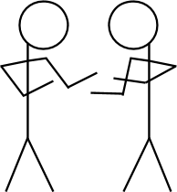

1. Why would there be different accounts of the fight?
My Response | My Partner’s Response
2. Who should the principal interview to try and figure out what happened during the fight and who started it?
My Response | My Partner’s Response
3. What questions would you ask interviewees if you were the principal?
My Response | My Partner’s Response
What is history?

Based on this definition of history, why is there no such thing as just “one” history?

Directions: The statements from Justin and Max are their personal histories of the lunchroom fight. Answer the questions below that are based on the definition of history above.

The principal soon found out that the two boys who were fighting were named Justin and Max. He spoke to both of them. Here were their responses:

Justin: “That kid started it. Max. I was just standing in line waiting to pay for my food, and he shoved me super hard. And, like, for no reason. He just freaked out on me. I don’t even know the kid, and he’s been weird to me ever since I started going to this school. He and his friends glare at me in English class for no reason.” | Max: “That kid is psycho. He turned around and punched me out of nowhere. Me and my friends were standing in line just joking around, and he turned around and punched me for no reason. He’s messed up and creepy. Ask anyone.”

1. History is an account of the past constructed from evidence. What evidence did Justin and Max use to construct their histories of the lunchroom fight?

2. How are Justin and Max’s histories of the lunchroom fight different?
3. How did Justin and Max’s perspectives affect their histories?
Objective: | What sources do historians use to learn about the past?  - Identify examples of primary sources.  - Identify examples of secondary sources.  - Explain the difference between a primary and secondary source.

Directions: Read the two sources below from the principal’s investigation into the lunchroom fight, then answer the question that follows.

 | Max, one of two boys in the fight: “That kid is psycho. He turned around and punched me out of nowhere. Me and my friends were standing in line just joking around, and he turned around and punched me for no reason. He’s messed up and creepy. Ask anyone.” | Alicia, a girl in the same grade as Max and Justin: “My friend Malik said he was in the lunchroom when Max and Justin started fighting. He told me that some people moved away to give the boys space while some others ran to break it up. I don’t really know either of them, but I bet Justin started it.”
1. What are the differences between these two sources?
2. What are the similarities between these two sources?

Historians use two types of resources to write about the past:
Primary Source | vs. | Secondary Source
Example: The Diary of Anne Frank, a diary written by a young Jewish girl who hid from the Nazis during the Holocaust. |  | Example: An essay written in 2016 about the Neolithic Revolution that occurred in 10,000 B.C.E.

Directions: Based on the definitions above, identify each of the documents below as either “primary” or “secondary” and explain why you identified it as that type of source.

1. A journal entry written by Christopher Columbus describing his voyage across the Atlantic Ocean. |  | 2. A biography of Napoleon Bonaparte (died in 1821) written by a historian in 2013. |  | 3. A textbook chapter about World War I (1914-1919), written in 1996. |  | 4. A photograph of your grandfather on his first day of school.
Circle one: |  | Circle one: |  | Circle one: |  | Circle one:
Primary  Source | Secondary  Source | Primary  Source | Secondary  Source | Primary  Source | Secondary  Source | Primary  Source | Secondary  Source
Why? |  | Why? |  | Why? |  | Why?
5. Winston Churchill’s autobiography about the first thirty years of his life which he wrote later in his life. |  | 6. A newspaper article about the start of World War II, written the day after it started. |  | 7. A letter from George Washington to Thomas Jefferson. |  | 8. A sword that was made in 1317.
Circle one: |  | Circle one: |  | Circle one: |  | Circle one:
Primary  Source | Secondary  Source | Primary  Source | Secondary  Source | Primary  Source | Secondary  Source | Primary  Source | Secondary  Source
Why? |  | Why? |  | Why? |  | Why?

Directions: Identify each of the sources above as either a primary source or a secondary source, then explain why you have categorized each source in that way.

Source | Primary Source or Secondary Source? |  | Why?
Max, one of two boys in the fight: “That kid is psycho. He turned around and punched me out of nowhere. Me and my friends were standing in line just joking around, and he turned around and punched me for no reason. He’s messed up and creepy. Ask anyone.” | Primary  Source | Secondary  Source
Alicia, a girl in the same grade as Max and Justin:  “My friend Malik said he was in the lunchroom when Max and Justin started fighting. He told me that some people moved away to give the boys space while some other ran to break it up. I don’t really know either of them, but I bet Justin started it.” | Primary  Source | Secondary  Source

Objective: | How do historians read sources?  - Source a source from the lunchroom fight.  - Annotate a source from the lunchroom fight.  - Close read a source from the lunchroom fight.

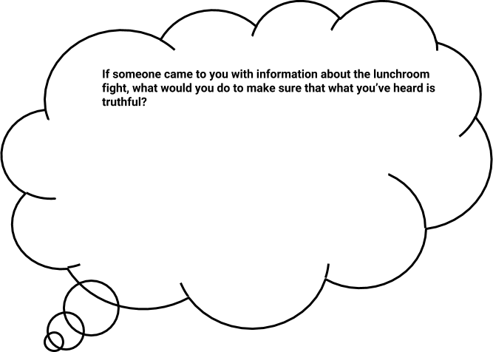
Directions: Respond to the question below.

How do historians read sources?
When historians read sources they try to figure out what the source is saying, if it is reliable, and how it relates to other sources and events that the historian knows about.

To do this, they engage in three practices that you are going to learn:

Annotate | Source | Close Read

Annotation is the act of using symbols and notes to show what you are thinking while you read. When you annotate, you interact with the source by underlining sections of the text, circling words, phrases, or images, and writing notes to yourself in the margins.
Annotate |  | Annotation helps the reader focus their attention when reading a source and record their thoughts as they read.  Whenever you annotate, you should have a purpose, like a question, that guides you.

Example of annotation of an image: | Example of annotation of text:
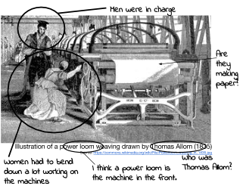 | 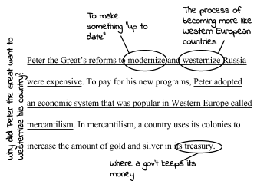

Annotation Practice

Annotation Key

M | J |  | 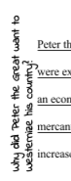
Place an “M” next to comments that suggest Max started the fight | Place a “J” next to comments that suggest Justin started the fight | Circle words that are unclear and identify possible meanings. | Write questions in the margins to clarify misunderstandings.

Directions: WITH YOUR TEACHER, annotate Source 1 using the annotation key above.

Annotate | Source 1  Eric (Max’s good friend): “The new kid (Justin) definitely started it. He really just attacked out of nowhere. He’s a freak, and he seriously thinks he’s better than everyone because of his dad.”

Directions: INDEPENDENTLY, annotate Source 2 using the annotation key above.

Annotate | Source 2  Megan (Max’s girlfriend): “I wasn’t there. All I can say is that Max has been really different lately and kind of mean. I don’t know what’s going on, but he’s not himself.”

Sourcing is the act of determining who created a document, when the document was created, where it was created and why it was created.
Source |  | Historians source in order to determine whether the document is a reliable (trustworthy) source. To source, historians ask themselves these questions whenever they investigate a source:  Who wrote this? When was it written? Where was it written? What type of source is this?  Why was it written? What is the author’s perspective? How is the source useful? How is the source not useful?

Sourcing Practice
Directions: Examine the documents below and answer the questions that follow to determine if they are reliable sources for historians to write about the past.

Sourcing Practice #1
This is another account of the lunchroom fight from the introduction to this lesson. Max wrote this account because the principal asked all witnesses to write down what they saw.

Max: “That kid is psycho. He turned around and punched me out of nowhere. Me and my friends were standing in line just joking around, and he turned around and punched me for no reason. He’s messed up and creepy. Ask anyone.”

- Who wrote this?

- Why was it written?

- What is the perspective of the author?

- How is this source useful evidence in determining what happened during the lunchroom fight?

- How is this source not useful evidence in determining what happened during the lunchroom fight?

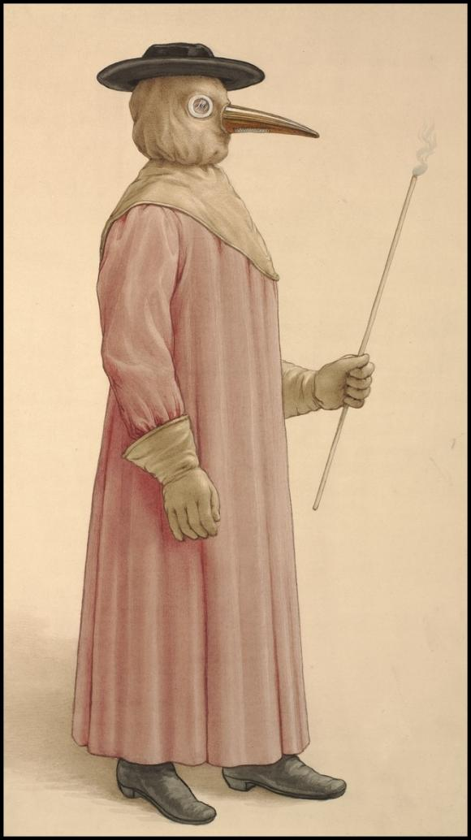
Sourcing Practice #2
The image to the right was made in 1910. It depicts the type of clothing worn by doctors when treating patients who had the plague, a disease that was deadly and spread quickly in the 17th century (1600s). The artist based the drawing on information about doctors’ clothing in a book written in 1721 by Jean Jacques Manget.

- Why might the artist have drawn image?

- When was this drawn?

- Is this a primary source or a secondary source? How do you know?

- How is this source useful evidence in determining what happened during the plague?

- How is this source not useful evidence in determining what happened during the plague?
Source: Adapted from the Stanford History Education Group’s “Plague Doctor” Assessment. https://beyondthebubble.stanford.edu/assessments/plague-doctor

Close Reading is the act of reading a source to identify the author’s argument and how they are making it.
Close Read |  | When close reading, we try to answer questions like:  What claim does the author make? What evidence does the author use?  What language (words, phrases, images, symbols) does the author use to persuade the document’s audience? How does the document’s language indicate the author’s perspective?

Close Reading Practice

Directions: Read the passage below, then answer the close reading questions on the right.

1  2  3  4  5  6  7  8  9  10  11  12  13  14  15  16  17  18 | Home-cooked food is healthier than fast food. According to a recent study by the Palo Alto Medical Foundation, fast food burgers have on average 71 calories per ounce compared to homemade burgers that contains 67 calories per ounce. That means that a fast food quarter pound burger (4 oz.), has sixteen more calories than the same burger made at home. Those added calories could lead to weight gain, which can be bad for one’s health. In addition, in a 2005 study, Dr. Harold Haines states “people who eat fast food meals more than twice a week gain about 9.92 pounds and are more likely to get diabetes than people who eat home cooked meals (2).” The more fast food you eat, the more overweight you will be, and the more likely it is that you will have health problems like heart disease, or diabetes which can prevent you from living an enjoyable and long life with your loved ones. | 1. What claim does the author make about home-cooked food?
 |  | 2. What evidence does the author use to support his/her claim?
 |  | 3. In addition to evidence, how does the author try to persuade the reader in lines 17 and 18?

Directions: Read the statement below from Max’s mother , then use it to annotate, source, and close read.
Annotate  Source  Close Read | 1. Annotate: Using the annotation guide below, annotate the passage.  M J  Place an “M” next to comments that suggest Max started the fight Place a “J” next to comments that suggest Justin started the fight Circle words that are unclear and identify possible meanings. Write questions in the margins to clarify misunderstandings.  1 2 3 4 5 Max’s mother: “Max would never start a fight. He’s the sweetest boy. I know he’s had a hard time lately with me and his dad losing our jobs, but he still would never start a fight with anyone. He’s a mentor to the younger boys and helps out at church. You can ask anyone in this town.”  2. Source: Answer each of the following questions based on the information provided above.  2a. Who wrote this?  2b. Why was it written?  2c. What is the author’s perspective [attitude toward something]?  2d. How is this source useful evidence in determining what happened during the lunchroom fight?  2e. How is this source not useful evidence in determining what happened during the lunchroom fight?  3. Close Read: From this author’s (Max’s mother) perspective, who started the lunchroom fight? Why does the author believe that?

Objective: | How and why do historians corroborate their sources?  - Describe what corroboration is.  - Corroborate sources to determine what happened during the lunchroom fight.

Directions: Read the information below and answer the question that follows.

The principal interviewed eleven people during the investigation, including Justin, Max, Eric (Max’s good friend), Anthony (a bystander), Megan (Max’s girlfriend), Alicia (a girl in the same grade as Max and Justin), a Cafeteria worker, Max’s mother, Justin’s father, Jamie (a student in English class with Max and Justin in the period right before lunch), and an English teacher.

Why do you think the principal interviewed so many people? What are the benefits of interviewing more people?
Corroboration is the act of comparing pieces of evidence to see where they agree or disagree.
Corroborate |  | Historians corroborate sources with their account of what happened to uncover what actually happened.  What do other documents say? Do the documents agree? If not, why?  What other documents may clarify our understanding? What is the perspective of the author of the statement? What is the author’s bias?

Corroboration Practice

Directions: Read the scenario and accounts below then answer the questions that follow to explain how each piece of evidence corroborates the initial account.

Scenario:  On the night before the big game between your school’s team, the Panthers, and you biggest rivals, the Bears, the Bears’ locker room was vandalized. Many of the players from the Bears are accusing members of your team of committing the vandalism. The Panthers say that they couldn’t have vandalized the locker room because they were all out for pizza when the locker room was raided. Additional testimony: | Account A:  Statement by the Panther quarterback’s older sister saying that she drove them to  the pizza place on the night the locker room was vandalized.
Account B:
Statement from the Bears' running back saying that he saw the Panthers at the pizza
place the night the locker room was vandalized.

1. What is the perspective of the author of Account A? What is the author’s bias? | 2. What is the perspective of the author of Account B? What is the author’s bias?
3. How do both Account A and Account B corroborate the Panthers’ account? | 4. Which of the two pieces of testimony would make their case stronger? Explain.
5. What other accounts might clarify whether the Panthers were at the pizza place? Who would they be from?

Directions: Returning to the lunchroom fight, read through the accounts of the fight and then, after considering the perspective and bias of each speaker, answer the question, “What happened during the lunchroom fight?”

Source | What is the perspective of the author of the statement? What is the author’s bias? | What evidence from this source will help you determine what caused the lunch room?
Justin: “That kid started it. Max. I was just standing in line waiting to pay for my food, and he shoved me super hard. And, like, for no reason. He just freaked out on me. I don’t even know the kid, and he’s been weird to me ever since I started going to this school. He and his friends glare at me in English class for no reason.”
Max: “That kid is psycho. He turned around and punched me out of nowhere. Me and my friends were standing in line just joking around, and he turned around and punched me for no reason. He’s messed up and creepy. Ask anyone.”
Eric (Max’s good friend): “The new kid definitely started it. He really just attacked out of nowhere. He’s a freak, and he seriously thinks he’s better than everyone because of his dad.”
Anthony (bystander): “I was pretty far back in the line, but Max and his friends were being kind of loud and joking around. I couldn’t really hear what they were saying. And then all of a sudden I saw people pulling Justin and Max apart."
Megan (Max’s girlfriend): “I wasn’t there. All I can say is that Max has been really different lately and kind of mean. I don’t know what’s going on, but he’s not himself.”
Cafeteria worker: “The group of boys were pushing each other around. I think it was an accident, and one of them pushed into the new boy, and he took it the wrong way.”

Corroborate | Directions: Based on the sources provided, describe what happened during the lunchroom fight.

Objective: | What is context? How do historians use it to understand and write about the past?  - Contextualize the lunchroom fight.
Directions: Read the information below about the lunchroom fight and answer the accompanying questions.

During the principal’s investigation she found out the following information:

The fight was between Justin and Max. Justin is a new student. He is shy, quiet, and does not have many friends. He moved to town last month because his father was hired to take over the town’s main business. Justin’s father fired many people, including Max’s parents, when he reorganized the business. Max is a popular student, who is known for his friendliness and good humor. In the past few weeks, however, he has been withdrawn and somewhat depressed.

1. What information does this passage provide about the lunchroom fight that the other sources you have read did not give you? | 2. Does this information change your idea of who started the lunchroom fight? If so, how? If not, why not?

Contextualizing a historical event is the act of describing where the event it took place, what led to it, and why.
Contextualize |  | To contextualize an event historians try to answer these questions:  When did it happen? Where did it happen?  What led to it?
Directions: Read the sources below from the principal’s investigation of the lunchroom fight, then use the evidence from each source to complete the table.

Max’s mother: “Max would never start a fight. He’s the sweetest boy. I know he’s had a hard time lately with me and his dad losing our jobs, but he still would never start a fight with anyone. He’s a mentor to the younger boys and helps out at church. You can ask anyone in this town.”
Justin’s father: “I can guarantee 100% that Justin would never lay a finger on anyone unless he was really provoked. Trust me. And I know because we’ve had to move around quite a bit in the last few years because of my job, so unfortunately, Justin knows what it’s like to be the new kid. And I’ve watched him go through these adjustment periods at each new school. He just lies low, and pretty soon the other kids see what a great kid he is. So I know as a fact that Justin wouldn’t stir up trouble. It’s really not in his nature.”
Jamie (student in English class with Max and Justin in the period right before lunch):
“I wasn’t in the cafeteria today, and I’m not friends with any of those guys, but I’ve seen Max and his friends be mean to Justin in the hallways and in class when the teacher isn’t looking. Not physical or anything, but they’ll like say jokes under their breath and then laugh and stuff like that. They make him uncomfortable.”
English teacher: “To be completely honest with you, I’m not surprised that this happened. There has been a lot of tension in the school and in the town, in general, with the reorganization plan. A lot of people are very upset with the decisions of the new management to fire people, and I must say that I myself am very surprised that they’ve done this. It’s a tremendous strain on the community, and I feel for all the boys.”

Town Context: What is happening in the town that might explain the lunchroom fight? | Who said this? | Explain if this source is useful for explaining the town context around the lunchroom fight or not and why.

School Context: What has been happening in the rest of the school (for example, in English class)? | Who said this? | Explain if this source is useful for explaining the school context around the lunchroom fight or not and why.

Contextualize | Directions: Based on the town and school contexts that you recorded in the table above, contextualize the lunchroom fight by describing what happened in the town and school before the fight that led to it.

Objective: | How do historians construct arguments?  - Identify the components of a historical argument.

Directions: Read through the two arguments below. List any differences and similarities between Argument A and Argument B.

Argument A | Argument B
Malcolm: Fast food is better than home cooked food.  Brittany: Why do you say that?  Malcolm: I like it.  Brittany: How can you prove that?  Malcolm: When I eat it, I say “Mmmmmm, good and greasy!”  Brittany: So, what?  Malcolm: So, that’s why it’s better. It tastes better to me. | Aliyah: Home cooked food is better than fast food.  Johnny: Why do you say that?  Aliyah: Home cooked food is healthier for you.  Johnny: How can you prove that?  Aliyah: In an experiment, researchers found that on average, home cooked burgers have four less calories per ounce than fast food burgers.  Johnny: So, what?  Aliyah: The more calories you eat, the more likely you are to be overweight.  Johnny: So, what?  Aliyah: The more overweight you are, the more likely it is that you will have health problems like heart disease, or a heart attack. Therefore, home cooked meals are healthier than fast food meals.
List differences and similarities between Argument A and Argument B.
Similarities | Differences

Which argument do you believe to be better? Why?
Constructing Arguments is the act of creating persuasive understandings of the past by using relevant evidence from primary and secondary sources.
Construct Arguments |  | Historians corroborate sources to their account of what happened is closer to what actually happened.  A historical argument IS NOT:  - supported by opinions.  - made up on the spot.  - won by the person who can yell the loudest.  A historical argument IS:  - supported by information from reliable sources.  - researched and carefully put together.

Historians construct arguments through
claims, evidence, and reasoning/explanation.
The Components of a Historical Arguments
CLAIM: The claim is the answer to your research question or response to the prompt you are addressing. It should be based on the evidence you have collected.
EVIDENCE: Evidence is information that supports your claim. We collect evidence from sources like texts, videos, and knowledgeable people to support our reasons.
REASONING/EXPLANATION: Reasoning is the explanation for why the evidence supports the claim. In history we contextualize, compare, corroborate, connect cause and effect, and use geography and economic ideas to explain our reasoning.

Constructing Arguments Practice
Construct Arguments | Directions: Reread the argument below from the introduction and annotate it using the symbols below to label the different components of the argument.  Claim Evidence Reasoning  C E R  Aliyah: Home cooked food is better than fast food.  Johnny: Why do you say that?  Aliyah: Home cooked food is healthier for you.  Johnny: How can you prove that?  Aliyah: In an experiment, researchers found that on average, home cooked burgers have four less calories per ounce than fast food burgers.  Johnny: So, what?  Aliyah: The more calories you eat, the more likely you are to be overweight.  Johnny: So, what?  Aliyah: The more overweight you are, the more likely it is that you will have health problems like heart disease, or a heart attack. Therefore, home cooked meals are healthier than fast food meals.

Construct Arguments | Directions: Based on the town and school contexts that you recorded in the table above, contextualize the lunchroom fight by describing what happened in the town and school before the fight that led to it.  Examine the statements below from the lunchroom fight between Justin and Max, then categorize each statement as a claim, evidence that supports that claim, or reasoning that supports the evidence. Place the letter corresponding with each statement in the appropriate place below. There will be only one claim.  The argument below does not reflect the only possible scenario.  Statement Letter Component Statement  _____ Claim A. Megan, Max’s girlfriend said that Max had been acting strange and “kind of mean.”  _____ Evidence #1 B. Justin’s father knows him better than anyone else, so if he believes his son is not capable of starting a fight, then Max probably started it.  _____ Reasoning/explanation in Support of Evidence #1 C. Max started the fight, not Justin.  _____ Evidence #2 D. If Max had been mean to Justin in line, that may have started the fight.  _____ Reasoning/explanation in Support of Evidence #2 E. Justin’s father said that his son “would never lay a finger on anyone unless he was really provoked” and that it was “really not in his nature” to “stir up trouble.”

So, what happened??
Using your historical thinking skills
and the evidence gathered, make a claim as to who started the fight.
Use multiple pieces of evidence to show why the fight occurred.
You may not use the claims and evidence from the last activity.

